Andreas Hanemann, hanemann@dfn.de; May 29, 2008
Design of Transformation Service

Background
A Transformation Service (TrS) has been planned as part of the perfSONAR service set for several years to transform data from MAs (Measurement Archives) or MPs (Measurement Points). The kinds of transformations that are considered are related to the data (the values) or to the monitoring intervals. Furthermore, correlation of data could be possible.
More general, it is to be considered where transformations can potentially be performed and therefore what is reasonable to locate in a specialized TrS. Locations for transformation are the following.
- On the archive itself
  - The transformation is done with scripts on the DB itself, i.e. transformed data are stored back in the archive (with the option to either replace the original data or create new data).
  - Pros: Full control over the data from the perspective of the domain
  - Cons: The transformation is performed in a local manner that cannot be shared among perfSONAR partners. Data is lost if it is aggregated (and not replicated).
- By the Measurement Archive web-service
  - The Measurement Archive checks the request and performs the appropriate transformation if it does not have the data in the appropriated format (or call an internal scripts). It then replies to the request.
  - Pros: Transformation can be shared if it is a general MA functionality. No raw data is lost or needs to be replicated.
  - Cons: Change of the MA concept of being just a data archive, no business functionality has been foreseen yet. On the fly conversion is more time consuming then data access.
- By a transformation web-service
  - The data is pulled by the transformation service and transformed or pushed to it and it performs the transformation.
  - Pros: Transformation methods can be easily shared. No raw data is manipulated. The service can be developed independently from the MA.
  - Cons: Additional protocol overhead can lead to slow data provisioning. May be more difficult to enforce data access policies.
  - Cons: Certain transformations can be efficiently done directly in e.g. relational DB, this will be impossible if the TrS will need to pull the data and process it in memory
- On the visualization tool
  - The data is received by the visualization and the visualization tool transforms the data on the fly.
  - Pros: No change in the access to MA. No protocol overhead.
  - Cons: Visualization tools may implement similar functionalities several times. Many raw data may be transferred to the tool which can be a performance bottleneck. Data protection cannot be realized.

Risks:
- Transformation function requires too much time to be usable by a user (less than a minute)
- Transformation function combined with web-services requires too much time (less than a minute)
- LS registration, authentication: how will they work?
- Schema extensions? Does it require modification on the web-service front?

Use Case Collection
UC1: The starting point for the implementation was DFN’s requirement to provide data in categories (i.e. DFN does not want to provide exact values for the utilization data, but only wants to report whether the utilization is within a certain interval like 15-30%). A flexible TrS should be implemented as intermediary between the MA and the outside world. The MA is going to store the exact values.
UC2: Another transformation that is of concrete interest is the match of time resolutions. An RRD MA stores the past values with resolutions as predefined in its RRD configuration (e.g. 2 minute intervals for data from the previous months and 30 minute intervals for data from the last year). Visualization tools such as perfsonarUI and CNM have their own time intervals (like 5 minute intervals). A transformation service could provide a standard means for converting the data into the desired resolution.
UC3: When the HADES MA is queried, it provides a large amount of data. The visualization tool developer has mentioned that the data set is too large to handle and aggregation is required. The transformation service would then be queried on behalf of the HADES MA and provides aggregated data to the visualization corresponding to either a pre-defined aggregation type or to an aggregation type specified in the request.
The use case is currently not considered further since the HADES MA is going to contain aggregated data on its own (precomputed to allow for quick responses). The TrS does not seem to be a good place for aggregation of data if the amount of data is the problem since this would require that all data would have to be transferred between the MA and the TrS. The TrS can be interesting if certain kinds of aggregation can be used for different kinds of services.
UC4: aggregation or concatenation in space: concatenate measurement in space to get a single value over multiple topological elements. There is currently no concrete request for this kind of transformation so that it is not going to be implemented in the beginning. An example would an aggregation along a traceroute (e.g. if the minimum bandwidth available for all path segments should be determined). However, the example can also be realized in the visualization tools.
UC5: the transformation service is being regularly pushed data from MAs or MPs and run some check on the data against some thresholds and against indicators representing past information. When the data is going over the threshold, an alarm is being sent (email or SNMP trap) to a list of recipients. It might even be more complex if trend analysis should be performed or certain patterns should be detected. This functionality has to be part of a larger alarming concept.
The alarming is currently discussed in the context of HADES data only so that an alarm system for this could be sufficient. The PERT mentioned that they would like to have baselines of usual values (for delays, etc) and would like to be informed about deviations of the baselines.
UC6: an MP or an MA pushes regularly some data to the transformation service to perform some transformation and request to send the data to one or more destination web-services. There is currently no specific need for this use of a TrS. Such static transformation may not be so interesting since users may prefer transformations for their purposes. It could be interesting to think about a caching mechanism to store transformations which have been asked for.
A use-case implemented at Internet2 is related to UC5/UC6 where their circuit-status service (being a transformation service) polls other services about the information that it can register to the LS.

Interaction Sequence
The idea for the implementation of the Transformation Service is to avoid changes in the clients and in the MA services as much as possible. The Transformation Service is then going to act as a proxy between the client and the MA. The client should not be aware whether is interacting with an MA directly or with a TrS. For the MA a request from the TrS should not differ from a request from the client directly.
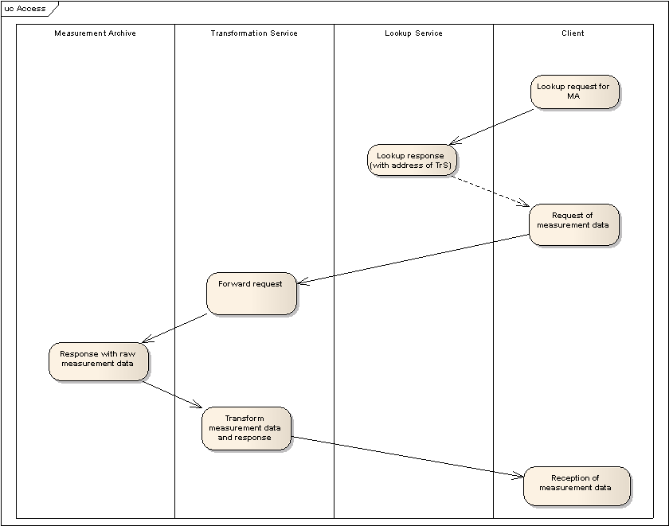
The usual interaction sequence then works as follows. The client is interested in a certain kind of data in a specific format and asks the Lookup Service which MA can provide these data. The situation may be that the raw data is provided by an MA, but that the format does not match so that a transformation is needed. The Lookup Service therefore replies with the address of the TrS instead of the address of the MA. The client asks the TrS for the measurement data (by using a request like the request to an MA). The TrS converts the request to a request for raw data to the MA. The MA replies to the TrS with the raw data (note that both transactions do not require a change of the MA). The TrS transforms the raw data and sends them back to the client.

As a prerequisite for the interaction sequence we need registrations with the Lookup Service and appropriate retrieval methods (see next figure). An MA can register with a Lookup Service as previously done. The new registration of a TrS is more complicated. The concept is to register the TrS as “virtualized MAs”. This means that a TrS has the potential to perform transformations for a set of MAs and then registers information about all the MAs and the transformations.
An example is the following. An MA has utilization data with a certain time resolution (e.g. two minute intervals). A TrS can transform time resolution to any time interval (e.g. to the five minute intervals as usually requested, but also to any other time interval). The TrS therefore registers to the LS providing information about the MA’s content and about the more flexible time resolution.
The registration of the TrS could potentially include many MAs, but a certain limit would be reasonable to avoid a performance bottleneck. The administrator of a TrS instance should configure this in the service.
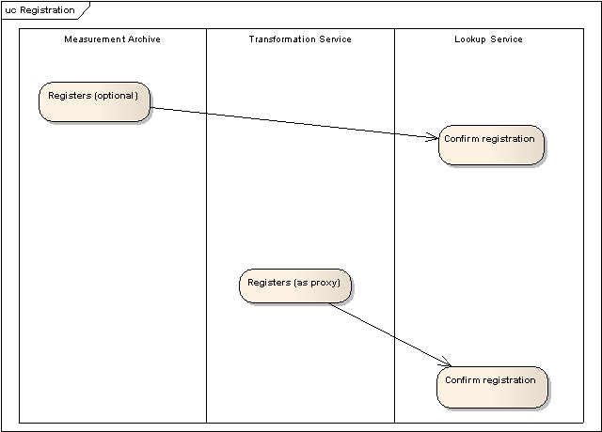
If the transformation takes quite a long time, an additional mechanism may be required, e.g. that a fetch address is provided where the data can be retrieved after transformation. In addition, the client may be informed about the progress via additional messages.

The previous interaction sequence does not consider AA issues. For limiting the access to the MA the TrS should be considered as a client which has to provide credentials. This has to be done by forwarding the credentials of the user. We may then need a new profile “service on behalf of a client”. For the DFN scenario the access to the MA can be limited by blocking requests from any other addresses apart from the address of a TrS installed by DFN. The DFN instance of the TrS has to perform the categorization of the utilization data in any case prior to forwarding the data to a client.

Protocol and Schema modifications

Lookup Service registration:
The Lookup Service registration of a TrS needs to be enhanced in relation to the MA registration with information about the transformation, however using an indirect manner which expresses the results of the transformation instead of the transformation itself. The code shows that there is an additional field for the time resolution which contains a value “any” for the TrS, while there would be a certain interval specified if the MA registers directly. Since the registration of the TrS may refer to several MAs, there may be multiple metadata blocks (one per MA). In practice, it has to be checked whether it makes sense to usually register all MAs for which transformations are offered in a combined registration or whether there should be individual registrations per MA/Transformation Service combination.
It is assumed that different URLs (e.g. with different ports) are used for the different virtual MAs. The reason for this is that the TrS can do the forwarding based on the ports. Otherwise, target MA names would have to be put into the MetadataKey requests.

<nmwg:message type="LSRegisterRequest"
id="msg1"
xmlns:perfsonar="http://ggf.org/ns/nmwg/tools/org/perfsonar/1.0/"
xmlns:nmwg="http://ggf.org/ns/nmwg/base/2.0/"
xmlns:psservice="http://ggf.org/ns/nmwg/tools/org/perfsonar/service/1.0/"
xmlns:nmwgt="http://ggf.org/ns/nmwg/topology/2.0/"
xmlns:netutil="http://ggf.org/ns/nmwg/characteristic/utilization/2.0/">

<nmwg:metadata id="serviceLookupInfo"> <!-- one metadata block per registered MA -->
<perfsonar:subject id="commonParameters" xmlns:perfsonar="http://ggf.org/ns/nmwg/tools/org/perfsonar/1.0/">
<psservice:service id="serviceParameters" xmlns:psservice="http://ggf.org/ns/nmwg/tools/org/perfsonar/service/1.0/">
<psservice:serviceName>My_test_TrS_for_MAx</psservice:serviceName>
<psservice:accessPoint>http://reed.man.poznan.pl:8080/axis/services/TrS</psservice:accessPoint> <!-- access point is going to be different in other metadata blocks -->
<psservice:serviceType>MA</psservice:serviceType><!—not necessary to define TrS as additional type -->
<psservice:serviceDescription>This is my testing TrS which represents MA x</psservice:serviceDescription>
</psservice:service>
</perfsonar:subject>
</nmwg:metadata>

<nmwg:data id="data0" metadataIdRef="serviceLookupInfo">
<nmwg:metadata id="meta1">
<perfsonar:subject id="subj1" xmlns:perfsonar="http://ggf.org/ns/nmwg/tools/org/perfsonar/1.0/">
<nmwgt:interface xmlns:nmwgt="http://ggf.org/ns/nmwg/topology/2.0/">
<nmwgt:hostName>atlang-hstnng.abilene.ucaid.edu</nmwgt:hostName>
<nmwgt:ifName>unknown</nmwgt:ifName>
<nmwgt:ifDescription>hstn:oc192(p2p)::show:intracloud</nmwgt:ifDescription>
<nmwgt:ifAddress type="ipv4">198.32.8.34</nmwgt:ifAddress>
<nmwgt:direction>in</nmwgt:direction>
<nmwgt:capacity>10000000000</nmwgt:capacity>
<nmwgt:timeResolution>any</nmwgt:timeResolution>
</nmwgt:interface>
</perfsonar:subject>
<nmwg:eventType>utilization</nmwg:eventType>
</nmwg:metadata>
</nmwg:data>

<nmwg:data id="data1" metadataIdRef="serviceLookupInfo">
<nmwg:metadata id="meta2">
<perfsonar:subject id="subj1" xmlns:perfsonar="http://ggf.org/ns/nmwg/tools/org/perfsonar/1.0/">
<nmwgt:interface xmlns:nmwgt="http://ggf.org/ns/nmwg/topology/2.0/">
<nmwgt:hostName>atlang22-hstnng.abilene.ucaid.edu</nmwgt:hostName>
<nmwgt:ifName>unknown</nmwgt:ifName>
<nmwgt:ifDescription>hstn:oc192(p2p)::show:intracloud</nmwgt:ifDescription>
<nmwgt:ifAddress type="ipv4">198.32.8.34</nmwgt:ifAddress>
<nmwgt:direction>in</nmwgt:direction>
<nmwgt:capacity>10000000000</nmwgt:capacity>
<nmwgt:timeResolution>any</nmwgt:timeResolution>
</nmwgt:interface>
</perfsonar:subject>
<nmwg:eventType>utilization</nmwg:eventType>
</nmwg:metadata>
</nmwg:data>

</nmwg:message>

The time resolution field has to be part of each interface so that this kind of registration can also be used for the MAs. In each MA it is possible that the time resolutions for individual interfaces are different.
The idea is so far that an installer of a TrS configures by hand which MAs his TrS should access. However, this may also be supported automatically by a perfSONAR protocol in later stages.
Lookup Service Query request:
The Lookup Service Request specified so far (http://anonsvn.internet2.edu/svn/perfsonar/trunk/perfsonar/schema/example-instances/perfSONAR/LS/test/LSQueryRequest.xml) is a simple dump of the contents of the LS so that the client has to parse on its own these contents. This needs to be enhanced for the interactions involved which is done in the following by specifying the required parameters.
Lookup of MA/TrS: specify interface IP address and desired time resolution, return MA/TrS access data

MetadataKey request (client to the TrS):
The communication between client, TrS and MA may happen in a synchronous manner so that the address of the client may not need to be stored for the return of information from the MA. This should be the starting point for the implementation.
However, the MetadataKey requests may need to contain the IP address of the client in the parameters. The reason for this is that the TrS would otherwise not know where to send the data to when the response is returned from the MA and if the connection is not maintained. A solution where the state of requests has to be maintained by the TrS has the disadvantage to results in a performance bottleneck and/or garbage collection issue if many requests are aborted. An alternative may be to get client information out of the client credentials.
Besides of that, the message can be the same as it is right now and can also be used for the communication between the TrS and the MA. The same holds for the response(s).

<?xml version='1.0' encoding='UTF-8'?>

<!-- Purpose: Requesting data from a partial metadata request. -->
<!-- Version: $Id$ -->

<nmwg:message type="MetadataKeyRequest"
id="mdrq1"
xmlns:netutil="http://ggf.org/ns/nmwg/characteristic/utilization/2.0/"
xmlns:nmwg="http://ggf.org/ns/nmwg/base/2.0/"
xmlns:nmwgt="http://ggf.org/ns/nmwg/topology/2.0/">

<!-- Optional message level parameters -->
<nmwg:parameters id="msgparam1">
<nmwg:parameter name="authToken">Internet2</nmwg:parameter>
<nmwg:parameter name="timeValue">1127250495</nmwg:parameter>
<nmwg:parameter name="timeType">unix</nmwg:parameter>
<nmwg:parameter name=”requesterIdentification”>123.45.23.12</nmwg:parameter>
</nmwg:parameters>

<!-- Metadata sent in - can be partially specified.
The response should fill it in. The response will point
at "key" versions of the metadata. Those versions will reference
completely filled in metadata blocks. -->

<nmwg:metadata id="meta1">
<netutil:subject id="subj1">
<nmwgt:interface>
<nmwgt:ifAddress type="ipv4">10.1.2.3</nmwgt:ifAddress>
<nmwgt:hostName>test-hostName</nmwgt:hostName>
</nmwgt:interface>
</netutil:subject>
<nmwg:eventType>http://ggf.org/ns/nmwg/characteristic/utilization/2.0</nmwg:eventType>
</nmwg:metadata>

<!-- This is the specific data we wish to see -->
<nmwg:data id="1" metadataIdRef="meta1"/>

</nmwg:message>

The key mechanism requires the client to poll whether result data for the transformation are available. This has to be replaced by a notification mechanism which is planned for perfSONAR in general.
SetupData request (client to TrS):
In this interaction the desired time resolution (use case 2) should be encoded. This can be done as a parameter or as part of the metadata. Since this is a general issue, I have put this as part of the parameters. In contrast to the registration this parameter is a general parameter so that a user would like to have the same resolution for all data elements. Alternatively, the parameter “timeResolution” may also be attached to individual interfaces to specify certain desired or delivered time resolutions.
On the way to the MA the parameter should be kept in the message, even though the MA cannot cope with it. The reason is that it will be sent back in the response so that the TrS has this information. Otherwise, it would be necessary to introduce stateful behavior in the TrS for this issue which should be avoided (compare above).
<?xml version='1.0' encoding='UTF-8'?>

<!-- Purpose: Requesting data from two keys (discovered earlier) -->
<!-- Version: $Id$ -->

<nmwg:message type="SetupDataRequest"
id="datarq1-1"
xmlns:netutil="http://ggf.org/ns/nmwg/characteristic/utilization/2.0/"
xmlns:nmwg="http://ggf.org/ns/nmwg/base/2.0/">

<!-- Optional message level parameters -->
<nmwg:parameters id="msgparam1">
<nmwg:parameter name="authToken">Internet2</nmwg:parameter>
<nmwg:parameter name="timeValue">1127250495</nmwg:parameter>
<nmwg:parameter name="timeType">unix</nmwg:parameter>
<nmwg:parameter name=”requesterIdentification”>123.45.23.12</nmwg:parameter>
<nmwg:parameter name=”timeResolutionGeneral”>300</nmwg:parameter>
</nmwg:parameters>

<nmwg:metadata id="meta1">
<nmwg:key>
<nmwg:parameters id="param1">
<nmwg:parameter name="file">/data/sonar/Abilene/atla-hstn.rrd</nmwg:parameter>
<nmwg:parameter name="dataSource">input</nmwg:parameter>
</nmwg:parameters>
</nmwg:key>
</nmwg:metadata>

<nmwg:metadata id="meta2">
<nmwg:key>
<nmwg:parameters id="param1">
<nmwg:parameter name="file">/data/sonar/Abilene/atla-hstn.rrd</nmwg:parameter>
<nmwg:parameter name="dataSource">output</nmwg:parameter>
</nmwg:parameters>
</nmwg:key>
</nmwg:metadata>

<!-- This is the specific data we wish to see -->
<nmwg:data id="data1" metadataIdRef="meta1" />
<nmwg:data id="data2" metadataIdRef="meta2" />

</nmwg:message>

SetupData response (TrS back to client):
The response contains the time resolution parameter. The transformed data looks similar to the raw data.

<!-- Purpose: Response to a request for data using keys. -->
<!-- Version: $Id$ -->

<nmwg:message type="SetupDataResponse"
id="datarq1-2"
messageIdRef="datarq1-1"
xmlns:nmwg="http://ggf.org/ns/nmwg/base/2.0/">

<!-- Optional message level parameters -->
<nmwg:parameters id="msgparam1">
<nmwg:parameter name="authToken">Internet2</nmwg:parameter>
<nmwg:parameter name="timeValue">1127250495</nmwg:parameter>
<nmwg:parameter name="timeType">unix</nmwg:parameter>
<nmwg:parameter name=”timeResolutionGeneral”>300</nmwg:parameter>
</nmwg:parameters>

<nmwg:metadata id="meta1">
<nmwg:key>
<nmwg:parameters id="param1">
<nmwg:parameter name="file">/data/sonar/Abilene/atla-hstn.rrd</nmwg:parameter>
<nmwg:parameter name="dataSource">input</nmwg:parameter>
</nmwg:parameters>
</nmwg:key>
</nmwg:metadata>

<nmwg:metadata id="meta2">
<nmwg:key>
<nmwg:parameters id="param1">
<nmwg:parameter name="file">/data/sonar/Abilene/atla-hstn.rrd</nmwg:parameter>
<nmwg:parameter name="dataSource">output</nmwg:parameter>
</nmwg:parameters>
</nmwg:key>
</nmwg:metadata>

<!-- Transformed data with the desired time resolution -->
<nmwg:data id="data1" metadataIdRef="meta1">
<nmwg:datum value="12345" timeValue="1106492081" timeType="unix" />
<nmwg:datum value="12349" timeValue="1106492082" timeType="unix" />
<!-- ... -->
<nmwg:datum value="32345" timeValue="1107492039" timeType="unix" />
</nmwg:data>

<nmwg:data id="data2" metadataIdRef="meta2">
<nmwg:datum value="2345" timeValue="1106492081" timeType="unix" />
<nmwg:datum value="2349" timeValue="1106492082" timeType="unix" />
<!-- ... -->
<nmwg:datum value="3450" timeValue="1107492039" timeType="unix" />
</nmwg:data>

</nmwg:message>

In case of the transformation needed for DFN (i.e. the categorization of data), an additional parameter has to be introduced into the message as follows.
<nmwg:parameter name=”transformationExplanation”>The utilization percentages have been transformed to provide the data in three categories (0 to 15%, 15 to 30%, 30 to 100%). Values in each interval have been converted to the medium of each interval (e.g. 17% has been changed to 22.5%)</nmwg:parameter>
The explanation can be used as it is in the visualization tools as additional information, while the display of utilization data can be performed as before.
There should be an event type defined for this purpose with a transformation category (here: data categorization or time resolution transformation) and an explanation field.

Implementation
The implementation of the TrS should be done in a modular way so that a chaining of different transformations may be possible (for instance, if DFN MA data should be transformed further for the time resolution or for other kinds of transformation).

Next steps
- Discuss on ML - done
- Check concept, maybe extend it to further transformations (identify what transformation we want to go for, identify risks) – done
- Discuss the concept in conf call and in Zagreb - done
- Enhance schemas for the purpose (additional description field, intermediate address) – in progress
- Implementation (David and Patricia)
- Testing at DFN (MA and TrS setup at DFN-NOC)

