Andreas Hanemann, hanemann@dfn.de; May 5, 2008
Finding related MPs/MAs for path investigation

Background
The starting point for the discussion of the functionality “finding closest MP” (renamed to “related MP” which better describes the situation) has been the consideration how perfSONAR measurements can be of help if there is a performance degradation along a path without measurement points being at the end. The idea is that there can be measurements which provide partial information to exclude some potential problem causes. Measurement points can either be on the path so that scheduled measurements may be existing or on-demand measurements may be triggered. Furthermore, also measurement points being away from path, but whose interconnection path does include one or more segments of the path can be included in the examination.
The previous discussion showed that different components of perfSONAR have to be considered to address this issue. The cNIS (or Internet2’s Topology Service) contains topological information on different network layers for which the IP layer neighborhood is of primary interest. The Lookup Service contains information about the location of services and is therefore either directly or indirectly a source of information where measurement data is available. The visualization tools may contain a logic to find the closest MPs related to a given traceroute output.

Workflow proposal
The workflow is depicted in the following figure. It starts with the desire of a user to examine a path which is described by a traceroute output (Activity 1). The traceroute output is transferred to a visualization tool (e.g. perfsonarUI or VisualperfSONAR) which has to contain an appropriate business logic (see section on this). The visualization tool has to check whether there are related measurements available (Activity 2) for which it uses the IP addresses contained in the traceroute to query the Lookup Service. The Lookup Service provides information about related MPs or MAs (Activity 3). This step requires that the Lookup Service can perform a matching of IP addresses to measurements being performed (this is sometimes not directly possibility so that a query to cNIS is then required). For utilization data it means that the Lookup Service knows which MA may contain information about given link segments. For HADES data the MA may be obvious, but not the match to the path (see detailed discussion for the visualization business logic).
The visualization tool receives the information and has to decide whether the network neighborhood should be investigated for further related MPs or MAs (Activity 4). This activity is the starting point for a first loop (please note the second loop after Activity 9 which is in particular relevant for MAs). If the result is not satisfactory (e.g. no MP on the path), the cNIS or Topology Service would be requested to provide information about the network neighborhood (Activity 5 and 6) so that it can again be checked whether interesting MPs or MAs are available. If there are some MAs or MPs then the visualization tool can request actually existing measurements. For example, concrete paths for HADES measurements can be requested from the HADES MA to see whether a HADES measurement is indeed overlapping with the input route (Activities 7 and 8). At this point there is again the possibility that the information may not be satisfactory (e.g. if no HADES path turns out to be overlapping with the input path) so that there is again the possibility included to further extend the network neighborhood. Finally, information is displayed to the user.
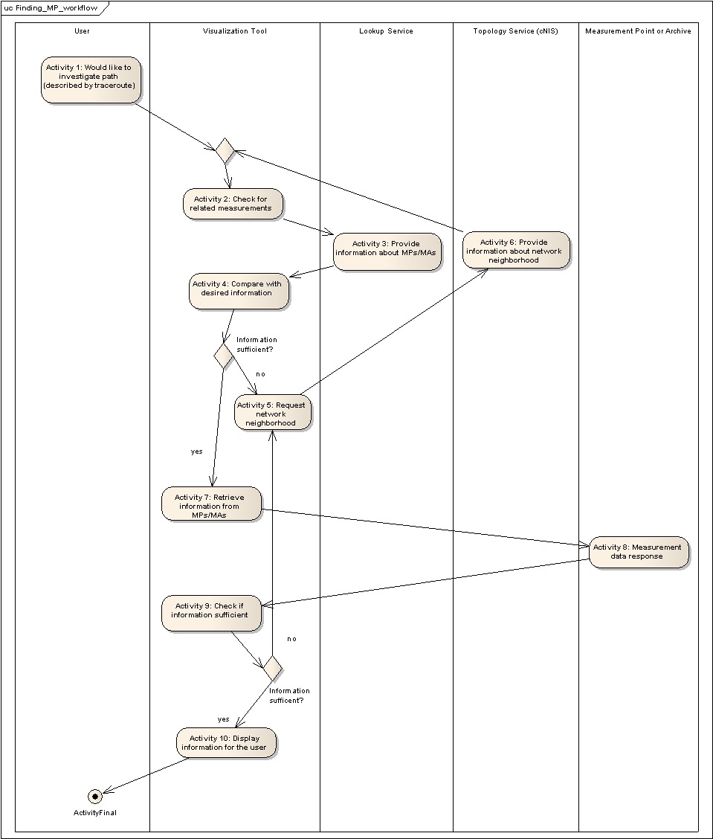

It is an open issue to what extent the decisions in the feedback loops can be made by the visualization tool automatically or whether they should be addressed by asking the user (e.g. “Search network neighborhood?” query to the user). As a starting point this question is posed to the user.
Furthermore, it should be noted that paths can be different in the other direction. This means that the examination as previously described in valid for a one-way path only. This fact is currently ignored.

Information involved
A router has a hostname which can serve as the common identification when measurements should be linked. It furthermore has a set of interfaces which are usually identified by their IP addresses. The HADES boxes (also containing BWCTL MPs) are usually located in a LAN next to the router so that a registration should focus on the router.
The following list indicates which information should be registered at the Lookup Service.
- RRD MA: all IP interface addresses and router hostnames
- SSH/Telnet MP: all the router hostnames (and all their interface IP addresses?)
- BWCTL MP: the router hostname it is connected to (optional in addition the router interface address to which the MP is connected to so we could look at the utilisation for that interface); problem: BWCTL MPs placed in universities. Can the NREN edge router information be used? (WebAdmin should ask to which hostname it is connected, ensure that it is same hostname as RRD MA)
- HADES MA: the router hostnames the HADES probes are connected to (optional in addition the router interface address to which the HADES probe is connected to)
- TC MP: the IP interface address on which the probe is capturing the packet (it might be that the traffic can be mirrored for all the router, however, I am unaware about this)
- Flow RRD MA: IP address of interface where flows are collected
- (Pinger MA: the list of router hostnames the probes are connected to (optional the router interface address to which the pinger probe is connected to)); specialized measurements that can hardly be matched to a traceroute

Interface and business logic in the visualization tool (perfsonarUI)
A new window should be added to perfsonarUI containing the following elements.
- Possibility to provide a path description as a traceroute output. This can be similar to the traceroute input possibility in the interfaces tab (copy&paste or load from a file).
- Below the elements of the path should be shown together with their interconnections (so it is a chain in the beginning). The metrics may be shown related to the interconnections. Furthermore, it should be displayed when there are MPs on elements of the paths. When related MPs which are not directly on the path are considered in further steps, they should be shown apart from the path together with their link to the path so that it can be seen which segments are overlapping.
- A metric selection possibility has to differentiate between the currently known metrics such as utilization, input errors, output drops, delay, jitter, loss, throughput, router information, flows.
- The management of the search should be run by two buttons. One of them is for investigations on the path only, while the second one is for searches in the network neighborhood (the second one can be disabled sometimes), both buttons should change to “stop query” options once pressed)
The business logic should work as follows.
- Utilization, input errors, output drops: The pressing of the path investigation button should trigger queries to MAs which contain information about the interfaces describing the path. The implementation can make use of the LS or may allow the user to select/deselect some MAs manually as currently available in the interfaces tab. The neighborhood investigation makes no sense for these metrics so that this button can be disabled once these metrics have been selected.
- Delay, jitter, loss: The situation is much more complicated when working with the HADES MA(s). The provided interface IP addresses are first send to cNIS (potentially requiring a Lookup of the cNIS services in the beginning) for retrieving the router host names related to the path. The visualization tool uses this information to query the HADES MA (assumption for simplicity that the HADES MA has a well-known location; otherwise, an additional query to the LS would be needed). It sends a list of router host names to the HADES MA and gets pairs of these host names back where measurements are available. E.g. assuming that the path has elements named A to G, there may be measurements between B and E as well as between C and F. However, it needs to be considered that the paths between the retrieved measurements may not be identical with the given path. Therefore, the query contains a time stamp and for the pairs their intermediate path is also returned. The measurement data are then retrieved by another query to the HADES MA and displayed attached to path representations.
For the HADES metrics the neighborhood query to cNIS is reasonable and can be triggered by the second button. It retrieves further routers in the neighborhood of the path which are then used as input for the query to the HADES MA. Again, pairs of measurement locations are returned which are displayed in relation to the path. The query can be repeated to further extend the network neighborhood.
- Throughput: In the European research networks throughput tests are usually only conducted on demand. Therefore, the functionality should not search for available measurements as done for the metrics before, but should point out possibilities for triggering active measurements.
Similar to the HADES MA workflow the visualization tool should translate the IP addresses to router hostnames by querying the cNIS at first. The router hostnames are then used for queries to the Lookup Service to check whether MPs are available at certain locations. If there are too few MPs, the user may decide to consider the network neighborhood so that more MPs can be retrieved.
A difficulty related to the MPs is that it is unknown so far how the potential way of measurements between the MPs would look like. For simplicity it is proposed that the user conducts queries with MPs of interest in the BWCTL MP tab and checks on its own whether the paths are matching.
- Router information: In the context of the Telnet/SSH MP the investigation starts again with a query to cNIS to convert the input IP addresses into router host names. Furthermore, the visualization tool can check with the Lookup Service whether data about the routers can be requested. The idea is that those routers are highlighted on the path, but that the further investigation is then conducted in the Telnet/SSH window (potentially being linked in a sophisticated way where certain parameters such as the MP and the router are already completed).
A neighborhood query (first to the cNIS to determine the neighborhood and then a check with the Lookup Service for routers being accessible) may be conducted.
- Flows: Difficult to determine at the moment what would be required.

Protocol and schema enhancements
Registration with the Lookup Service:
For the registration with the Lookup Service it needs to be differentiated between the different services. The registration related to the RDD MA can be left unchanged as the interfaces being contained in the MA are already part of the registration.
For the HADES MA the idea is to avoid a detailing of the registration at the moment since there is basically one HADES MA currently. Therefore, there is no current need to implement a sophisticated mechanism which one contains the relevant information.
In contrast the BWCTL MP registration needs to be enhanced to contain information about a related router hostname. BWCTL MPs are currently placed in a PoP and are connected via a short LAN connection to a router. The idea is now to ignore this LAN and treat the BWCTL MP like it would reside on the router directly. A modified LS register message may then look as follows.
<nmwg:message type="LSRegisterRequest"
id="msg1"
xmlns:perfsonar="http://ggf.org/ns/nmwg/tools/org/perfsonar/1.0/"
xmlns:nmwg="http://ggf.org/ns/nmwg/base/2.0/"
xmlns:psservice="http://ggf.org/ns/nmwg/tools/org/perfsonar/service/1.0/"
xmlns:nmwgt="http://ggf.org/ns/nmwg/topology/2.0/"
xmlns:netutil="http://ggf.org/ns/nmwg/characteristic/utilization/2.0/">

<nmwg:metadata id="serviceLookupInfo">
<perfsonar:subject id="commonParameters" xmlns:perfsonar="http://ggf.org/ns/nmwg/tools/org/perfsonar/1.0/">
<psservice:service id="serviceParameters" xmlns:psservice="http://ggf.org/ns/nmwg/tools/org/perfsonar/service/1.0/">
<psservice:serviceName>My_BWCTL_MP</psservice:serviceName>
<psservice:accessPoint>http://reed.man.poznan.pl:8080/axis/services/MP</psservice:accessPoint>
<psservice:serviceType>BWCTL MP</psservice:serviceType>
<psservice:serviceDescription>This is my testing BWCTL MP which is near router “router host name”</psservice:serviceDescription>
<psservice:relatedRouter>router host name</psservice:relatedRouter>
</psservice:service>
</perfsonar:subject>
</nmwg:metadata>

</nmwg:message>

For the registration of the Telnet/SSH MP there is a need to provide a list of routers that can be accessed similar to the list of interfaces that are contained in the RRD MA registration.
<nmwg:message type="LSRegisterRequest"
id="msg1"
xmlns:perfsonar="http://ggf.org/ns/nmwg/tools/org/perfsonar/1.0/"
xmlns:nmwg="http://ggf.org/ns/nmwg/base/2.0/"
xmlns:psservice="http://ggf.org/ns/nmwg/tools/org/perfsonar/service/1.0/"
xmlns:nmwgt="http://ggf.org/ns/nmwg/topology/2.0/"
xmlns:netutil="http://ggf.org/ns/nmwg/characteristic/utilization/2.0/">

<nmwg:metadata id="serviceLookupInfo">
<perfsonar:subject id="commonParameters" xmlns:perfsonar="http://ggf.org/ns/nmwg/tools/org/perfsonar/1.0/">
<psservice:service id="serviceParameters" xmlns:psservice="http://ggf.org/ns/nmwg/tools/org/perfsonar/service/1.0/">
<psservice:serviceName>My_test_Telnet/SSH_MP</psservice:serviceName>
<psservice:accessPoint>http://reed.man.poznan.pl:8080/axis/services/MP</psservice:accessPoint>
<psservice:serviceType>Telnet/SSH MP</psservice:serviceType>
<psservice:serviceDescription>This is my testing Telnet/SSH MP</psservice:serviceDescription>
</psservice:service>
</perfsonar:subject>
</nmwg:metadata>

<nmwg:data id="data0" metadataIdRef="serviceLookupInfo">
<nmwg:metadata id="meta1">
<perfsonar:subject id="subj1" xmlns:perfsonar="http://ggf.org/ns/nmwg/tools/org/perfsonar/1.0/">
<nmwgt:router xmlns:nmwgt="http://ggf.org/ns/nmwg/topology/2.0/">
<nmwgt:routerName>chaos169….ugent.be</nmwgt:routerName>
</nmwgt:router>
</perfsonar:subject>
<nmwg:eventType>???</nmwg:eventType>
</nmwg:metadata>
</nmwg:data>

… add more routers which can be queried with this MP …

</nmwg:message>

In addition there is also a need to have a registration of the cNIS to the Lookup Service.

Query to the Lookup Service:
Cannot be completed since information is missing.

“Mapping IP address to router host name”-Query to the cNIS:
This request to cNIS should take an IP address of a router interface and match it to the router host name. This mapping issue cannot be resolved by a simple DNS query since the DNS would reply with a name of the router interface, but this is not representative for the whole router.
<!-- Purpose: -->
<!-- Version: $Id$ -->

<nmwg:message type="SetupDataRequest"
id="datarq1-1"
xmlns:netutil="http://ggf.org/ns/nmwg/characteristic/utilization/2.0/"
xmlns:nmwg="http://ggf.org/ns/nmwg/base/2.0/">

<!-- Optional message level parameters -->
<nmwg:parameters id="msgparam1">

</nmwg:parameters>

<nmwg:metadata id="meta1">
<nmwg:parameters id="param1">
<nmwg:parameter name="if_address">12.35.64.65</nmwg:parameter>
</nmwg:parameters>
</nmwg:metadata>

<nmwg:metadata id="meta2">
<nmwg:parameters id="param1">
<nmwg:parameter name="if_address">45.34.67.89</nmwg:parameter>
</nmwg:parameters>
</nmwg:metadata>

<!-- This is the specific data we wish to see -->
<nmwg:data id="data1" metadataIdRef="meta1" />
<nmwg:data id="data2" metadataIdRef="meta2" />

</nmwg:message>

The reply should then look as follows.
<!-- Purpose: -->
<!-- Version: $Id$ -->

<nmwg:message type="SetupDataResponse"
id="datarq1-2"
messageIdRef="datarq1-1"
xmlns:nmwg="http://ggf.org/ns/nmwg/base/2.0/">

<!-- Optional message level parameters -->
<nmwg:parameters id="msgparam1">

</nmwg:parameters>

<nmwg:metadata id="meta1">
<nmwg:parameters id="param1">
<nmwg:parameter name="if_address">12.35.64.65</nmwg:parameter>
</nmwg:parameters>
</nmwg:metadata>

<nmwg:metadata id="meta2">
<nmwg:parameters id="param1">
<nmwg:parameter name="if_address">45.34.67.89</nmwg:parameter>
</nmwg:parameters>
</nmwg:metadata>

<nmwg:data id="data1" metadataIdRef="meta1">
<nmwg:datum value="pot1.x-win.dfn.de"/>
</nmwg:data>

<nmwg:data id="data2" metadataIdRef="meta2">
<nmwg:datum value="han1.x-win.dfn.de" />
</nmwg:data>

</nmwg:message>

“Neighborhood”-Query to the cNIS:
The idea of the neighborhood query to cNIS is to get adjacent routers with respect to a given input router. This means that in the request a router host name is provided.
<!-- Purpose: -->
<!-- Version: $Id$ -->

<nmwg:message type="SetupDataRequest"
id="datarq1-1"
xmlns:netutil="http://ggf.org/ns/nmwg/characteristic/utilization/2.0/"
xmlns:nmwg="http://ggf.org/ns/nmwg/base/2.0/">

<!-- Optional message level parameters -->
<nmwg:parameters id="msgparam1">

</nmwg:parameters>

<nmwg:metadata id="meta1">
<nmwg:parameters id="param1">
<nmwg:parameter name="router_host_name">han1.x-win.dfn.de</nmwg:parameter>
</nmwg:parameters>
</nmwg:metadata>

<!-- This is the data about the neighborhood we wish to see -->
<nmwg:data id="data1" metadataIdRef="meta1" />

</nmwg:message>

The reponse should then look like the following.
<!-- Purpose: -->
<!-- Version: $Id$ -->

<nmwg:message type="SetupDataResponse"
id="datarq1-2"
messageIdRef="datarq1-1"
xmlns:nmwg="http://ggf.org/ns/nmwg/base/2.0/">

<!-- Optional message level parameters -->
<nmwg:parameters id="msgparam1">

</nmwg:parameters>

<nmwg:metadata id="meta1">
<nmwg:parameters id="param1">
<nmwg:parameter name="router_host_name">han1.x-win.dfn.de</nmwg:parameter>
</nmwg:parameters>
</nmwg:metadata>

<nmwg:data id="data1" metadataIdRef="meta1">
<nmwg:datum value="pot1.x-win.dfn.de"/>
<nmwg:datum value="fra1.x-win.dfn.de"/>
<nmwg:datum value="ber1.x-win.dfn.de"/>
</nmwg:data>

</nmwg:message>

Query to HADES MA for measurements between pairs:
The query to the HADES MA should contain a list of router host names. The HADES MA should check whether measurements are being conducted between the routers and reply with a list of pairs including the current path between the pairs.
<!-- Purpose: -->
<!-- Version: $Id$ -->

<nmwg:message type="SetupDataRequest"
id="datarq1-1"
xmlns:netutil="http://ggf.org/ns/nmwg/characteristic/utilization/2.0/"
xmlns:nmwg="http://ggf.org/ns/nmwg/base/2.0/">

<!-- Optional message level parameters -->
<nmwg:parameters id="msgparam1">

</nmwg:parameters>

<nmwg:metadata id="meta1">
<nmwg:parameters id="param1">
<nmwg:parameter name="router_host_name">han1.x-win.dfn.de</nmwg:parameter>
<nmwg:parameter name="router_host_name">pot1.x-win.dfn.de</nmwg:parameter>
<nmwg:parameter name="router_host_name">ber1.x-win.dfn.de</nmwg:parameter>
</nmwg:parameters>
</nmwg:metadata>

<!-- This is the data about the neighborhood we wish to see -->
<nmwg:data id="data1" metadataIdRef="meta1" />

</nmwg:message>

The response may then look like as follows (the key can be provided as a means to more easily get the measurement values in the next step).
<!-- Purpose: -->
<!-- Version: $Id$ -->

<nmwg:message type="SetupDataResponse"
id="datarq1-2"
messageIdRef="datarq1-1"
xmlns:nmwg="http://ggf.org/ns/nmwg/base/2.0/">

<!-- Optional message level parameters -->
<nmwg:parameters id="msgparam1">

</nmwg:parameters>

<nmwg:metadata id="meta1">
<nmwg:parameters id="param1">
<nmwg:parameter name="router_host_name">han1.x-win.dfn.de</nmwg:parameter>
<nmwg:parameter name="router_host_name">pot1.x-win.dfn.de</nmwg:parameter>
<nmwg:parameter name="router_host_name">ber1.x-win.dfn.de</nmwg:parameter>
</nmwg:parameters>
</nmwg:metadata>

<nmwg:data id="data1" metadataIdRef="meta1">
<nmwg:datum value="han1.x-win.dfn.de pot1.x-win.dfn.de" path="han1.x-win.dfn.de mad1.x-win.dfn.de pot1.x-win.dfn.de" key=… />
<nmwg:datum value="pot1.x-win.dfn.de ber1.x-win.dfn.de" path="pot1.x-win.dfn.de zib1.x-win.dfn.de ber1.x-win.dfn.de" key=… />
</nmwg:data>

</nmwg:message>

Implementation proposal
The workflow proposal has shown that extensions are needed on different parts of perfSONAR.
- perfSONAR schemas: Needs to be extended for the new queries (see above)
- Topology Service/cNIS: Has to be able to provide a network neighborhood for a router hostname and resolve IP interface addresses to router host names
- Visualization tool (perfsonarUI): has to contain a business logic for the workflow and also a GUI extension to communicate with the user accordingly (traceroute reception, display of related paths, etc); proposal see above
- Lookup Service: has to be enhanced to store information related to the identified needs (match IP address to locations of MAs and MPs, interface address summary algorithm from Internet2); hostname field should become mandatory on registration (easier to match if a router/router interface has multiple IP addresses)
- HADES MA: has to provide information about the paths for measurements on demand, for LS registration is has to provide the names of routers where the HADES boxes are in the LAN
- Telnet/SSH MP: has to register names of all hosts that it can potentially query to the LS
- RRD MA: has to provide a summary of interfaces it has information about to the LS(should be something like a list of IP address spaces), a later check directly with the MA will then show whether there is really information available;
- Flow MA/MPs, Pinger MA: ?

Action points:
- Nicolas, all: check document and timeline
- Nina: check business logic description, start implementing for RRD MA (possible without dependencies, even though not optimal)
- Martin: check proposed schemas
- DFN Erlangen, Stijn, cNIS Team: implement interactions once agreed

