Andreas Hanemann, hanemann@dfn.de; April 2, 2008
Design of Transformation Service

Background
A Transformation Service (TrS) has been planned as part of the perfSONAR service set for several years to transform data from MAs (Measurement Archives) or MPs (Measurement Points). The kinds of transformations that are considered are related to the data (the values) or to the monitoring intervals. Furthermore, correlation of data could be possible.
More general, it is to be considered where transformations can potentially be performed and therefore what is reasonable to locate in a specialized TrS. Locations for transformation are the following.
- On the archive itself
  - The transformation is done with scripts on the DB itself, i.e. transformed data are stored back in the archive (with the option to either replace the original data or create new data).
  - Pros: Full control over the data from the perspective of the domain
  - Cons: The transformation is performed in a local manner that cannot be shared among perfSONAR partners. Data is lost if it is aggregated (and not replicated).
- By the Measurement Archive web-service
  - The Measurement Archive checks the request and performs the appropriate transformation if it does not have the data in the appropriated format (or call an internal scripts). It then replies to the request.
  - Pros: Transformation can be shared if it is a general MA functionality. No raw data is lost or needs to be replicated.
  - Cons: Change of the MA concept of being just a data archive, no business functionality has been foreseen yet. On the fly conversion is more time consuming then data access.
- By a transformation web-service
  - The data is pulled by the transformation service and transformed or pushed to it and it performs the transformation.
  - Pros: Transformation methods can be easily shared. No raw data is manipulated. The service can be developed independently from the MA.
  - Cons: Additional protocol overhead can lead to slow data provisioning. May be more difficult to enforce data access policies.
  - Cons: Certain transformations can be efficiently done directly in e.g. relational DB, this will be impossible if the TrS will need to pull the data and process it in memory
- On the visualization tool
  - The data is received by the visualization and the visualization tool transforms the data on the fly.
  - Pros: No change in the access to MA. No protocol overhead.
  - Cons: Visualization tools may implement similar functionalities several times. Many raw data may be transferred to the tool which can be a performance bottleneck. Data protection cannot be realized.

Risks:
- Transformation function requires too much time to be usable by a user (less than a minute)
- Transformation function combined with web-services requires too much time (less than a minute)
- LS registration, authentication: how will they work?
- Schema extensions? Does it require modification on the web-service front?

Use Case Collection
UC1: The starting point for the implementation was DFN’s requirement to provide data in categories (i.e. DFN does not want to provide exact values for the utilization data, but only wants to report whether the utilization is within a certain interval like 15-30%). A flexible TrS should be implemented as intermediary between the MA and the outside world. The MA is going to store the exact values.
UC2: Another transformation that is of concrete interest is the match of time resolutions. An RRD MA stores the past values with resolutions as predefined in its RRD configuration (e.g. 2 minute intervals for data from the previous months and 30 minute intervals for data from the last year). Visualization tools such as perfsonarUI and CNM have their own time intervals (like 5 minute intervals). A transformation service could provide a standard means for converting the data into the desired resolution.
UC3: When the HADES MA is queried, it provides a large amount of data. The visualization tool developer has mentioned that the data set is too large to handle and aggregation is required. The transformation service would then be queried on behalf of the HADES MA and provides aggregated data to the visualization corresponding to either a pre-defined aggregation type or to an aggregation type specified in the request.
The use case is currently not considered further since the HADES MA is going to contain aggregated data on its own (precomputed to allow for quick responses). The TrS does not seem to be a good place for aggregation of data if the amount of data is the problem since this would require that all data would have to be transferred between the MA and the TrS. The TrS can be interesting if certain kinds of aggregation can be used for different kinds of services.
UC4: aggregation or concatenation in space: concatenate measurement in space to get a single value over multiple topological elements. There is currently no concrete request for this kind of transformation so that it is not going to be implemented in the beginning. An example would an aggregation along a traceroute (e.g. if the minimum bandwidth available for all path segments should be determined). However, the example can also be realized in the visualization tools.
UC5: the transformation service is being regularly pushed data from MAs or MPs and run some check on the data against some thresholds and against indicators representing past information. When the data is going over the threshold, an alarm is being sent (email or SNMP trap) to a list of recipients. This functionality has to be part of a larger alarming concept.
The alarming is currently discussed in the context of HADES data only so that an alarm system for this could be sufficient. The PERT mentioned that they would like to have baselines of usual values (for delays, etc) and would like to be informed about deviations of the baselines.
UC6: an MP or an MA pushes regularly some data to the transformation service to perform some transformation and request to send the data to one or more destination web-services.
A use-case implemented at Internet2 is related to UC5/UC6 where their circuit-status service (being a transformation service) polls other services about the information that it can register to the LS.

Interaction Sequence

The interaction sequence (as proposed by Roman) is depicted in the following figure. It has the advantage that it allows more easily for the combination of Transformation Services and Measurement Archives than in the previous proposal (see appendix). In addition, it keeps the complexity away from the client which does not become aware that there is a TrS involved.
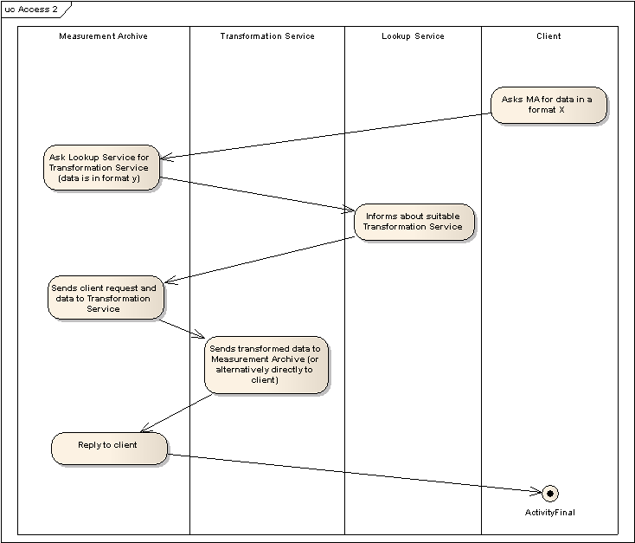
The details are as follows. A client asks for MA data in a certain format x (may be necessary to extend perfSONAR protocol to express this?). The MA notices that it does have the data only in another format y. It therefore asks the Lookup Service whether there is a TrS which can convert data from format y to format x. The reply is reported back to the MA. If there is no service available the request cannot be fulfilled (maybe need to define appropriate error message like “transformation not possible”) which is reported to the client. Otherwise, the data is sent to the TrS for transformation. It can then be reported either directly to the client or be reported back to the MA which then forwards the data to the client. The latter possibility is more compliant to a request/response schema, but may be a performance bottleneck.
Further options can be that a client specifies the TrS that should be used (e.g. for performance reasons a local TrS may be asked for) or that an MA fetch address is specified. The latter is relevant if a transformation takes very long so that the client does not want to wait for it (e.g. an aggregation of a large amount of data). The fetch address will later enable to client to fetch the transformed data from the MA.
The interactions may also be client-driven. A client may request the data from the MA at first and forward them on its own to a TrS.
As a prerequisite for the interactions TrSs and MAs register with the Lookup Service (can be done independently with this model). The flexible combination of services requires that there is a common description format for specifying the capabilities of a TrS (e.g. service can transform MA time intervals, etc).
The interaction sequence does not include authentication which is however a prerequisite especially for using the DFN MA. An extended interaction sequence including AA is therefore given in the following figure. It assumes that trustful relationships between MA, TrS and LS have been established previously.
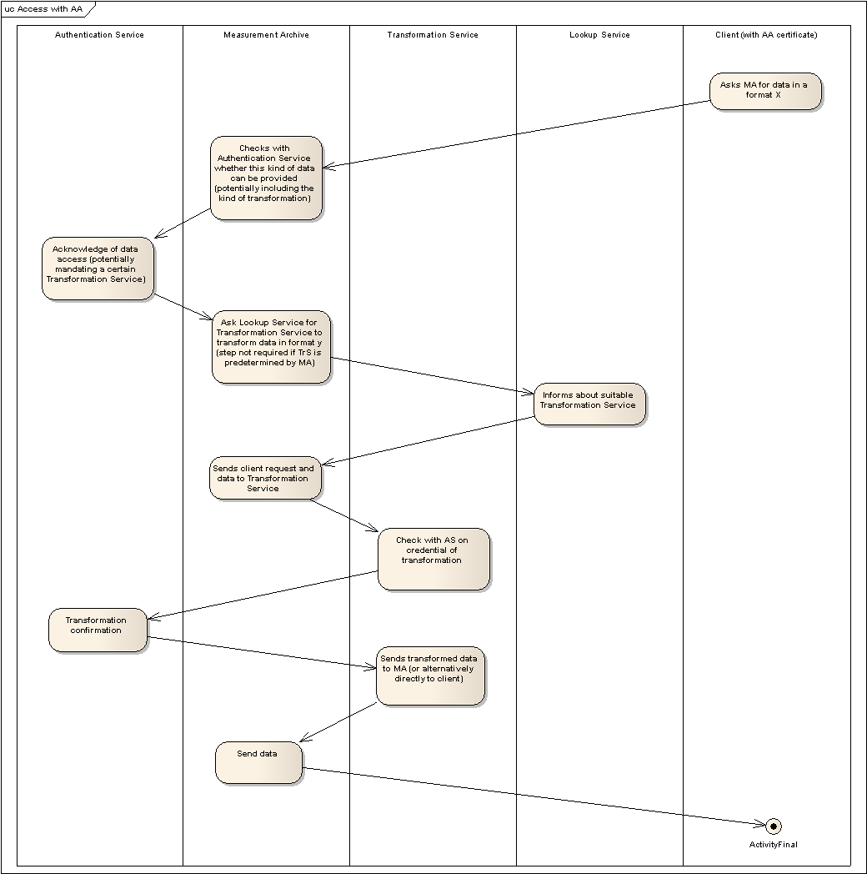
The request from the Measurement Archive to the Authentication Service has to contain information about both the Measurement Archive and the client. A new AA profile for this, maybe called “service on behalf of a client”, may be required.

Implementation
The implementation of the TrS could be done in a modular way so that a chaining of different transformations may be possible (for instance, if DFN MA data should be transformed further for the time resolution or for other kinds of transformation).

Next steps
- Discuss on ML - done
- Check concept, maybe extend it to further transformations (identify what transformation we want to go for, identify risks) – partially done
- Discuss the concept in conf call and in Zagreb
- Enhance schemas for the purpose (additional description field, intermediate address)
- Implementation (David and Patricia), reuse of interface code from MA
- Testing at DFN (MA and TrS setup at DFN-NOC)

Appendix: Original interaction sequence proposal from Andreas (replaced by Roman’s proposal)

The idea for the use of the TrS is the following. The service registers itself with the Lookup Service instead of the MA (see Figure below). Its outside interface is the same as the one of the MA so that it is transparent to users whether there is a direct answer from an MA or from the TrS. The MA may register with the Lookup Service if it should also be directly accessible (this would not be the case for the DFN MA). It needs to be discussed how the description of a TrS may look like in the LS. In the simplest case it may just look like the one of an MA so that a user does not know that there is an MA involved. The connection between TrS and MA may be hardcoded (would be sufficient for DFN use case, UC1; also for UC3). For other situations where a TrS may be applied dynamically for several MAs (UC2, UC4) it could also be variable.
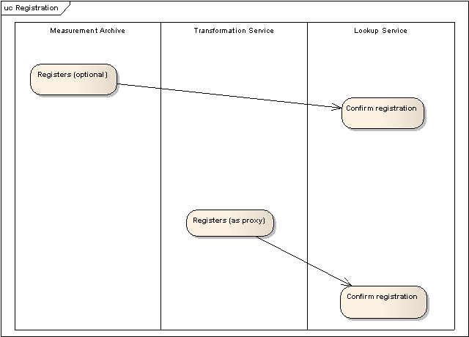
Upon reception of a client request the TrS forwards it to the MA just changing the receiver and sender address, but the query is basically unchanged. The MA answers the query to the TrS. The TrS does the transformation internally and replies to the client (see Figure 2).
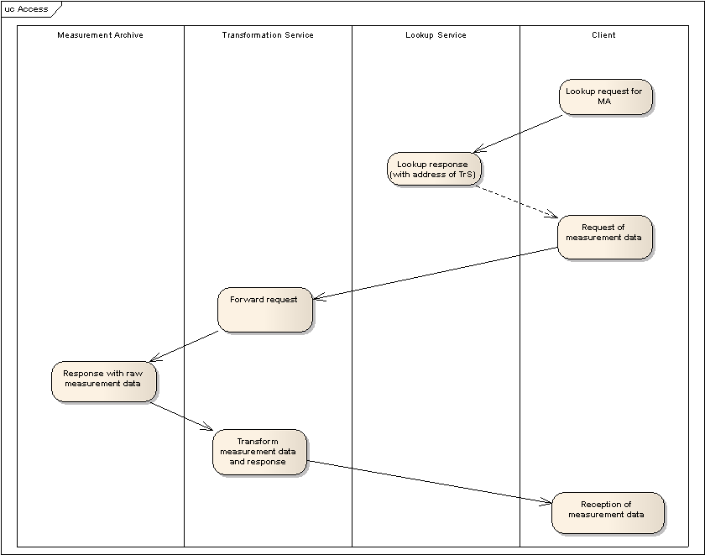
The perfSONAR protocol needs to be enhanced with an additional field that explains the transformation. The idea is to leave the metric field itself unchanged, but to explain in an additional field what has been done. For example, a utilization of 17% is within the interval of 15-30%. The interval would be represented by its intermediate value (22.5%) which would be returned by the TrS. A further metadata field would contain a verbal description (e.g. “The utilization for the DFN MA is reported in three intervals: 0 to 15%, 15 to 30% and 30 to 100%, represented by its average value”). The description can be displayed as further information when a user accesses the data in a visualization tool.
The MA needs to be protected so that it can only be accessed by the TrS or internally.
For UC5 and UC6 another interaction would be needed for the push model.

