Andreas Hanemann, hanemann@dfn.de; March 5, 2008
Design of Transformation Service

Background
A Transformation Service (TrS) has been planned as part of the perfSONAR service set for several years to transform data from MAs (Measurement Archives) or MPs (Measurement Points). The kinds of transformation that are considered are related to the data (the values) or to the monitoring intervals. Furthermore, correlation of data could be possible.
More general, it is to be considered where transformations can potentially performed and therefore what is reasonable to locate in a specialized TrS. Locations for transformation are the following.
- on the archive itself
  - The transformation is done with scripts on the DB itself.
  - Pros: Full control over the data from the perspective of the domain
  - Cons: Data may be lost if it is aggregated. Otherwise, it may need to be replicated. The transformation is performed in a local manner that cannot be shared among perfSONAR partners.
- By the Measurement Archive web-service
  - The measurement Archive checks the request and performs the appropriate transformation if it doesn’t have the data in the appropriated format (or call an internal scripts). Then reply to the request.
  - Pros: Transformation can be shared if it is a general MA functionality. No raw data is lost or needs to be replicated.
  - Cons: Change of the MA concept of being just a data archive, no business functionality has been foreseen yet. On the fly conversion is more time consuming then data access.
- By a transformation web-service
  - The data is pulled by the transformation service and transformed or pushed to it and it performs the transformation.
  - Pros: Transformation methods can be easily shared. No raw data is manipulated. The service can be developed independently from the MA.
  - Cons: Additional protocol overhead can lead to slow data provisioning. May be more difficult to enforce data access policies.
  - Cons: Certain transformations can be efficiently done directly in e.g. relational DB, this will be impossible if the Tr service will need to pull the data and process it in memory
- On the visualization
  - The data is received by the visualization and the visualization transforms the data on the fly.
  - Pros: No change in the access to MA. No protocol overhead.
  - Cons: Visualization tools may implement similar functionalities several times. Many raw data may be transferred to the tool which can be a performance bottleneck. Data protection cannot be realized.

Risks:
- Transformation function requires too much time to be usable by a user (less than a minute)
- Transformation function combined with web-services requires too much time (less than a minute)
- LS registration, authentication: how will they work?
- Schema extensions? Does it requires modification on the web-service front.

Use Case Collection
UC1: The starting point for the implementation is DFN’s requirement to provide data in categories (i.e. DFN does not want to provide exact values for the utilization data, but only wants to report whether the utilization is within a certain interval like 15-30%). A flexible TrS should be implemented as intermediary between the MA and the outside world. The MA is going to store the exact values.
UC2: Another transformation that is of concrete interest is the match of time resolutions. An RRD MA stores the past values with resolutions as predefined in its RRD configuration (e.g. 2 minute intervals for data from the previous months and 30 minute intervals for data from the last year). Visualization tools such as perfsonarUI and CNM have their own time intervals (like 5 minute intervals). A transformation service could provide a standard means for converting the data into the desired resolution.
UC3: When the Hades MA is queried, it provides a large amount of data. The visualization tool developer has mentioned that the data set is too large to handle and aggregation is required. The transformation service would then be queried on behalf of the Hades MA and provides aggregated data to the visualization corresponding to either a pre-defined aggregation type or to an aggregation type specified in the request. NJ and Win Labor to refine.
UC4: (possible use case, to be confirmed by visualization tool developers) aggregation or concatenation in space: concatenate measurement in space to get a single value over multiple topological elements.
UC5: the transformation service is being regularly pushed data from MAs or MPs and run some check on the data against some thresholds and against indicators representing past information. When the data is going over the threshold, an alarm is being sent (email or SNMP trap) to a list of recipient. This functionality has to be part of a larger alarming concept.
UC6: an MP or an MA pushes regularly some data to the transformation service to perform some transformation and request to send the data to one or more destination web-services.

Interaction Sequence
The idea for the use of the TrS is the following. The service registers itself with the Lookup Service instead of the MA (see Figure 1). Its outside interface is the same as the one of the MA so that it is transparent to users whether there is a direct answer from an MA or from the TrS. The MA may register with the Lookup Service if it should also be directly accessible (this would not be the case for the DFN MA). It needs to be discussed how the description of a TrS may look like in the LS. In the simplest case it may just look like the one of an MA so that a user does not know that there is an MA involved. The connection between TrS and MA may be hardcoded (would be sufficient for DFN use case, UC1; also for UC3). For other situations where a TrS may be applied dynamically for several MAs (UC2, UC4) it could also be variable.
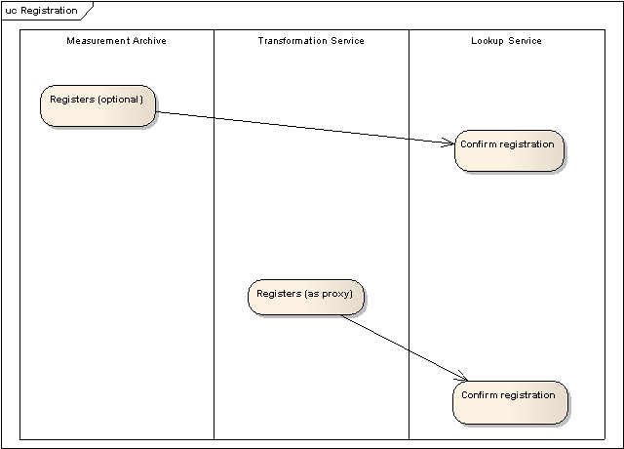
Upon reception of a client request the TrS forwards it to the MA just changing the receiver and sender address, but the query is basically unchanged. The MA answers the query to the TrS. The TrS does the transformation internally and replies to the client (see Figure 2).
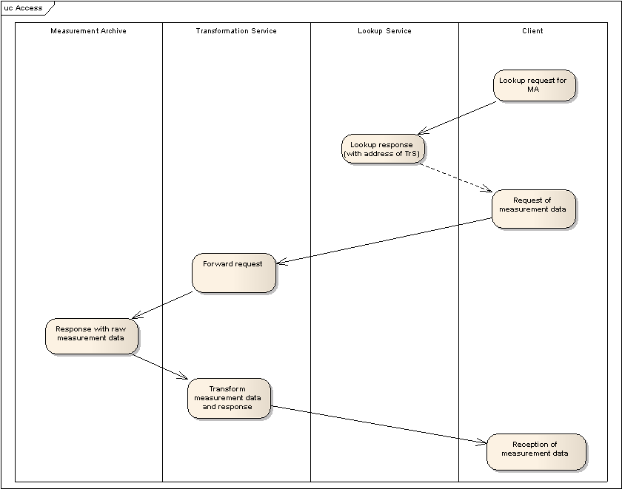
The perfSONAR protocol needs to be enhanced with an additional field that explains the transformation. The idea is to leave the metric field itself unchanged, but to explain in an additional field what has been done. For example, a utilization of 17% is within the interval of 15-30%. The interval would be represented by its intermediate value (22.5%) which would be returned by the TrS. A further metadata field would contain a verbal description (e.g. “The utilization for the DFN MA is reported in three intervals: 0 to 15%, 15 to 30% and 30 to 100%, represented by its average value”). The description can be displayed as further information when a user accesses the data in a visualization tool.
The MA needs to be protected so that it can only be accessed by the TrS or internally.
For UC5 and UC6 another interaction would be needed for the push model.

Implementation
The implementation of the TrS could be done in a modular way so that a chaining of different transformations may be possible (for instance, if DFN MA data should be transformed further for the time resolution or for other kinds of transformation).

Next steps
- Check concept, maybe extend it to further transformations (identify what transformation we want to go for, identify risks)
- Discuss the concept on the ML
- Enhance schemas for the purpose (additional description field, intermediate address)
- Implementation (David and Patricia), reuse of interface code from MA
- Testing at DFN (MA and TrS setup at DFN-NOC)

