PerfSONAR Schema Specification Document Overview – draft

Overview 1
Next steps 2
Base Schema 2
Extension 3
Protocol 5
Implementation documentation 5
Rationale 6
Resources 6

Overview
The goal of this document is to provide a “framework” of documents (specifications, documentation) for perfSONAR and to identify the information required so that we can have a stable documentation/specification documentation structure.

The document aims at identifying
- the different technical documents (specifications) that the developers needs to have to implement inter-actions between the services.
- the documentation that are provided for each service (e.g. for the GUI developers to inter-act with a particular implementation of a message or protocol).
- the process involved (e.g. to extend a schema, etc)

For each type of documents, a high level description of the document content or the multiple document that need to be produced is provided.

The figure below represents the different documents identified and some of their relations.
- perfSONAR base: the commonalities for all the message exchanged are described with two documents, the RNC for the syntax and a semantic document. (specification)
- The perfSONAR extensions that are specific for a some type of information exchanges. The extensions are extension of the perfSONAR base. The semantic specification describes the relationships/combination between the blocks (data - metadata) described with the syntax (RNC) (specification)
- The protocol defines order of messages exchanged between services/clients to perform specific actions. For each of the messages exchanged, it points towards a section of a extension semantic document. (specification)
- The Implementation documents describes what parts of the specifications have been implemented for a given instance of a service.

The specifications are used by the web-services developers to implement their services or to add new functionality that are consistent across the board. They are also used by the GUI developers to understand what message should be sent, what format and in which order.

The Implementation documents are used by the functional test team to build test scripts to test the web-services and by the functional testers to build the proper functional test scripts. (what is allowed, what is not allowed, what is wrong, what is right)

Below in black, you can find represented the specification. In grey, the processes and the implementation documents.

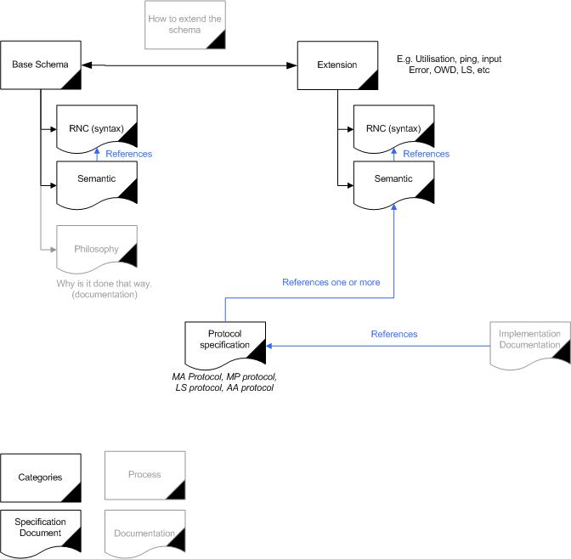

Relation ship between the perfSONAR schema documents

Questions:
- Are we missing some document types?
- Is the utilisation made by the developer of the document correct>
Loukik/Michalis to be more specific about the meaning of “what is allowed, what is not allowed, what is wrong, what is right)“

Next steps
- JRA1 to review the draft, identifying missing documents and enhancing the documents description. (before end of December)
- NS to identify with JB where the profiles document fits
- NS to identify with LH where the current release document fits (and what part can be re-used)
- MS, VV, LB, RL to identify what documents are already existing and which part can be re-used. (before end of December ?)
- Identify the series of actions to be followed to have the documents (for release 4.0 or end of 2008).
- Prioritise what document need to be worked on first (?)

Base Schema

The Base schema corresponds to a framework providing a structure for specific schema instantiation (the extensions for different characteristics). It contains the commonalities amongst all entire schema. Those common parts are used by the extension which reference back to the base schema for more detail.

Documents
- The base schema syntax (RNC) [specification]
  - Must describe the base syntax allowed for the common functionalities.
  - See Base Common Functionality for the list of functionalities that are common and need to be described in that document.
    - LS registration
    - Handling of EchoRequestPing
    - Authentication
    - Using defined result codes
    - and maybe more, to be discussed
<base RNC list covering those functionalites>
  - User: the web-services developers, the people who want to extend the schema
  - Priority: tbd
  - The base schema semantics [specification]
  - Must specify the relationships/combination between the blocks (data metadata) described with the syntax (RNC) (e.g. you need at least one metadata, etc)
  - Must specify the meaning, the values, the value ranges and unit of elements/parameters, in other word, everything that makes a certain element valid.
  - User: the web-services developers, the people who want to extend the schema
  - Priority: tbd
- Schema philosophy [documentation]
  - This document describes why the schema is as it is, what are the building blocs (data and metadata and how they relate to each other) and what is the relationship/difference between the NM-WG and the perfSONAR schema.
  - User: the web-services developers, the people who want to extend the schema
  - Priority: tbd
- How to read the RNC? [pointer to existing documentation]
- How to read this series of specifications [documentation]

Question:
- What is covered in the base?
- Do we include in the base schema everything that are common (e.g. the error messages).
- How do we represent the message semantics / what document template to use?
- Question: do we need to have a separated document for the schema philosophy or is it part of the base schema semantics?
- What are the priorities/importance for having those document available. When will they be used (a common development will take the priority over something that is not planned to be used) ? (we possibly need to break down this question per functionality)

Base schema to be considered (to be verified)
- nmbase.rnc
- nmtime.rnc
- nmtopo.rnc
- result.rnc
- filter.rnc (not sure)

Extension
The extensions are the schema parts that are specific for a given usage (LS, utilisation, AA, etc). They are based on the base schema (References it) and contains the specifics.

Documents
- The extension syntax (RNC) [specification]
  - Must describe the base syntax allowed for the specific functionalities.
  - User: the web-services developers, the people who want to extend the schema
  - Priority: tbd
- The extension semantics [specification]
  - Must specify the relationships/combination between the blocks (data metadata) described with the syntax (RNC) (e.g. you need at least one metadata, etc). This will ensure compliance to the NM-WG.
  - Must specify the meaning, the values, the value ranges and unit of elements/parameters (?).
  - It consist of sections, each sections describes a message (e.g. the registration of a service to the LS, the metadata key request, the metadata key response, etc). Each section must point to the specific syntax that must be used.
  - User: the web-services developers, the people who want to extend the schema
  - Priority: tbd
- How to extend a schema [Document]
  - Document describing how a developer can create a schema extension or modify a extension. The document should explain where to start from, how the modification can be done and how the resulting schema can be validated (for consistency with other schema and to be NM-WG compatible) and under which condition it needs to be validated.
  - Two flavour might exist
    - Extension extension
    - Base extension
  - User: the web-services developers, the people who want to extend the schema
    - Priority: tbd
- Extension [process]
  - This process describe what are the steps needed to extend the schema. It is based on the “how to extend a schema” document.
  - User: the web-services developers, the people who want to extend the schema
  - Priority: tbd

Questions:
- What other naming for “extension extension”?
- What priorities are there
- What rnc are included
- Is there a difference between extending an extension and extending the base schema?

Extension to be considered (to be verified)
- FlowsaMA.rnc (?)
- PassiveAnomal.rnc (?)
- PassiveBand.rnc (?)
- PassiveLoss.rnc (?)
- PassiveTracefile.rnc
- abw.rnc
- bwctl.rnc
- errors.rnc
- event.rnc (?)
- iperf.rnc (?)
- netflow.rnc (?)
- ping.rnc (?)
- pinger.rnc (?)
- service.rnc (?)
- snmp.rnc (?)
- sonar.rnc (?)
- topo/ (?)
- traceroute.rnc
- utilization.rnc

Protocol
The protocol defines order of messages exchanged between services/clients to perform specific actions. For each of the messages exchanged, it points towards a section of a extension semantic document.

This allows the developers to identify the suite of messages to be exchanged with different services, the information that need to be in the messages (semantics) and what the message should look like (the syntax).

The protocol document (referencing the semantics and syntax documents) are used by the developers who wants to make their web-service or GUI with compliant to perfSONAR.
In their Implementation Documentation, those same developers will mention what part of the protocol they have implemented and what choices they have made.

Documents
- There might be a place for a common protocol document. Although at this stage, no requirement for such document has been identified as we haven’t produced any protocol. It is thus not straightforward to know if there are commonalities between them.
- Protocol specification [specification]
  - The protocol document must specify the order of messages exchanged between services/clients to perform specific actions. For each of the messages exchanged, it must points towards a section of a extension semantic document.
  - Each protocol document must describes the different inter-actions with one particular type of services
    - Inter-action with an MA
    - Inter-action with an MP
    - Inter-action with the LS
    - Inter-actions with the AA
    - Inter-actions with a Topology Service
    - Inter-actions with a Resource Protector
    - Inter-actions with a Transformation Service
  - (e.g. LS registration: (1) send registration to the LS, (2) LS send back confirmation it got the registration)
  - User: the web-services developers, the people who want to extend the schema
  - Priority: tbd

Question:
- What format/template to use for the protocol document? (Jason is working on it)
- What priority?
- Check the list of protocol documents, are there some overlap.
- This might lead to having a single document for MA and MP if we find out that they are the same.

Implementation documentation

Describes what parts of the specifications have been implemented for a given instance of a service.

Please note that this part is currently under-specified. Please comment on it.

Documents
- Implementation Documentation
  - Must points towards the specifications (protocol an semantics?) implemented, mentioning what part hasn’t been implemented (the reasons and what error message is received in that case)
  - how you can use the functionalities
  - list the features added over the specifications
  - User: the web-services testers (they need to know what they will be testing without having to browse through multiple documents), the GUI developers (they need to know exactly how to inter-act with a service and how, the developer of a service that needs to inter-act with that particular web-service.
  - Priority: tbd

Questions:
- What should be contained in this/those documents? What is the difference with the current ones?
- The GUI and web-service developer will they use only the Implementation documentation (That is specific to a web-service) or will they look on the protocol document specification to have a more general case? What will they use?
- What should contain the implementation documentation? What document are needed?

The document should be extended with the user documentation documents (for completeness).

Rationale

The development work would be fastened with better specification of the interfaces as
- it will reduced the different interpretation that are of the schema
- it will reduce the release time as it is usually during functional test that it is discovered that there are multiple interpretation
- it will reduce the implementation time as the same messages are being implemented in multiple services and clients (less subject to interpretation)
- it will allow to have more easily on board new developers
- it will allow external developers to extend the schema and develop based on NM-WG more easily

Base Common Functionality
- LS registration
- Handling of EchoRequestPing
- Authentication
- Using defined result codes
- and maybe more, to be discussed

Resources

- RNC
  - http://anonsvn.internet2.edu/svn/nmwg/trunk/nmwg/schema/rnc/
  - http://anonsvn.internet2.edu/svn/nmwg/trunk/nmwg/schema/
- How to create schema extension
  - http://anonsvn.internet2.edu/svn/nmwg/trunk/nmwg/schema/README.txt
- Schema introduction (Jeff)
  - http://wiki.perfsonar.net/jra1-wiki/index.php/Generalities
  - Question: where does it fit?
- Relax NG tutorial
  - http://relaxng.org/compact-tutorial-20030326.html
- Wiki pointer to the schema
  - http://wiki.perfsonar.net/jra1-wiki/index.php/PerfSONAR_Developers_information#NMWG_Schema
- Schema evolution
  - http://damsl.cis.udel.edu/NMWG/
- Developer Guide
  - http://damsl.cis.udel.edu/NMWG/devguide.pdf
  - Question: where does it fit?
- Examples
  - http://nmwg.internet2.edu/example-queries.html
- OGF NM-WG page
  - http://nmwg.internet2.edu/
  - http://nmwg.internet2.edu/products.html
- Papers on schema
  - http://www.cis.udel.edu/~swany/papers/ZurawskiSwanyGunter-TridentCom.pdf
  - Where do they fit, what do they cover?
- Release documentation
  - http://anonsvn.internet2.edu/svn/perfsonar/trunk/perfsonar-doc/release-management/templates/
  - Where do they fit in? Are they specification (syntax/semantics/protocol) or part of it? Are they product documentation of a service implementation (or part of it)?

