Multi-Domain Monitoring Service for LHCOPN
Service Specification
Version 4

Document History
Product/Version Number: | Multi-Domain Monitoring Service for LHCOPN 4
Date of Release: | 30/07/26
Contract Number: | 511082
Instrument type: | Integrated Infrastructure Initiative (I3)
Activity: | SA3
Work Item: | WI-15
Dissemination Level | RE (Restricted)
Lead Partner
Document Code | <MDM-07-05v4>
Authors: | Loukik Kudarimoti

Table of Contents
1 Executive Summary 3
2 LHCOPN Monitoring Requirements 4
3 Managed Service specification 6
3.1 Service Definition 6
3.2 Appliance specification 7
3.2.1 Hardware 7
3.2.2 Operating System 8
3.2.3 Software suite 8
3.3 Deployment Location 9
3.4 Site Requirements 11
3.5 Installation and Maintenance 14
3.5.1 Hardware Installation and maintenance 14
3.5.2 Operating System Maintenance 14
3.5.3 Software configuration 15
3.5.4 Software Maintenance 15
3.6 Security 15
3.6.1 Measurement Capabilities and Measured Data 15
3.6.2 Appliances 16
3.6.3 Network 16
4 Support 17
5 Extending the MDM Service 17
5.1 Measurement footprint 17
5.2 Additional Network Metrics and Software 17
6 Conclusions 18
7 References 18
Appendix A Hardware Specification 20
A.1 Hardware configuration 20
A.1.1 Server 1 (Green box) 20
A.1.2 Server 2 (Blue box) 21
A.1.3 Server 3 (Yellow box) 22
A.1.4 Terminal server for remote management 22
A.1.5 GPS Antenna 23
Appendix B Software Description 24
B.1 Measurement Tools 24
B.2 perfSONAR Software 25
B.3 Other Software 25
Appendix C Hardware - Software - Metrics mapping 26

Executive Summary
The LHC project is designing and implementing an Optical Private Network (OPN) dedicated to support the LHC experiments. As with the operation of any network, monitoring plays a critical role. This document draws up a specification for a monitoring service that can fulfil the monitoring requirements of LHCOPN.
The monitoring service, named as the Multi-Domain Monitoring Service, is delivered by using products designed and developed by an international consortium of backbone network operators. This consortium, called perfSONAR, has developed products that are highly advanced in their capabilities to measure and display network metrics. Users from various organisations across the world can gain seamless access to measurement data being gathered for the entire network with the help of these products.
The Multi-Domain Monitoring service has been successfully rolled out to six backbone networks across Europe, delivered with the help of a dedicated Service Desk setup at DANTE. This service provides a complete solution that can be readily deployed at the Tier-0 and Tier-1 sites across the world. This complete solution includes support for the monitoring software, the operating system and the required hardware that are needed to provide a reliable and precise monitoring of the network. The primary users of the service and the data are the Network Operations Centre responsible for the IP operations of the LHCOPN and the Tier-0 and Tier-1 personnel. Other users can also make use of the monitoring data and measurement capabilities.
This document specifies the service by defining its scope and describing the products that will be provided as part of the service. It lists out the requirements expected from a site where it will be deployed and very importantly, it discusses the ideal locations for these products to be deployed within the various sites. Another key area discussed in this document is the way in which this service specification can compliment the security policies followed by the various sites.
To summarize, a study of the LHCOPN project, its objectives, its monitoring requirements and its geographically distributed users gives a good indication that a combination of the cutting edge perfSONAR products, the Multi-Domain Monitoring Service together with many years of backbone monitoring experience, can meet the challenges posed by the complex multi-domain scenarios in which this network has to be operated.

<Introduction section to be added>

LHCOPN Monitoring Requirements
The table below provides a summary of the network metrics and features that are required to be monitored for the LHCOPN. The details of these requirements, which have been proposed and discussed by the LHCOPN group, are available in [1].

 | Network Metrics | Description | Features
1 | Delay measurements between Tier-0 and Tier-1 sites | Regularly measure one way delay and jitter experienced during high volume data transfers | Periodic and on-demand scheduling of measurements  Archive measurement results for trend analysis  Visualise measurement results  Raise alarms when defined thresholds are crossed
2 | Achievable Bandwidth measurements between Tier-0 and Tier-1 sites | Regularly measure bandwidth achievable on the network using the TCP protocol | Periodic and on-demand scheduling of measurements  Archive measurement results for trend analysis  Visualise measurement results  Raise alarms when defined thresholds are crossed
3 | Status of circuits (paths) connecting Tier-1 sites to Tier-0 | Real time status of circuits indicating at least whether the circuits are up or down | Measure status  Archive status for trend analysis  Visualise status of all circuits  Raise alarms when status changes
4 | IP interface statistics for IP connectivity between Tier-0 and Tier-1 sites | Regularly measure IP link statistics such as link capacity, link utilisation, input errors, and output drops | Measure various metrics  Archive measurement results for trend analysis  Visualise measurement results  Raise alarms when defined thresholds are crossed

Scope of Measurements

Data Archiving and Visualisation

Managed Service specification

Service Definition
The Multi-Domain Monitoring Service (MDM Service) provides support to its users of perfSONAR software. It delivers complete hardware and software support with the help of its Managed Service portfolio. This Managed Service is the recommended solution to meet the network monitoring requirements of the LHCOPN. It includes the following:
- Deploy and maintain hardware required for network monitoring
- Install and maintain required software. This software includes Operating System, monitoring tools and perfSONAR software suite
- Regularly measure network metrics and store measurement data
- Using perfSONAR software, make measured data and measurement capabilities available to users across multiple administrative domains
- Display measurements using visualisation tools
A Service Desk, which acts as the Single Point of Contact for users, has been setup for the Multi-Domain Monitoring Service. The Service Desk will deliver the service to LHCOPN by deploying ‘appliances’ at the Tier-0 site and 11 Tier-1 sites. As the Tier-1 site at CERN is co-located with the Tier-0 site, only one set of appliances will be deployed at CERN. Each appliance consists of three parts: pre-configured hardware, pre-installed Operating System and the necessary software for monitoring which includes the perfSONAR software suite. Further information about the appliances is available in the sub-section on Appliance Specification.
The deployed appliances will then need to be deployed at a location within the Tier-0 and the Tier-1 sites. This deployment phase of the service will require some participation from site administrators. This participation involves:
- Preparing the deployment location to meet the specified site requirements
- Physical installation of the appliances
- On site Network configurations
- Providing information about the network so that the monitoring software can be configured
Once the appliances are deployed, the service desk will be responsible for maintaining the appliances but some participation from the site administrators will be required. This participation involves:
- Providing ‘eyes and hands’ which might be required for tasks such as basic hardware maintenance, loading DVD discs into the servers if necessary, shipping hardware back to service desk for repairs, modifying network patches, etc
- Updating information about network topology and configurations whenever there are any changes. The procedures for providing this updated network information will be made known to the local administrators
The later sub-section on Deployment Location suggests ideal locations within the sites where these appliances can be deployed. The sub-section on Site Requirements lists out details of what is expected from such deployment locations in order to house the appliances. The appliances will need to be physically installed, configured and maintained. The sub-section on Installation and Maintenance provides detailed information about these aspects.
The specifications provided in this document currently describe an ideal case for deployment of the MDM appliances. However, these specifications can be tailored to meet the specific requirements of the Tier-0 and Tier-1 sites. For this purpose, some sub-sections below, specifically the ones on deployment location and security, can be treated as being part of a “design phase” in order to facilitate discussions and to arrive at an agreement that can then be seen as the final specification.

Appliance specification

Hardware
In order to deploy perfSONAR software, hardware with recommended configuration is necessary. For this purpose, the following hardware will be deployed at Tier-0 and the 11 Tier-1 sites
- Three servers
- A Terminal Server to assist in remote management via in-band access (if a compatible one is not already available)
The complete hardware specifications for the above items are available in Appendix A.

Operating System
The Operating system installed on the servers is Red Hat Enterprise Linux 4. The operating system will be updated with the latest patches available at the time of deployment.

Software suite
The software suite that meets the monitoring requirements of LHCOPN consists of various software products. These products can be grouped into three main categories.
- Measurement tools and scripts
- perfSONAR software (i.e., web service software) for exporting data gathered by measurement tools and scripts
- perfSONAR visualisation tools for viewing data exported by perfSONAR software
The Third category of product in the list above includes visualisation tools that are web based and do not require to be deployed at the Tier-0 or any of the Tier-1 sites. All software products belonging to the first two categories (i.e., measurement tools and perfSONAR software) will need to be deployed at the Tier-0 and all the Tier-1 sites. The list below introduces all the products belonging to these two categories.

Measurement Tools
The following is a list of the Measurement Tools that will be deployed at the Tier-0 and Tier-1 sites. Further information for these tools is available in the annex.
- AMI scheduler + OWAMP tool – One Way Delay Measurement tool
- BWCTL and Iperf Tool – TCP Achievable Bandwidth measurements
- CACTI – Open source tool to gather and store IP interface statistics via SNMP
- HADES System – One Way Delay Measurement system
- Circuit status information system

perfSONAR software with multi-domain capabilities
The following is a list of perfSONAR software that will be deployed at the Tier-0 and Tier-1 sites. Further information for these tools is available in the annex.
- AMI Measurement Archive – Access to one way delay measurement results
- BWCTL Measurement Point – Capability to schedule TCP throughput measurements
- BWCTL Measurement Archive – Access to TCP throughput measurement results
- HADES Measurement Archive – Access to one way delay measurement results
- Pinger Measurement Point – Capability to make measurement a ping measurement
- Pinger Measurement Archive – Access to Ping Measurement results
- RRD Measurement Archive – Access to IP Interface statistics
- SQL Measurement Archive – Access to circuit status information
- Lookup Service XMLDB – Discovery of capabilities of appliances
- Authentication Service – Stores user identities and attributes, provides Authentication

Deployment Location
The primary objective of the Multi-Domain Monitoring service is to monitor the LHCOPN network connectivity. Therefore, the monitoring hardware specified in the previous section will be deployed at the Tier-0 and all Tier-1 sites. The monitoring hardware, at all sites, has to be connected to the links that are part of the LHCOPN. This is required to ensure that any active measurements made by the monitoring hardware will use the links that are used for data transfer between Tier-0 and Tier-1 and also between two Tier-1 sites.
The figure below provides an abstract view of the connectivity between Tier-0 and Tier-1 sites and illustrates some of the active measurements that will be made by the appliances deployed at these sites.
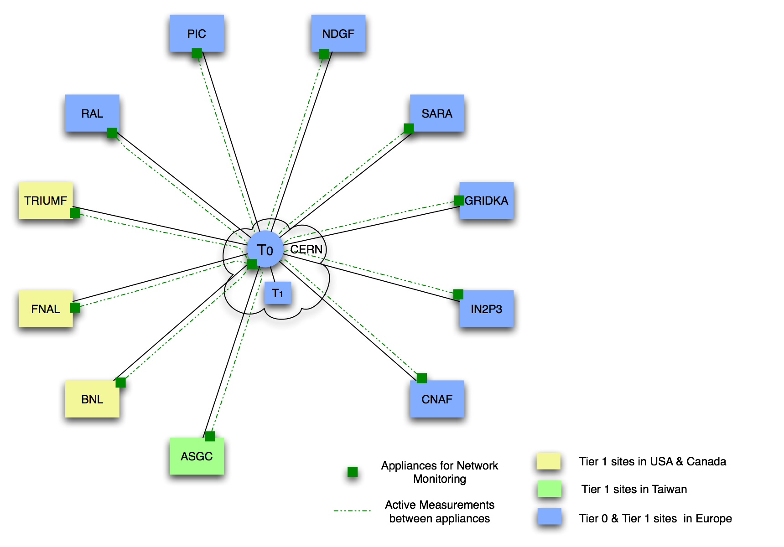
Fig. 1: Illustration of active measurements over network connections between Tier-0 and Tier-1 sites.
The appliances should be connected as close as possible to the border router(s) of the Tier-0 and Tier-1 sites. Where possible, a switch used to connect these appliances to the network, should be connected to the border router(s) via a dedicated interface on the border router(s). Since each site could have its own network architecture depending on the site’s choices, the following sections list out some common scenarios that we can expect and then describe the deployment location for the appliances for these scenarios.
Scenario 1: Appliances connected to a dedicated interface
Connecting the appliances via a dedicated LAN to a separate interface on the router(s) helps in monitoring the characteristics of the network connectivity between the Tier-0 and Tier-1 sites. As the appliances are connected to a separate LAN, measurements made by these appliances are not affected by any of the problems in the LAN on which the cluster elements are connected. Such a setup also allows the cluster elements to be ‘firewalled’ from these appliances thus making it easier to work with existing security policies of the site.
Figure 2 below is an illustration of this scenario where appliances are connected via a dedicated switch to a dedicated interface on the border router of the Tier-1 sites. The Tier-1 site in the figure consists of one border router with a few interfaces. One of the interfaces (green in colour) is dedicated to the monitoring appliances connected via a dedicated switch. The LANs on which the cluster elements are present, can be seen connected to the router via separate interfaces.
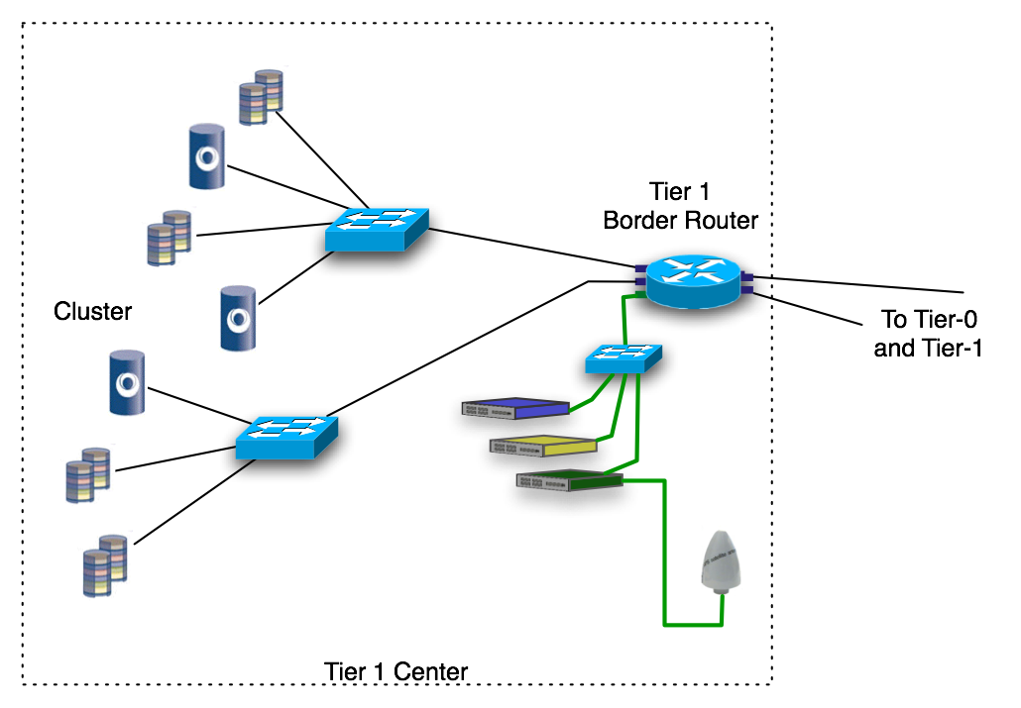
Figure 2: Illustration of Scenario 1 where appliances are connected to dedicated interfaces on a router

Scenario 2: Sites with multiple border routers
Some sites may have more than one border router to provide network connectivity between Tier-0 and Tier-1 sites. Figure 3 illustrates a scenario in which the Tier-0 site has two border routers. In this case, the site’s routing policies determine whether the network load between the Tier-0 and Tier-1 site is shared across the two links or if one of the links acts as a primary and the other one link acts as a backup.
The appliances can be seen connected to the switch that is connected to both the border routers via dedicated interfaces. It is important to note that the appliances have been deployed and connected to the LHCOPN network in a manner that ensures that the active measurement traffic get treated the same way as the actual data traffic between the Tier-0 and the Tier-1 site.
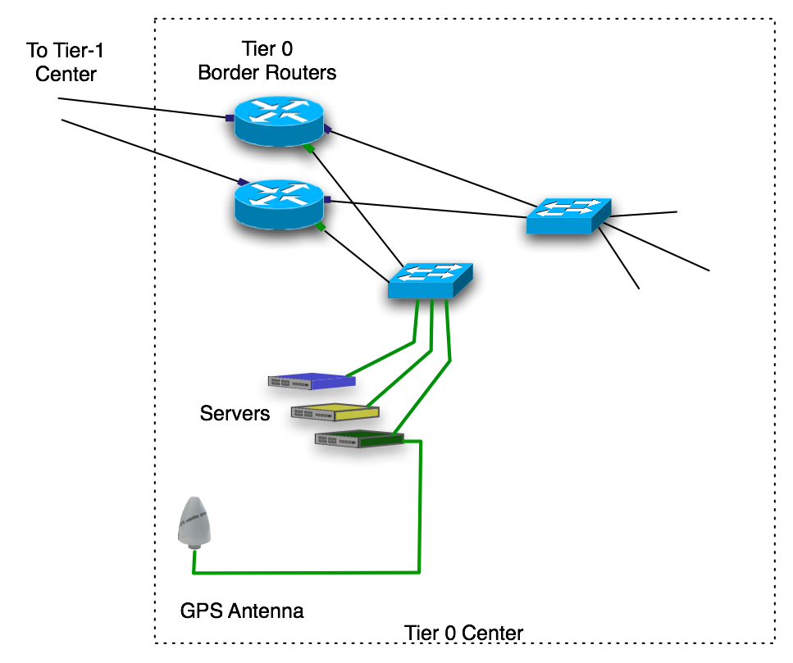
Figure 3: Illustration of appliances being connected to interfaces on two dedicated routers

Site Requirements
In order to deploy the appliances, each Tier-1 site will need to provide the following:
Electricity

- 8 power sockets, each providing 100-240v of power supply
- Total power consumption of 1.8 Kilo Watts
  - Connection via UPS (Uninterrupted Power Supply) that provides at least 30 minutes of electricity backup for all servers in case of a power supply failure.
Note: There are additional power requirements for a terminal server if there isn’t one already present at the site. The sub-section on Terminal Server below explains these requirements.

Rack space

- Total rack space of 8 units for servers in a standard19” rack
  - Includes ventilation space between servers
Note: There are additional rack space requirements in order to house a terminal server if there isn’t one already present. The sub-section on Terminal Server below explains these requirements.

Network Connections
- 10 ports on a switch for data connectivity
  - 1 Gigabit Ethernet port, 9 Fast Ethernet (at least)
- 3 ports on a terminal server for remote management
  - Terminal Server has to be connected to a switch for in-band access and to an ISDN line and/or PSTN line for out-of-band access
- 15 Public IP addresses and DNS entries (DNS entry managed by the Tier-0 and Tier-1 sites)

Terminal Server
If the site does not have a Terminal Server similar to the configuration specified in Appendix A, then a new Terminal Server will need to be deployed. Similar configuration is required in order to ensure that the remote management cards on the servers are compatible with the terminal server
If a compatible terminal server is not already present for remote management, the site will need to provide the following
- 1 additional unit of rack space for terminal server
- 1 additional port on the switch for in-band remote access
- Connection to an ISDN line and/or PSTN line for resilience (out-of-band access)
- 1 additional power socket providing 100-240v of power supply (180 watts)

Accurate Time Signal
One of the deployed servers will require an accurate time source to be available at the site. A GPS antenna with the make and model similar to the one listed in the appendix A has to be available at the Tier-0 and Tier-1 sites for this purpose. The time signal has to be delivered to the server via a co-axial cable (RG58).
If a GPS antenna is already available and is connected to an existing GPS signal receiver card, it is possible to re-use the clock on this card via a PPS signal (if the existing GPS card supports PPS). This PPS signal has to be delivered to the MDM appliance via a serial cable. There are however some constraints to this solution. As a result it is not the preferred solution and its use will have to be decided on a case-by-case basis.
The figure 3 below illustrates the connection between the one of the servers (green box) and a GPS antenna. Other key points to note in this figure are the use of a splitter, a lightning protector and the GPS receiver card on the server
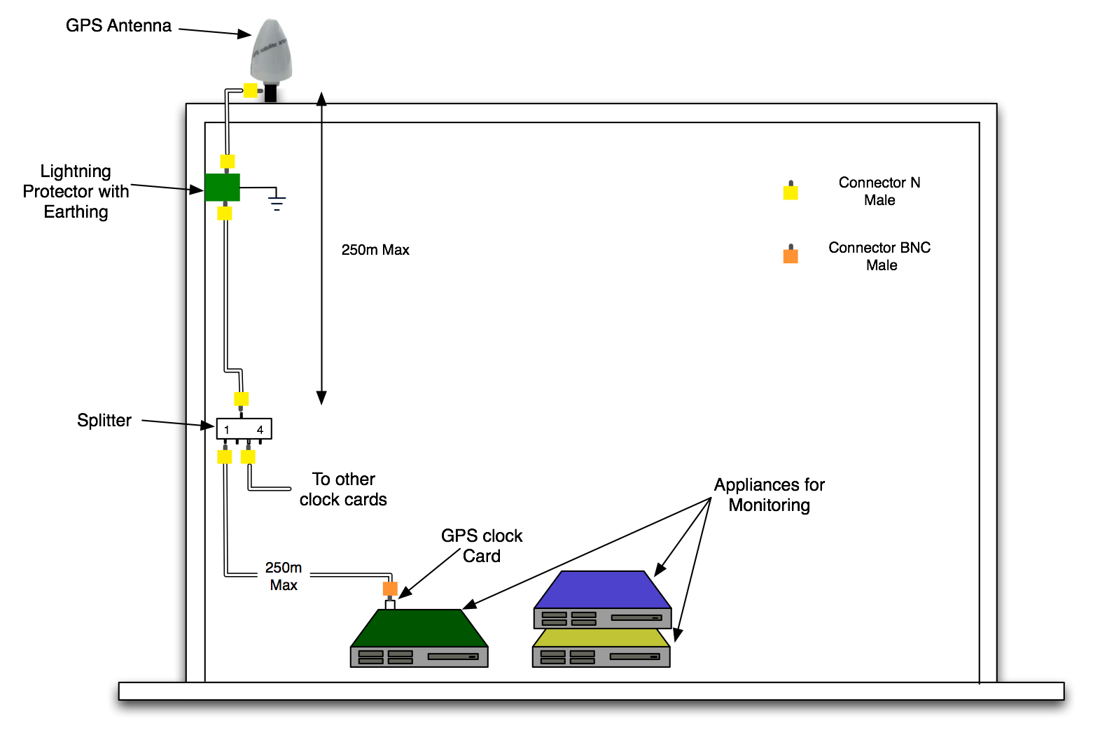
Figure 3: Illustration of connections between GPS time source and a monitoring appliance
If a GPS antenna is not already present at the site, the site will need to install a GPS Antenna of the same make and model and also the necessary co-axial cable (RG58) connections. Ideally a splitter should be used to allow re-use of the signal by multiple servers/cards.
If a similar GPS antenna is already present at the site, a co-axial cable (RG58) connection between a splitter connected to the antenna and the GPS card on one of the deployed servers is required.

The figure 5 below illustrates the on-site hardware setup and the required connections.
<Figure 5 required>

Installation and Maintenance

Hardware Installation and maintenance
All three servers and the terminal server (if needed) that are deployed to the tier-1 sites will have to be received and installed by the sites’ local system administrators. These installations can be carried out with the help of detailed instructions and illustrations provided along with the hardware. Service desk personnel will be available as well to provide any required assistance.
If installation of a GPS antenna is necessary, such installations and the necessary cabling work will have to be carried out by a local company/contractor and has to be chosen by the site management. Installation instructions and information on how to test installations will be available.
If a GPS antenna is already installed, the additional cabling required to connect the cable to the deployed server (green server) will have to be installed by a local company/contractor who has been chosen by the site management. As before, installation instructions and information on how to test installations will be available.
On-site maintenance
The need for on-site maintenance tasks to be carried out by local administrators will be low because of the remote management capability available on all servers. On-site maintenance tasks will be necessary mainly in case of hardware faults and upgrades. For such cases, depending on the hardware, one of the following procedures will be followed:
- Local system administrators will need to follow instructions provided by the service desk to carry out tasks such changing hardware components, shipping faulty hardware to the service desk or replacing the hardware with a replacement.
- 3rd party hardware support personnel will be required to visit the site to carry out hardware repair or upgrade tasks. Such visits will be planned with a short notice as hardware repairs and replacements have to be carried out as soon as possible. The personnel will be given details about the site location and site security procedures that are required to be followed.

Operating System Maintenance
The Service Desk will install the Operating System before the servers are deployed at the Tier-0 and Tier-1 centres. The Linux operating system installed on the servers is of enterprise quality supplied and supported by Red Hat. If any security patches and software updates are available, Red Hat notifies its users (i.e. the service desk).
The service desk will upgrade the Operating System by installing the latest patches and software updates whenever Red Hat makes them available. Software upgrades and all other necessary maintenance of Operating System will be done remotely with the help of the servers’ remote management capabilities. This reduces the need for on-site maintenance.
On-site maintenance
In the unlikely case of the installed Operating System requiring a complete re-install, local system administrators will be required to provide on-site support to the service desk. This support usually involves popping a DVD into the DVD drive of the server and taking it out a later point in time. In some cases, it might be necessary to ship the hardware to the service desk.

Software configuration
The service desk will install all necessary software including measurement tools, perfSONAR suite and the required dependency software. Basic configuration of the installed software will be done before the appliances are deployed at the sites.
Once the appliances have been deployed, further configuration will be required. These advanced configurations require local information such as local network details and SNMP router polling capabilities. Hence this task will have to be done jointly by the service desk and the local system administrator. Once configured and working, any changes to the local network will require this advanced configuration to be updated as well. The local system administrators will need to work with the service desk to make sure such changes are applied.

Software Maintenance
The service desk will maintain the software that they have installed on the appliances. This maintenance includes applying patches and upgrading software to newer versions whenever updates are available.

Security

Measurement Capabilities and Measured Data
Many administrative domains (example: the CERN domain, the GEANT2 domain) make use of technologies such as digital certificates, etc. in order provide credentials to its users. Users make use of these credentials to access resources such as measurement data within their domain. The eduGAIN framework makes it possible for users of domains with compatible authentication technologies (for example: Shibboleth [3]) to use their existing credentials in order to access resources made available by other domains. Such domains will however need to be part of the eduGAIN federation. For domains that do not use eduGAIN compatible authentication technologies, eduGAIN and GIdP [4] can provide credentials to the users these domains. eduGAIN is also investigating the compatibility of VOMS (Virtual Organisation Membership Service) [4] with its framework.
The perfSONAR software provides the capability to restrict access to measurement data and the usage of measurement tools to authenticated and authorized users only. These capabilities are available via the eduGAIN framework [2] with which the perfSONAR framework is compatible. If access to the measured data and the measurement capabilities of the deployed perfSONAR software has to be restricted to a selected group of users, then it is necessary for all these users to posses credentials compatible with the eduGAIN framework.

Appliances

Operating System
The Operating System used in the appliances is the industry-standard Red Hat Enterprise Linux (RHEL) 4. This operating system makes use of a well tested Linux kernel to provide platform stability and enterprise level security. RHEL 4 comes with an assurance from the Red Hat Corporation to quickly update the Operating System if any vulnerability is found. Red Hat also alerts users about available patches so that they can be immediately applied onto the deployed Operating System.
With the help of the strengths of a UNIX operating system, a built-in firewall and the Red Hat support, the Operating system in the appliances can be guaranteed to provide high levels of security.

Monitoring Tools and perfSONAR software
The monitoring tools, the perfSONAR software and other dependency software used in the appliances for deployment at the Tier-0 and Tier-1 sites are stable, open-source software that are supported by their respective development teams. All these software are designed to run with very low privileges that gives the software restricted access to operating system capabilities. The ports used by the software are well defined and moderated by the operating system firewall policies. All these factors make it possible to operate a secure set of software necessary to deliver the Multi-Domain Monitoring Service.

Network

Security Filters
<more discussions needed for this section>

Support

Extending the MDM Service

Measurement footprint
The primary objective of this MDM Service for LHCOPN is to provide a monitoring service that meets the network’s monitoring requirements. The initial scope of this network monitoring is hence limited to the network connections that are part of this Optical Private Network i.e., the connections between the Tier-0 site and all the Tier-1 sites.
This, however, does not limit the service from being extended to monitor, for example, the network connections between Tier-1 and Tier-2 sites. Such extensions are subject to at least one main condition that they do not introduce an overhead that reduces the quality of service provided to meet the primary objective. Overheads could be a result of factors such as increase in the number/type of measurements, a stress on the hardware and a stress on the monitoring software. The service desk will be responsible for evaluating the impact of extending the measurement footprints and implementing such extensions.

Additional Network Metrics and Software
The software set listed to be installed on the appliances has been chosen to meet the monitoring requirements of LHCOPN. Other software in addition to this list might be needed to meet any new requirements (for example, extensions to LHCOPN’s monitoring requirements or monitoring connectivity between Tier-1 and Tier-2 sites).
For cases where additional software is needed to meet new requirements of LHCOPN, such software will be investigated and deployed. If needed, hardware upgrades required to support these additional software will be investigated. These additional software will be also be supported by the service desk.
For all other cases, additional software can be introduced onto the appliances provided
- They have been tested and determined to be of good quality (in the appliances’ environment)
- They do not interfere or reduce the quality of service provided to meet the primary objective of LHCOPN monitoring
- The service desk can provide support for such software
The service desk will be responsible for evaluating the software, judging the impact of introducing new software onto the appliances and implementing such additions.

Conclusions

References
[1] LHC Monitoring requirements proposal and discussions – Joe Metzger et. Al.:
http://indico.cern.ch/getFile.py/access?contribId=4&amp;resId=1&amp;materialId=slides&amp;confId=15319
[2] eduGAIN
[3] Shibboleth
[4] GIdP

http://www.meinberg.de/english/products/gpsant.htm#Characteristics
http://www.meinberg.de/download/docs/manuals/english/gpsant.pdf
http://wiki.perfsonar.net/jra1-wiki/index.php/Image:GPS-installation_Splitter.jpg
http://wiki.perfsonar.net/jra1-wiki/index.php/Image:GPS-installation_PPS_2PC.jpg

Hardware Specification

Hardware configuration

Server 1 (Green box)
Bee Linux Server specification
- (SN: 2523/06) 19" Server chassis
- Pentium® 4Motherboard
- two 10/100/1000MBit onboard NICs
- one onboard graphics
- one CPU Intel® Pentium®4 630 (3,0GHz)
- 1GB DDR2 RAM, PC533, ECC (2 x 512MB)
- two SATA 80GB HDD one
- ATAPI DVD and a 3.5" Floppy
- Standard Rail kit
- eRIC express (short eRIC X) remote management
- GPS clock card - A Meinberg clock card GPS170PCI (if GPS antenna is installed)

Power supply
- 3 * 100-240v AC power supply. Server runs with two supplies, third one is for redundancy. 650 watts power consumption (2*325). Standard three pin sockets on the server and standard power plug (North America/Europe).
- 1 * 100-240 v AC power supply to an AC-to-DC adapter (adapter supplied with remote management card), 50 watts power consumption. Standard power plug with necessary converters (North America/Europe)

Network connectivity
- 2 Ethernet ports connected to a switch with the help of CAT 6 cables. Connected to data VLAN (if applicable)
- 1 Ethernet port for remote management connected to a switch. Connected to management VLAN (if applicable)
Rack space
- 3 units in a 19” rack

Server 2 (Blue box)
Sun Fire configuration

- Sun Fire X4100 M2 x64 Server,
- 2 x AMD Opteron Model 2216 (2.4 GHz) Processor,
- 4 x 1GB Memory, 2 x 73 GB Disks
- DVD/CD-RW Drive
- 2 x PSU
- Service Processor
- 4 x 10/100/1000 Ethernet Ports
- Sun Slide Rail Kit
- In-built Serial Management RJ45 port

Power supply
- 2 * 100-240v AC power supply. Power consumption of 400 Watts. Standard three pin sockets on the server and standard power plug (North America/Europe).

Network connectivity
- 4 Ethernet ports connected to a switch with the help of CAT 6 cables. (Data connection)
- 1 Serial management RJ45 port connected to a terminal server
Rack space
- 1 units in a 19” rack

Server 3 (Yellow box)
This server configuration is identical to Server 2 (Blue box).
Sun Fire configuration

- Sun Fire X4100 M2 x64 Server,
- 2 x AMD Opteron Model 2216 (2.4 GHz) Processor,
- 4 x 1GB Memory, 2 x 73 GB Disks
- DVD/CD-RW Drive
- 2 x PSU
- Service Processor
- 4 x 10/100/1000 Ethernet Ports
- Sun Slide Rail Kit
- In-built Serial Management RJ45 port

Power supply
- 2 * 100-240v AC power supply. Power consumption of 400 Watts. Standard three pin sockets on the server and standard power plug (North America/Europe).

Network connectivity
- 4 Ethernet ports connected to a switch with the help of CAT 6 cables. (Data connection)
- 1 Serial management RJ45 port connected to a terminal server
Rack space
- 1 unit in a 19” rack

Terminal server for remote management
Cisco 2600 series terminal server configuration
- Capable of supporting up to 16 servers (using RJ45 cables for serial remote management)
- ISDN card and/or PSTN card for out-of-band access
- 10/100 Ethernet port
- RJ45 port for console access (management of terminal server)
Power supply
- 1 * 100-240v AC power supply. Power consumption of 180 Watts. Standard three pin sockets on the server and standard power plug (North America/Europe).

Network connectivity
- 1 Ethernet port connected to a switch (In-band access)
- 1 RJ45 port connected to ISDN line or 1 RJ11 connected to PSTN line
- Serial management RJ45 port connected to another terminal server
Rack space
- 1 unit in a 19” rack

GPS Antenna
The compatible GPS antenna is a Meinberg GPSANT which has the following specifications
- Roof mounted, requires clear view of the sky
- Connections to clock card via co-axial cable (RG58)
- Lightning protector
- Splitter (if required)
Power supply is not required.
Rack space is not required but roof space is required.
Network connectivity is not required but co-axial connection between the antenna and the GPS clock card is required.

Software Description

Measurement Tools
AMI scheduler + OWAMP tool
The OWAMP tool is an active measurement tool that makes use of probe packets to measure One Way Delay between two OWAMP tool deployments. The OWAMP tool is an implementation of the OWAMP RFC. The AMI Scheduler provides the capability to schedule regular and on-demand one way delay measurements between a set of OWAMP tool deployments.
The OWAMP tool and the AMI scheduler will be installed at all sites and regular measurements will be made between the Tier-1 sites and the Tier-0 site. The results of the measurements will be archived and exported with the help of perfSONAR software.

Circuit status gathering software – tailored to individual technology
<So far, these have been developed by the NRENs themselves with some guidance from DANTE. This is very technology specific>

BWCTL and Iperf tool
Iperf is a tool to measure maximum TCP bandwidth. BWCTL tool is a command line client application that wraps around Iperf and allows test sessions to be setup between Iperf tool deployments on two different servers.
The Iperf and BWCTL tools will be installed at all sites (Tier-0 and Tier-1). Regular measurements will be scheduled between all the Tier-1 sites and the Tier-0 site. Measurement data and measurement capabilities will be exported with the help of perfSONAR software.

Cacti
The Cacti system is an open source software which provides a fast poller (includes SNMP pollling), multiple data acquisition methods and user management features. It relies on Round Robin Database (RRDTool) for storing polled data.

Cacti will be installed at all sites and will be used for polling router interfaces to gather IP interface statistics. The gathered data will be archived and available to read via perfSONAR software.

HADES System

Hades Active Delay Evaluation System (HADES) devices (previously called IPPM devices) are developed by WiN-Labor at RRZE (Regional Computing Centre Erlangen), to provide QoS evaluation in backbone networks. The HADES systems make use of active measurement techniques to calculate very precise one way delay and one way delay variation (jitter) between any two HADES measurement boxes. This work is based on the IETF approach and the extensive framework by the Work Group IP Performance Metrics passed in 1998

perfSONAR Software
perfSONAR SQL Measurement Archive
<Need descriptive text> <Developed by GEANT2/PSNC>
Pinger MP and Pinger MA
<Need descriptive text> <Developed by SLAC & Internet2 - Added to this list upon request by Internet2>

RRD Measurement Archive
<Need descriptive text> <Developed by GEANT2/PSNC>
HADES MA
<Need descriptive text> <Developed by GEANT2 - DFN>

AMI MA
<Need descriptive text> <Developed by Internet2 for periodic data gathering and storage>

BWCTL MP & MA
<Need descriptive text> <Developed by GEANT2 – DFN>

- XMLDB Lookup Service
<Need descriptive text> <Developed by GEANT2 - PSNC>
- Authentication Service
<Need descriptive text> <Developed by GEANT2 – RedIRIS with some help from JRA5>

Other Software

Hardware - Software - Metrics mapping
The table below maps out the software that need that will be installed on the servers that were discussed in the previous section on hardware. It also maps out the network metrics that will be measured by the software.

Server | Network Metrics | List of software installed on the server
Server 1 (Green) | Delay and Jitter | HADES measurement tool  perfSONAR HADES Archive (?)  OWAMP tool  AMI scheduler and archive
Server 2 (Blue) | Achievable bandwidth measurements | BWCTL measurement tool  perfSONAR BWCTL MP  BWCTL Archive  pinger MP and MA
Server 2 (Blue) |  | Authentication Service for user authentication and authorization policies
Server 3 (Yellow) | Status of circuits | Circuit status gathering software  perfSONAR SQL archive
Server 3 (Yellow) | IP interface statistics | SNMP Polling tool  RRD Measurement Archive
Server 3 (Yellow) |  | Lookup Service for discovery

