Performance Testing on perfSONAR services

The development of the perfSONAR framework and later perfSONAR services fulfilled the need of cross domain monitoring capabilities and the need of a closer collaboration between interconnecting networks in an automated and efficient way. Several perfSONAR services have been developed so far in order to meet the previously stated needs. Each service had to comply to a set of rules and instructions in order to be functionally correct and to comply with the perfSONAR framework, hence making it interoperable with the rest of perfSONAR services and clients. The compliance of these services with the perfSONAR framework was tested through functional testing. Functional testing confirmed the conformity of he tested services with their functional specifications and perfSONAR protocol and made sure that any inconsistencies were discovered and reported. But a service just compatible with the framework is not necessarily a usable service. If a service is going to be used effectively, it must provide the functionality that it was designed for, not only reliably but also in a reasonable amount of time. The latter statement leads to the conclusion that functional testing a service is not enough and most importantly that performance testing is needed to determine if a service can be usable in terms of time needed to respond and under a reasonable load of users. For this a set of benchmarks has to be set in order for the performance testing to be successful.
Performance testing a service can be divided into smaller testing parts each described by the initial state of the tested service and the types of requests that are fed into the service. But first let’s give a general outline of the testing configuration.
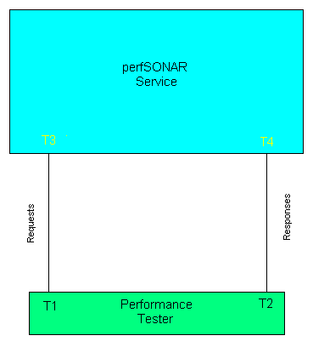
Fig 1. General Testing Configuration
Above the general configuration of the testing is shown. The set up is quite simple. A set of requests are fed by the tester to the service. The time T1 that each request leaves the tester is noted. The services response to the original request is received at time T2 which is also noted. The time taken to respond is T2-T1. It must be noted that the measurements of T1 and T2 are not the optimal time measurement instances since T2-T1 also includes the time taken for the request to traverse through the network and reach the service and also includes the time taken for the response to traverse through the network and reach the tester. The optimal time instance measurements would be T3 and T4. T3 is the time instance in which the request arrives at the service and T4 is the time instance in which the response leaves the service. But taking the latter measurements would mean interfering with the service code which at the moment is not an option. So in order to mitigate the effects of the network travelling delay to our measurements, performance testing has to take place in a local network configuration. Otherwise network delays that are not relevant with the service performance will affect the testing results, thus giving a disturbed image of the service capabilities.
Given the general testing outline we can proceed to the characteristics that must define each performance test.
- Types of requests
Not all requests are the same in regards of the processing time needed by the service. A simple echo request demands a trivial amount of computational time. In the contrary an LSQuery request that asks for information about all available perfSONAR services registered in a LS, demands a great effort by the service. So requests must be divided in regards of the effort that a particular service needs in order to respond to the request. In this context requests can be divided according to their type. I.e. an echo request takes a lot less time to process than an LSQuery request since there is no need to access and retrieve data from the data base. Furthermore a new division can be made between requests of the same type. An LSQuery asking for information about a particular interface in PSNC is not the same as an LSQuery request asking for information about all the interfaces of PSNC. So a categorisation of requests in regards of the processing effort needed is essential for the successful conducting of performance tests and it’s important to safely make our conclusions out of the results of the tests. Keeping in mind all the above I recommend the categorisation of the requests into three sub categories in regards of processing effort:
  - Trivial effort requests(i.e. echo request)
  - Medium effort requests(i.e. LSRegister)
  - Great effort requests.(i.e. LSQuery)

As stated above requests like LSQuery can further divided in the example of the latter list.
- Service Data load
By service data load, I mean the amount of data that are stored in a service database (if there is any). The time it takes to find any piece of information inside a database is relevant to the size of the database. An LS which has an eXist database that contains information about ten(10) MAs will normally take less time to process an LSQuery request than an LS containing information about 100 MAs. So performance testing should take in account the data load of the service, again dividing test cases were the tested service has:
  - Small data load
  - Medium data load
  - Heavy data load.
Making this kind of separation and increasing the data load of the service during the tests we can at the end determine the limits of the service and recommend a maximum data load value if such estimation can be made.

- Hardware load
In order to have reliable results, all tests for a particular service have to be made on the same machine. In addition to that the load of the machine must be taken into consideration. A machine dedicated only to a perfSONAR service will definitely have better response times than a machine that is also a mail server an MA and also hosts an apache web server. It is expected though that in real life perfSONAR services will be sharing resources with other kinds of services and the scenario of a server dedicated only in a perfSONAR service is unlikely. But for testing it is necessary to get results for a clean system just hosting a perfSONAR service in order to make sure that the result times that the service is producing is based on the service performance alone. Off course we have to test real life conditions as well, so testing a service in a machine hosting multiple services, as close as real life conditions, is also necessary. So I recommend the following division:

  - Service running on a dedicated machine.
  - Service running on a “real life conditions” machine.

- Rate of incoming requests
This is a key performance factor. How many requests per time unit can a service handle? Usually random and unrelated requests can be described by the Poisson distribution:
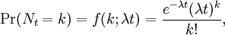

Were λ is the rate of requests and k is the number of requests before time t.
One can say that this is the usual case for perfSONAR services as well. But given the existence of metadatakey requests in perfSONAR services it is expected that not all perfSONAR requests are random and unrelated. It is expected that a metadatakey request will be followed by a setup data request asking for data pointed by the previously retrieved key. So for many perfSONAR services the use of a Poisson distribution to simulate the expected incoming requests may not be sufficient. To deal with this issue I recommend that the tests are configured in such a way as i.e. when a metadatakey request is send, a setup data key request must follow. Off course if this scenario is selected further issues may arise in regards of keeping the rate of incoming requests in the selected value.
Step increasing the rate of incoming requests should provide a safe indication of the tested service deterioration of response times, and finally determine the limit of the service capabilities.

Having defined the characteristics that must be taken into account when designing performance tests one must note that all four characteristics must be simultaneously taken into to account in order to produce reliable results. So a series of performance tests have to take place changing each time one of the above characteristics and keeping the others constant. But given the number of the types of perfSONAR requests, the number of tests may become enormous. So a careful selection of the types of requests that are going to be included in the tests along with the percentage of participation to the test of each selected type must be made.
It’s also necessary that each request be treated as it was send by a different client. This can be achieved when using a programming language such as Java with the use of threads.
It’s also important to have each test case running until the response times converge to a certain price and the service has reached a steady state.

Summarising all the above performance testing has to take in account the previously described characteristics: Type of request in regards of the processing load that a certain type of request inflicts on the services, data load stored in the service database, load on the machine running the service and finally the rate of incoming requests. Every test consists of a combination of the latter characteristics and in every test one of these characteristics is changed while the rest remain constant in order to have a clear view of performance. In addition each request is threaded in order to simulate different and independent clients. Finally this process needs to lead to tests as close to reality as possible, so an estimate of “real life performance” can be made and suggestions for optimal configuration and practices can be forwarded to the people in charge of deploying these services. At the end any performance insufficiencies found will be forwarded to the developers so solutions for an upgrade in performance can be found.
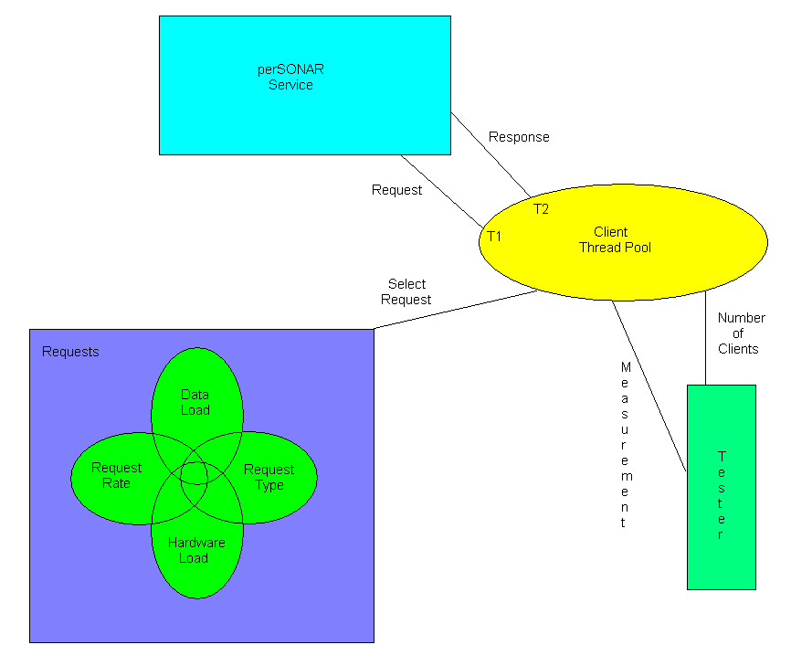
Fig 2. General Testing Architecture

