Proposal for Naming Schema used in E2E Monitoring System
Matthias Hamm, Mark Yampolskiy
{matthias.hamm, mark.yampolskiy}@dfn.de
Version 0.01
Revision Date: 13. October 2006

Introduction

E2E Monitoring System developed by Géant2 JRA4/WI3 requires global unique names for the following resources:
- E2E Links
- Projects
- Topology Points (including End Points of E2E Links)

Definitions of these terms can be found in [1].

The goal of this paper is to elaborate a proposal for assuring global uniqueness of resource identifier. To meet the needs of the multi-national federative project environment a distributed approach for naming authority is used.

The concept of Uniform Resource Names (URN) seems well-suited as a basis for an appropriate naming schema. [2], [3] In the research and education area the Middleware Architecture Committee for Education (MACE) administers an own formal URN namespace. [5]

We propose to integrate the E2E Monitoring Namespace in the MACE schema as described below.

Naming Schema

The namespaces listed in Table 1 should be managed by a single central naming authority. This can either be MACE itself or this function can be delegated to an organisation involved in E2E Monitoring.

Namespace | Purpose
urn:mace:e2emon | E2E Monitoring System related URNs
urn:mace:e2emon:e2elink | E2E Link URNs
urn:mace:e2emon:project | Project URNs
urn:mace:e2emon:tp | URNs of Topology Points (including End Points)

Table 1 - Centrally administered Namespaces

Delegated Naming Authorities

The administration of the namespaces below urn:mace:e2emon:e2elink, urn:mace:e2emon:project and urn:mace:e2emon:tp is delegated to the participating organisations. The organisations have to request to be granted subordinate naming authority status. They may propose candidate names for that authority. One way for such entities to guarantee uniqueness of their proposed name is to base it on a DNS name.
For the urn:mace:e2emon:e2elink and urn:mace:e2emon:project only the organisations which are allowed to assign names for E2E Links and Projects can be registered.
Under the urn:mace:e2emon:tp namespace all network domains participating in providing E2E Links have to be registered. They have to register all Topology Points within their own network used in E2E Link Provisioning. This can also include End Points connected to the network. In addition End Point Organisations may apply naming authority status for themselves independently of a network domain. This extension is only useful for “global player” institutions like CERN.

All Naming Authorities have to publish all used names in a commonly agreed way.

Examples

To illustrate the proposed naming schema some real life example are given in Table 2 and corresponding Illustration 1.

URN | Description
urn:mace:e2emon:e2elink:DANTE.net:FOO-013 | E2E Link ID administered by DANTE
urn:mace:e2emon:project:DANTE.net:LHC | E2E Project ID administered by DANTE
urn:mace:e2emon:tp:Geant2.net:GEN | Topology Point ID administered by Géant2
urn:mace:e2emon:tp:Geant2.net:MIL | Topology Point ID administered by Géant2
urn:mace:e2emon:tp:DFN.de:BAS | Topology Point ID administered by DFN
urn:mace:e2emon:tp:DFN.de:MUE | Topology Point ID administered by DFN

Table 2 - Example for E2E Link URNs
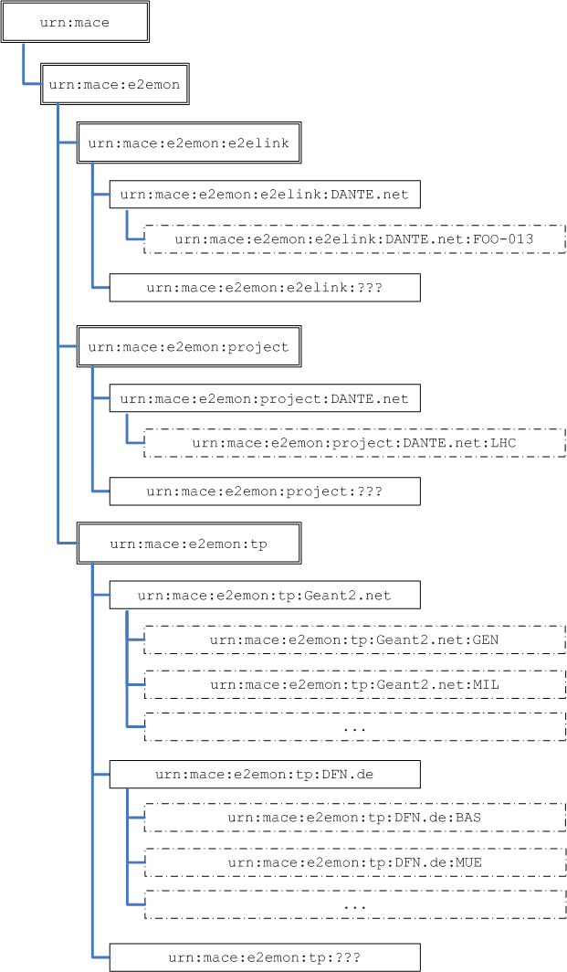

Illustration 1 - Example for E2E Link Schema

Related Documents

[1] System Design for E2E Link Monitoring http://wiki.geant2.net/bin/view/JRA4/DmsDocGN2JRA406017

[2] RFC 3406, "Uniform Resource Names (URN) Namespace Definition Mechanisms", describes how URN namespaces are registered.
http://www.ietf.org/rfc/rfc3406.txt

[3] RFC 2141, "URN Syntax", defines the syntax of URNs.
http://www.ietf.org/rfc/rfc2141.txt

[4] MACE Homepage: http://middleware.internet2.edu/MACE/

[5] RFC 3613 “Definition of a Uniform Resource Name (URN) Namespace for the Middleware Architecture Committee for Education (MACE)”
http://www.ietf.org/rfc/rfc3613.txt

