PerfSONAR Definitions to Topology Service
This document describes the basics information it is suppose to have in the Topology Service to fit in the PerfSONAR framework. The inicial idea is to have a basic support in which the others epecifics information are going to be extended making the service flexible.
These definions in this document is based in the definions of the perfSONAR wiki page.

The minimal information needed to the topology service:

Interface Information
name | This is the name of the interface. It can be a port, a vlan name or IP/mask. This information should be unique.
node name | DNS registry – this information need to be unique so if it uses a DNS registry it guarantees that this is a unique field and it makes flexible to identify the equipment. It does not bind an IP interface with an equipment. It is good because the IP interface can change easer than and DNS registry. In the first moment, this information should be of routers, after it can include other equipments information.

Connection information (relationship of connected interfaces)
interface name 1 | Interface name defines in the Interface Information
node name 1 | Node name defines in the Interface Information
interface name 2 | Interface name defines in the Interface Information
node name 2 | Node name defines in the Interface Information

Figure 1 is a schematic view of this definition.
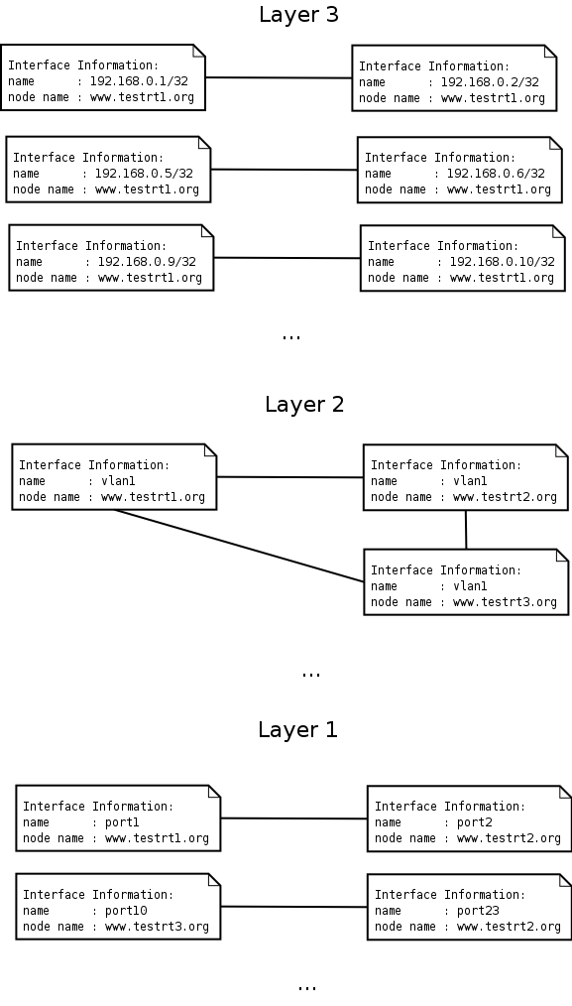
Figure 1 – Schematic View

It is how the information of Figure 1 would be populate in this definition.

Interface Information
name | node name
192.168.0.1/32 | www.testrt1.org
192.168.0.2/32 | www.testrt1.org
192.168.0.5/32 | www.testrt1.org
192.168.0.6/32 | www.testrt1.org
192.168.0.9/32 | www.testrt1.org
192.168.0.10/32 | www.testrt1.org
vlan1 | www.testrt1.org
vlan1 | www.testrt2.org
vlan1 | www.testrt3.org
port1 | www.testrt1.org
port2 | www.testrt2.org
port10 | www.testrt3.org
port23 | www.testrt2.org

Connection information (relationship of connected interfaces)
interface name 1 | node name 1 | interface name 2 | node name 2
192.168.0.1/32 | www.testrt1.org | 192.168.0.2/32 | www.testrt1.org
192.168.0.5/32 | www.testrt1.org | 192.168.0.6/32 | www.testrt1.org
192.168.0.9/32 | www.testrt1.org | 192.168.0.10/32 | www.testrt1.org
vlan1 | www.testrt1.org | vlan1 | www.testrt2.org
vlan1 | www.testrt2.org | vlan1 | www.testrt3.org
vlan1 | www.testrt1.org | vlan1 | www.testrt3.org
port1 | www.testrt1.org | port2 | www.testrt2.org
port10 | www.testrt3.org | port23 | www.testrt2.org

