30.07.26
Deliverable D.J.1.3.2:
Phase II - Implementation report
Deliverable D.J.1.3.2
Contractual Date: | 31/08/06
Actual Date: | 30/07/26
Contract Number: | 511082
Instrument type: | Integrated Infrastructure Initiative (I3)
Activity: | JRA1
Work Item: | Work Item 3
Nature of Deliverable: | R
Dissemination Level | PU
Lead Partner | PSNC
Document Code | <GN2-0n-nnnvn> GN2-06-195
Authors: | <Insert author names here>
<Deliverable title, number and doc code are fields. Modify in File -> Properties; update the document by selecting and pressing F9. NB footers are NOT automatically updated when ‘selecting all’ in Word – View -> Headers and Footers, Select All, F9>
Abstract
The GN2 JRA1 activity has delivered a second set of services and enhancements were conducted on the services developed previously. Graphical User Interfaces (GUIs) have been produced, or modified, to make use of the functionality offered by those services and, thus, operate over multiple boundaries. This document presents the status of the services and GUI delivered so far as well as an summary of the first release management process set up to provide the first service release. This document presents as well the directions for future development for those services.
Document Revision History
<This page to be deleted before submission to the EC>
Version | Date | Description of change | Person
1 | 09-06-06 | Template issued | ST
 | 05-07-06 | ABW MP, IPPM MA, PerfsonarUI, Visualization intro, and CNM text added | SU, VV/SK, VJ, and AH
 | 06-07-06 | BWCTL, Looking Glass, TCMP, and SSH/ Telnet added | SK, SV, UJ, and SV
 | 07-07-06 | Relational DB, Result codes, LS update added | MG, RL, ST
 | 11-07-06 | Release Management added | LM
 | 12-07-06 | Release Management (w/LS comments) added | LM
1.1 | 20-07-05 | Abstract, Conclusion | NS
 | 23-07-05 | SNMP MP, Push Mechanism | LK
 |  | Review
 |  | Approved

REVIEW | Main reviewer |  |  | N. Surname
Summary of suggested changes
Recommendation | 1) Major revision |  | 2) Minor revision
Re-submitted for review - if 1) | DD/MM/YY
Final comments
Approved: | DD/MM/YY

Table of Contents
0 Executive Summary vi
1 Introduction 9
2 Services 10
2.1 New services 10
2.1.1 Relational Database Measurement Archive (MA) 10
2.1.2 SSH / Telnet MP 25
2.1.3 Tracefile Capture MP (TCMP) 37
2.1.4 ABW MP 41
2.1.5 SNMP MP 46
2.1.6 Alcatel NMS MP 47
2.2 Services update 54
2.2.1 IPPM MA 55
2.2.2 BWCTL MP 58
2.2.3 Lookup Service 60
2.2.4 RRD MA 61
2.3 Services components 61
2.3.1 Push Interface 61
2.3.2 Result codes 61
3 Visualization tools update 65
3.1 Introduction 65
3.2 PerfsonarUI 66
3.2.1 Overview 66
3.2.2 Description of the new functionalities and their usage 67
3.2.3 Implementation status and future evolution 69
3.3 CNM 69
3.3.1 Overview 69
3.3.2 Description of new Functionalities and their Usage 70
3.3.3 Implementation Status and Future Evolution 70
3.4 Looking Glass 71
3.4.1 Tool overview 71
3.4.2 Specification 72
3.4.3 Implementation status 75
3.4.4 Details and future evolution 76
4 Targeting the NOC users 76
5 Functional test results 77
6 Release management process 77
7 Conclusions 79
8 References 80
9 Acronyms 82
Appendix A <Appendix Heading Text Goes Here> 84
Appendix B <Appendix Heading Text Goes Here> 86

Table of Figures
Figure 1.1: <Insert figure caption text here – type fig and press F3 to insert new figure captions> Error! Bookmark not defined.
Table 2.1: <Example table - caption text goes here – type table and press F3 to add additional tables> Error! Bookmark not defined.
Figure A.1: <Example appendix figure caption - text here – type figa and press F3 to insert new appendix figures> 84
Table A.1: <Example appendix table - caption text goes here – type tablea and press F3 to add additional tables> 84

<Accidentally deleted tables can be replaced by copies from a blank template>

Executive Summary
Over the last four months, the perfSONAR activity has been enhancing the services described in DJ1.3.1 Phase I – Implementation [DJ1.3.1]. In addition to those services, new services have been produced. Those new services produced are also following the General Framework Design [GFD] recommendations. JRA1 is pursuing the goal of providing at least one implementation for each of the basic services defined in the GFD. For two categories of services, the Measurement Point (MP) and the Measurement Archive (MA) services, JRA1 has provided the integration of several tools and type of data store. This diversity allows the development team get more experience with those service types, to extend the perfSONAR schema accordingly, and to strengthen the overall services. The following services have been developed:
- Measurement Point Service (MP) - Create/publish monitoring information related to active and passive measurements. Four new MPs have been developed in addition to the already existing BWCTL MP.
  - SSH/Telnet MP enables to retrieve, upon request, information from routers to which it has access, using standard protocols such as SSH or Telnet. Mostly, these commands are “show-like” commands. It can be seen as a backend system of a looking glass tool currently used by the NRENs.
  - Trace file Capture MP (TCMP) is the first MP service to make use of the packet capture cards. The TCMP receives requests to trigger packet capturing on remote packet capture cards and indicates where the output file, containing a packet trace, can be retrieved.
  - Available BandWidth (ABW) Measurement Point is a service that allows the monitoring, on a remote packet capture card, of the proportion of bandwidth used by one or several particular protocols at a very fine granularity.
  - SNMP Measurement Point which, when receiving a router or interface name and an OID or a MIB field name, retrieves the value associated to that OID on the selected router/interface and returns it to the requester.
- Lookup Service (LS) - Registry of all participating services and their capabilities. It is a single point of contact to discover all the data to which a user can have access. The LS has been enhanced and provides results code.
- The Relational Database Measurement Archive Service (MA) - Create/publish monitoring information stored on a data archive. A new The Relational DataBase Measurement Archive Service (RDB MA) is available. It is using a relational database for data access and storage (MySQL or postgreSQL). This new MA is in addition to the Round Robin Database (RRD) MA and to the Hades MA previously described.
- The Authentication Service (AA), the last of the four basic services. This service and its inter-action with the perfSONAR services are jointly designed by JRA1 and JRA5. The design has greatly advanced over the last four months and will be reported in DJ1.2.4 - PerfSONAR AA Service Specification in November.The AA is a major piece in the perfSONAR framework since it will be necessary to allow a wide deployment of the perfSONAR services.
RRD MAs have been deployed by 13 national research and educational networks (NRENs) and are currently providing link capacity and link utilisation to the perfSONAR tools. Ten instances of the Hades delay measurement tools (formerly known as DFN IPPM) have been deployed by JRA1 at this time, and their measurement results are available through the Hades MA. Four BWCTL MPs, two Lookup services and one SSH/Telnet MP have been deployed.
Figure 0.1: Number of RRD MA deployed per month and over time.

In parallel to the services developments, a looking glass GUI has been created or modified to make use of the perfSONAR Telnet/SSH MP. It is used as the visualisation of the behind the scenes active SSH/Telnet MP. It can serves as a perfSONAR-integrated front-end having similar functionalities as the currently available looking glasses written in Perl or CGI. CNM and perfsonarUI have both been enhanced based on users feedback.
The first perfSONAR release is ready. XXX here XXX

Section 1 introduces the deliverable. Section 2 describes the unit and functional test methodologies as well as giving some examples. Section 3 details the release management process. Section 4 presents an overview, the specifications, the implementation status, and the future extension of the Hades MA, BWCTL MP, LS and RRD MA services. The services specifications allow any GUI developer to easily interact with those services. An overview, implementation status, and description of future extensions of the CNM and PerfsonarUI GUIs are presented in section 5. This section also provides user guides for those two tools. All abbreviations are explained in paragraph 8.

Introduction

Services
This section describes new services, updates of services reported in the last deliverable, and components of services.

New services

Relational Database Measurement Archive (MA)
This section describes a new MA using a relational database for data access and storage (e.g. MySQL or postgreSQL).

Overview
This service provides two main functionalities:
- Publishing measurement data – the service uses a relational database for publishing measurement data. The database can be populated by other applications (home-made scripts, network management systems) or measurement points (e.g. SNMP MP). Once the database is populated, results are available through requests for data. This service works as an interface for users who want to access data in a standardized way, compatible with perfSONAR specification.
- Accepting and writing measurement data – a relational database MA service can accept data from other publishers as defined in the perfSONAR framework. These can be measurement points (MPs) that are designed to perform regular or on-demand measurements, or ones that use ‘write’ functionality to store measurement results in a relational database. Currently, the service stores L2 path status and utilization data.

Specification
This section provides details on the input and output for the relational database MA. Each section presents an example message of each type, together with its content explanation.

Input
The relational database MA currently supports the following types of input messages (both for L2 path status and utilization data):
- MetadataKeyRequest
- SetupDataRequest (without a key)
- SetupDataRequest (with a key)
- MeasurementArchiveStoreRequest

MetadataKeyRequest
Message type=MetadataKeyRequest
This request provides an optimisation to the measurement data retrieval parameters. The request contains some parameters, in a metadata element, that remain static over time. The key is given back after processing the request and identifying the location of data that can satisfy the request. Then, the client can use the key to request data. This mechanism prevents recurring reading and analysing the full requests, thus helping service optimisation.
Example request for key for L2 path status:
<?xml version='1.0' encoding='UTF-8'?>
<nmwg:message type="MetadataKeyRequest"
xmlns:nmwg="http://ggf.org/ns/nmwg/base/2.0/"
xmlns:nmtl2="http://ggf.org/ns/nmwg/topology/l2/3.0/"
xmlns:select="http://ggf.org/ns/nmwg/ops/select/2.0/">

<nmwg:metadata id="meta1">
<nmwg:subject id="subject1">
<nmtl2:link>
<nmtl2:globalName type="logical">PSNC-DFN-MUE-003</nmtl2:globalName>
</nmtl2:link>
</nmwg:subject>
<nmwg:eventType>Path.Status</nmwg:eventType>
</nmwg:metadata>

<nmwg:metadata id="meta2">
<select:subject id="iusub2" metadataIdRef="meta1"/>
<select:parameters id="param1">
<nmwg:parameter name="startTime">1144318520</nmwg:parameter>
<nmwg:parameter name="endTime">1144318523</nmwg:parameter>
</select:parameters>
<nmwg:eventType>select</nmwg:eventType>
</nmwg:metadata>

<nmwg:data id="data1" metadataIdRef="meta2"/>

</nmwg:message>

The request for a key for L2 path status can contain a set of metadata and data blocks. The above example shows two metadata blocks. The first one describes the path for which measurement data is searched. The block consists of elements defined in L2 and L3 topology schema (see Appendix) and corresponding values defined in configuration file. The full end-to-end path can be identified either by its global name or partial segments identified by nodes. When the metadata block describing the link is omitted, the request retrieves keys for all known links from the configuration file of the service.
The second metadata block allows the user to specify the time range of measurement data. It specifies:
- startTime – start time of data series (the unit is seconds since epoch 1970-01-01)
- endTime – end time of data series (the unit is seconds since epoch 1970-01-01)
- time – an element that can replace the two above elements and provides the functionality of selecting the last available value. This parameter must have value now.
The data element should correspond to the number of metadata blocks. This is a placeholder for future data returned from service.
An example request for key for utilization:
<?xml version='1.0' encoding='UTF-8'?>
<nmwg:message type="MetadataKeyRequest"
xmlns:netutil="http://ggf.org/ns/nmwg/characteristic/utilization/2.0/"
xmlns:nmwg="http://ggf.org/ns/nmwg/base/2.0/"
xmlns:nmwgt="http://ggf.org/ns/nmwg/topology/2.0/">

<nmwg:metadata id="meta1">
<netutil:subject id="subj1">
<nmwgt:interface>
<nmwgt:ifAddress type="ipv4">10.1.2.3</nmwgt:ifAddress>
<nmwgt:hostName>test-hostName</nmwgt:hostName>
</nmwgt:interface>
</netutil:subject>
<nmwg:eventType>utilization</nmwg:eventType>
</nmwg:metadata>

<nmwg:data id="1" metadataIdRef="meta1"/>

</nmwg:message>

The metadata block consists of interface-specific information, which refers to parameters in the configuration file. The more properties you provide in the request, the more exact the response will be. You can provide zero or more elements apart from those that are required. A metadata block can contain the following parameters:
- IfAddress – Indicates the IP address of the interface for which measurement data is sought. A second (required) attribute type is added to indicate the type of protocol used for providing the IP address. Currently supported types: ipv4 | ipv6.
- hostname – Indicates the interface hostname.
- ifDescription – Indicates a textual description of the interface for which measurement data is collected.
- direction – Indicates the direction of traffic for which measurement data is sought. Currently supported values: in | out
- capacity – Indicates the capacity of the interface.
- authRealm – Indicates the authentication token. Not used at present.
- eventType – Indicates the type of measurement data requested. Currently supported type is: utilization. It is a required parameter.
The data element should correspond to the number of metadata blocks. This is a placeholder for future data returned from service.

SetupDataRequest (without a key)
Message type=SetupDataRequest
This request provides measurement data based on some parameters. In this type of request the key is not provided so the service goes through an intermediate process of discovery (of a key) for the given request first then retrieves data from relational database.
Example request for L2 path status without a key:
<?xml version='1.0' encoding='UTF-8'?>
<nmwg:message type="SetupDataRequest"
xmlns:nmwg="http://ggf.org/ns/nmwg/base/2.0/"
xmlns:nmtl2="http://ggf.org/ns/nmwg/topology/l2/3.0/"
xmlns:select="http://ggf.org/ns/nmwg/ops/select/2.0/">

<nmwg:metadata id="meta1">
<nmwg:subject id="subject1">
<nmtl2:link>
<nmtl2:globalName type="logical">PSNC-DFN-MUE-003</nmtl2:globalName>
</nmtl2:link>
</nmwg:subject>
<nmwg:eventType>Path.Status</nmwg:eventType>
</nmwg:metadata>

<nmwg:metadata id="meta2">
<select:subject id="iusub2" metadataIdRef="meta1"/>
<select:parameters id="param1">
<nmwg:parameter name="time">now</nmwg:parameter>
</select:parameters>
<nmwg:eventType>select</nmwg:eventType>
</nmwg:metadata>

<nmwg:data id="data1" metadataIdRef="meta2"/>

</nmwg:message>

The first metadata block consists of an element globalName indicating logical path name known to user. This name is used for searching configuration file to find an appropriate key for relational database data retrieval. This block describes the path for which measurement data is searched. The block can consist of elements defined in L2 and L3 topology schema (see Appendix) and corresponding values defined in configuration file.
A request may contain additional optional metadata block with parameters used to provide more focused selection of measurement data. These parameters are:
- startTime – start time of data series (the unit is seconds since epoch 1970-01-01)
- endTime – end time of data series (the unit is seconds since epoch 1970-01-01)
- time – an element which can replace two above elements and provides functionality of selecting last available value. This parameter must have value now.
If time constraints are not present in the message default one (now) is taken.
The data element should correspond to the number of metadata blocks. This is a placeholder for future data returned from service.
Example request for utilization without a key:
<?xml version='1.0' encoding='UTF-8'?>
<nmwg:message type="SetupDataRequest"
xmlns:netutil="http://ggf.org/ns/nmwg/characteristic/utilization/2.0/"
xmlns:nmwg="http://ggf.org/ns/nmwg/base/2.0/"
xmlns:nmwgt="http://ggf.org/ns/nmwg/topology/2.0/"
xmlns:select="http://ggf.org/ns/nmwg/ops/select/2.0/">

<nmwg:metadata id="meta1">
<netutil:subject id="iusub1">
<nmwgt:interface>
<nmwgt:ifAddress type="ipv4">10.1.2.3</nmwgt:ifAddress>
<nmwgt:direction>in</nmwgt:direction>
<nmwgt:hostName>test-hostName</nmwgt:hostName>
<nmwgt:ifName>test-0</nmwgt:ifName>
<nmwgt:direction>in</nmwgt:direction>
<nmwgt:authRealm>TestRealm</nmwgt:authRealm>
<nmwgt:capacity>1000BaseT</nmwgt:capacity>
</nmwgt:interface>
</netutil:subject>
<nmwg:eventType>utilization</nmwg:eventType>
</nmwg:metadata>

<nmwg:metadata id="meta2">
<select:subject id="iusub2" metadataIdRef="meta1"/>
<select:parameters id="param1">
<nmwg:parameter name="startTime">1143034700</nmwg:parameter>
<nmwg:parameter name="endTime">1143034710</nmwg:parameter>
</select:parameters>
<nmwg:eventType>select</nmwg:eventType>
</nmwg:metadata>

<nmwg:data id="data1" metadataIdRef="meta2"/>

</nmwg:message>

The metadata block consists of interface specific information, which refers to parameters in configuration file. Parameters are described in section MetadataKeyRequest. Once a request of this type is received, the MA service begins an intermediate phase of internal key discovery, whee it searches its configuration file for a key described by the metadata block. If found, the key is used to retrieve the available measurement data from the relational database. A request may contain an additional, optional metadata block with parameters used to provide more focused selection of measurement data. These parameters are:
- startTime – start time of data series (the unit is seconds since epoch 1970-01-01)
- endTime – end time of data series (the unit is seconds since epoch 1970-01-01)
- time – an element which can replace two above elements and provides functionality of selecting last available value. This parameter must have value now.
The data element should correspond to the number of metadata blocks. This is a placeholder for future data returned from service.

SetupDataRequest (with a key)
Message type=SetupDataRequest
This request provides measurement data based on the key which has been previously discovered with the use of MetadataKeyRequest. The key is used to optimise data access, as the service can query the database immediately. The response also will return the key. The structure and content of the key in the following messages is only for example and is subject to change.
Example request for L2 path status with a key:
<?xml version="1.0" encoding="UTF-8"?>
<nmwg:message type="SetupDataRequest"
xmlns:nmwg="http://ggf.org/ns/nmwg/base/2.0/"
xmlns:nmtl2="http://ggf.org/ns/nmwg/topology/l2/3.0/"
xmlns:select="http://ggf.org/ns/nmwg/ops/select/2.0/">

<nmwg:metadata id="meta1">
<nmwg:key id="localhost.517272ee:10c24fb1ce1:-7ff0">
<nmwg:parameters id="localhost.517272ee:10c24fb1ce1:-7fef">
<nmwg:parameter name="pathId">PSNC-DFN-MUE-Link-1001</nmwg:parameter>
<nmwg:parameter name="ibatisConfig">ibatis-SqlMapConfig-L2-status.xml</nmwg:parameter>
</nmwg:parameters>
</nmwg:key>
</nmwg:metadata>

<nmwg:metadata id="meta2">
<select:subject id="iusub2" metadataIdRef="meta1"/>
<select:parameters id="param1">
<nmwg:parameter name="time">now</nmwg:parameter>
</select:parameters>
<nmwg:eventType>select</nmwg:eventType>
</nmwg:metadata>

<nmwg:data id="data1" metadataIdRef="meta2"/>

</nmwg:message>

The message consists of metadata and data blocks. An attribute name is used to indicate the type of parameter used in the key. It has three values:
- pathId – a pointer to the identifier of the requested path. The identifier is used to search and extract data from the relational database.
- ibatisConfig – relevant relational database configuration file.
- startTime, endTime or time – time range.
The data element should correspond to the number of metadata blocks. This is a placeholder for future data returned from service.
Example request for utilization with a key.
The idea of this message is the same as the previous one, but the metric is different.
<?xml version='1.0' encoding='UTF-8'?>
<nmwg:message type="SetupDataRequest"
id="mdrq1"
xmlns:netutil="http://ggf.org/ns/nmwg/characteristic/utilization/2.0/"
xmlns:nmwg="http://ggf.org/ns/nmwg/base/2.0/"
xmlns:nmwgt="http://ggf.org/ns/nmwg/topology/2.0/"
xmlns:select="http://ggf.org/ns/nmwg/ops/select/2.0/">

<nmwg:metadata id="meta1">
<nmwg:key id="localhost.648d2dab:10c33bffe91:-7fa9">
<nmwg:parameters id="localhost.648d2dab:10c33bffe91:-7fa8">
<nmwg:parameter name="ibatisConfig">ibatis-SqlMapConfig-utilization.xml</nmwg:parameter>
<nmwg:parameter name="metadataId">meta1-test</nmwg:parameter>
</nmwg:parameters>
</nmwg:key>
</nmwg:metadata>

<nmwg:metadata id="meta2">
<select:subject id="iusub2" metadataIdRef="meta1"/>
<select:parameters id="param1">
<nmwg:parameter name="startTime">1143034709</nmwg:parameter>
<nmwg:parameter name="endTime">1149070711</nmwg:parameter>
</select:parameters>
<nmwg:eventType>select</nmwg:eventType>
</nmwg:metadata>

<nmwg:data id="1" metadataIdRef="meta2"/>
</nmwg:message>

MeasurementArchiveStoreRequest
Message type= MeasurementArchiveStoreRequest
This message is used for submitting measurement data for storage into an MA.
Example store request for L2 path status:
<?xml version='1.0' encoding='UTF-8'?>
<nmwg:message type="MeasurementArchiveStoreRequest"
xmlns:nmwg="http://ggf.org/ns/nmwg/base/2.0/"
xmlns:nmtl2="http://ggf.org/ns/nmwg/topology/l2/3.0/"
xmlns:select="http://ggf.org/ns/nmwg/ops/select/2.0/">

<nmwg:metadata id="meta1">
<nmwg:subject id="subject1">
<nmtl2:link>
<nmtl2:globalName type="logical">PSNC-DFN-MUE-003</nmtl2:globalName>
</nmtl2:link>
</nmwg:subject>
<nmwg:eventType>Path.Status</nmwg:eventType>
</nmwg:metadata>

<nmwg:data id="data1" metadataIdRef="meta1">
<nmwg:datum value="up" timeValue="1149071685" timeType="unix" />
</nmwg:data>

</nmwg:message>

metadata block is used to search the configuration file to see whether such a path already exists. If found, the data is written into the relational database for that path. It is a requirement to have the path described in the configuration file before attempting to store measurement data.
The data block contains datum element with timeValue indicating the measurement timestamp (in UNIX, since standard epoch of 1/1/1970) and value indicating path status.
Example store request for utilization:
<?xml version='1.0' encoding='UTF-8'?>
<nmwg:message type="MeasurementArchiveStoreRequest"
xmlns:netutil="http://ggf.org/ns/nmwg/characteristic/utilization/2.0/"
xmlns:nmwg="http://ggf.org/ns/nmwg/base/2.0/"
xmlns:nmwgt="http://ggf.org/ns/nmwg/topology/2.0/">

<nmwg:metadata id="meta1">
<netutil:subject id="subj1">
<nmwgt:interface>
<nmwgt:hostName>test-hostName</nmwgt:hostName>
<nmwgt:ifAddress type="ipv4">10.1.2.3</nmwgt:ifAddress>
<nmwgt:ifName>test-0</nmwgt:ifName>
<nmwgt:ifDescription>test description</nmwgt:ifDescription>
<nmwgt:direction>in</nmwgt:direction>
<nmwgt:authRealm>TestRealm</nmwgt:authRealm>
<nmwgt:capacity>1000BaseT</nmwgt:capacity>
</nmwgt:interface>
</netutil:subject>
<nmwg:eventType>utilization</nmwg:eventType>
</nmwg:metadata>

<nmwg:data id="data1" metadataIdRef="meta1">
<nmwg:datum value="1234" timeValue="1149070711" timeType="unix" valueUnits="bps" />
</nmwg:data>

</nmwg:message>

The metadata block consists of interface-specific information that refers to parameters in the configuration file. Parameters are described in section MetadataKeyRequest.
The data block consists of datum elements. Each datum element contains a timestamp (in UNIX since standard epoch of 1/1/1970) and corresponding value recorded at this time period. ValueUnits element specifies units the value is counted in e.g. bps.

Output
The relational database MA currently supports the following types of input messages (both for L2 path status and utilization data):
- MetadataKeyResponse
- SetupDataResponse (without a key)
- SetupDataResponse (with a key)

MetadataKeyResponse
Message type= MetadataKeyResponse
A message of this type is a response to MetadataKeyRequest. Based on the measurement data description described in the request, the service searches its configuration file for available measurements and returns the key, which is the pointer to where the data can be found. The client can then use the key to request data. The key is opaque to the client.
Example response for MetadataKeyRequest for L2 path status:
<?xml version="1.0" encoding="UTF-8"?>
<nmwg:message xmlns:nmwg="http://ggf.org/ns/nmwg/base/2.0/"
id="localhost.-72070c7f:10c1ff99342:-7f56_resp"
messageIdRef="localhost.-72070c7f:10c1ff99342:-7f56"
type="MetadataKeyResponse">

<nmwg:metadata id="md2_0">
<nmwg:subject id="sub-DFN-MUE">
<nmwgtopo3:node xmlns:nmwgtopo3="http://ggf.org/ns/nmwg/topology/base/3.0/"
id="DFN-MUE">
<nmwgtopo3:type>TopologyPoint</nmwgtopo3:type>
<nmwgtopo3:name type="logical">DFN-MUE</nmwgtopo3:name>
<nmwgtopo3:country>Germany</nmwgtopo3:country>
<nmwgtopo3:city>Muenster</nmwgtopo3:city>
<nmwgtopo3:longitude>Y</nmwgtopo3:longitude>
<nmwgtopo3:latitude>X</nmwgtopo3:latitude>
<nmwgtopo3:institution>DFN-Verein</nmwgtopo3:institution>
</nmwgtopo3:node>
</nmwg:subject>
</nmwg:metadata>

<nmwg:metadata id="md4_1">
<nmwg:subject id="sub-PSNC-PL">
<nmwgtopo3:node xmlns:nmwgtopo3=”http://ggf.org/ns/nmwg/topology/base/3.0/”
id="PSNC-PL">
<nmwgtopo3:type>TopologyPoint</nmwgtopo3:type>
<nmwgtopo3:name type="logical">PSNC-PL</nmwgtopo3:name>
<nmwgtopo3:country>Poland</nmwgtopo3:country>
<nmwgtopo3:city>Poznan</nmwgtopo3:city>
<nmwgtopo3:longitude>Y</nmwgtopo3:longitude>
<nmwgtopo3:latitude>X</nmwgtopo3:latitude>
<nmwgtopo3:institution>PSNC</nmwgtopo3:institution>
</nmwgtopo3:node>
</nmwg:subject>
</nmwg:metadata>

<nmwg:metadata id="md-link-PSNC-DFN-MUE-003_2">
<nmwg:subject id="sub1">
<nmtl2:link xmlns:nmtl2="http://ggf.org/ns/nmwg/topology/l2/3.0/"
id="localhost.-72070c7f:10c1ff99342:-7f4f">
<nmtl2:type>ID_Link</nmtl2:type>
<nmtl2:name type="logical">PSNC-DFN-MUE-Link-1001</nmtl2:name>
<nmtl2:globalName type="logical">PSNC-DFN-MUE-003</nmtl2:globalName>
<nmwgtopo3:node xmlns:nmwgtopo3="http://ggf.org/ns/nmwg/topology/base/3.0/"
id="localhost.-72070c7f:10c1ff99342:-7f49"
nodeIdRef="DFN-MUE">
<nmwgtopo3:role>DemarcPoint</nmwgtopo3:role>
</nmwgtopo3:node>
<nmwgtopo3:node xmlns:nmwgtopo3="http://ggf.org/ns/nmwg/topology/base/3.0/"
id="localhost.-72070c7f:10c1ff99342:-7f4b"
nodeIdRef="PSNC-PL">
<nmwgtopo3:role>DemarcPoint</nmwgtopo3:role>
</nmwgtopo3:node>
</nmtl2:link>
</nmwg:subject>
<nmwg:parameters id="localhost.-72070c7f:10c1ff99342:-7f47">
<nmwg:parameter name="supportedEventType">Path.Status</nmwg:parameter>
</nmwg:parameters>
</nmwg:metadata>

<nmwg:data id="d2_0" metadataIdRef="md-link-PSNC-DFN-MUE-003_2">
<nmwg:key id="localhost.-72070c7f:10c1ff99342:-7f45">
<nmwg:parameters id="localhost.-72070c7f:10c1ff99342:-7f44">
<nmwg:parameter name="pathId">PSNC-DFN-MUE-Link-1001</nmwg:parameter>
<nmwg:parameter name="startTime">1144318520</nmwg:parameter>
<nmwg:parameter name="ibatisConfig">ibatis-SqlMapConfig-L2-status.xml</nmwg:parameter>
<nmwg:parameter name="endTime">1144318523</nmwg:parameter>
</nmwg:parameters>
</nmwg:key>
</nmwg:data>

</nmwg:message>

The response contains the full metadata blocks retrieved from configuration file describing the path and nodes of which the path consists. The data block contains a key. An attribute name is used to indicate the type of parameter used for creating a key. It has three values:
- pathId – a pointer to identifier of the requested path. The identifier is used to search and extract data from relational database.
- ibatisConfig – the relevant relational database configuration file.
- startTime, endTime or time – time range as specified in the request.
If eventType element were not provided in the request, this element would be replaced by parameters specifying the list of supported event types as shown in the following example:
<nmwg:parameters>
<nmwg:parameter name="supportedEventType">Path.Status</nmwg:parameter>
</nmwg:parameters>

Example response for MetadataKeyRequest for utilization:
<?xml version="1.0" encoding="UTF-8"?>
<nmwg:message xmlns:nmwg="http://ggf.org/ns/nmwg/base/2.0/"
id="localhost.7da4e57:10c1f156b94:-7fdf">

<nmwg:metadata id="meta1-test">
<netutil:subject xmlns:netutil="http://ggf.org/ns/nmwg/characteristic/utilization/2.0/"
id="subj1">
<nmwgt:interface xmlns:nmwgt="http://ggf.org/ns/nmwg/topology/2.0/">
<nmwgt:hostName>test-hostName</nmwgt:hostName>
<nmwgt:ifName>test-0</nmwgt:ifName>
<nmwgt:ifDescription>test description</nmwgt:ifDescription>
<nmwgt:ifAddress type="ipv4">10.1.2.3</nmwgt:ifAddress>
<nmwgt:direction>in</nmwgt:direction>
<nmwgt:authRealm>TestRealm</nmwgt:authRealm>
<nmwgt:capacity>1000BaseT</nmwgt:capacity>
</nmwgt:interface>
</netutil:subject>
<nmwg:eventType>utilization</nmwg:eventType>
</nmwg:metadata>

<nmwg:data id="data1-test" metadataIdRef="meta1-test">
<nmwg:key id="localhost.7da4e57:10c1f156b94:-7fe3">
<nmwg:parameters id="localhost.7da4e57:10c1f156b94:-7fe2">
<nmwg:parameter name="ibatisConfig">ibatis-SqlMapConfig-utilization.xml</nmwg:parameter>
<nmwg:parameter name="metadataId">meta1-test</nmwg:parameter>
</nmwg:parameters>
</nmwg:key>
</nmwg:data>

</nmwg:message>

The metadata element consists of interface-specific information that refers to parameters in the configuration file. It contains a complete set of information found in configuration file related to the given interface. For a detailed description of elements, see MetadataKeyRequest.
The data element contains of a key that consists of two parts. An attribute name is used to indicate the type of parameter used for creating a key. It has two values:
- ibatisConfig – refers to the relational database configuration filename relevant for this measurement.
- metadataId – refers to metadata identifier as defined in the configuration file. The identifier is used to search and extract data from the relational database.

SetupDataResponse (without a key)
Message type= SetupDataResponse
A message of this type is a response to SetupDataRequest without providing a key. Based on the measurement data description submitted with the request, the service searches its configuration file for available measurements and finds the key, which is the pointer to where the data can be found in the relational database. Then a database is queried and this response returned containing measurement data together with complete interface information.
Example response for SetupDataRequest (without a key) for L2 path status:
<?xml version="1.0" encoding="UTF-8"?>
<nmwg:message xmlns:nmwg="http://ggf.org/ns/nmwg/base/2.0/"
id="localhost.-72070c7f:10c1ff99342:-7e64_resp"
messageIdRef="localhost.-72070c7f:10c1ff99342:-7e64"
type="SetupDataResponse">

<nmwg:metadata id="md-link-PSNC-DFN-MUE-003_0">
<nmwg:subject id="sub1">
<nmtl2:link xmlns:nmtl2="http://ggf.org/ns/nmwg/topology/l2/3.0/"
id="localhost.-72070c7f:10c1ff99342:-7e5e">
<nmtl2:type>ID_Link</nmtl2:type>
<nmtl2:name type="logical">PSNC-DFN-MUE-Link-1001</nmtl2:name>
<nmtl2:globalName type="logical">PSNC-DFN-MUE-003</nmtl2:globalName>
<nmwgtopo3:node xmlns:nmwgtopo3="http://ggf.org/ns/nmwg/topology/base/3.0/"
id="localhost.-72070c7f:10c1ff99342:-7e5a"
nodeIdRef="PSNC-PL">
<nmwgtopo3:role>DemarcPoint</nmwgtopo3:role>
</nmwgtopo3:node>
<nmwgtopo3:node xmlns:nmwgtopo3="http://ggf.org/ns/nmwg/topology/base/3.0/"
id="localhost.-72070c7f:10c1ff99342:-7e58"
nodeIdRef="DFN-MUE">
<nmwgtopo3:role>DemarcPoint</nmwgtopo3:role>
</nmwgtopo3:node>
</nmtl2:link>
</nmwg:subject>

<nmwg:parameters id="localhost.-72070c7f:10c1ff99342:-7e56">
<nmwg:parameter name="supportedEventType">Path.Status</nmwg:parameter>
</nmwg:parameters>
</nmwg:metadata>

<nmwg:data id="localhost.-72070c7f:10c1ff99342:-7e41_0" metadataIdRef="md-link-PSNC-DFN-MUE-003_0">
<nmwg:datum timeValue="1144318525" value="up" />
</nmwg:data>

</nmwg:message>

The metadata block contains blocks retrieved from the configuration file describing the path. Even if the request had not contained the eventType element in the request, the response would contain an eventType element. If there are more than one supported eventType parameters listed under metadata in the store, the service will return a metadata block for each eventType and data for that eventType.
The data block contains a datum element with timeValue, indicating the measurement timestamp and a value, indicating path status.
Example response for SetupDataRequest (without a key) for utilization:
<?xml version="1.0" encoding="UTF-8"?>
<nmwg:message xmlns:nmwg="http://ggf.org/ns/nmwg/base/2.0/"
id="localhost.7da4e57:10c1f156b94:-7f63">

<nmwg:metadata id="meta1-test">
<netutil:subject xmlns:netutil="http://ggf.org/ns/nmwg/characteristic/utilization/2.0/"
id="subj1">
<nmwgt:interface xmlns:nmwgt="http://ggf.org/ns/nmwg/topology/2.0/">
<nmwgt:hostName>test-hostName</nmwgt:hostName>
<nmwgt:ifName>test-0</nmwgt:ifName>
<nmwgt:ifDescription>test description</nmwgt:ifDescription>
<nmwgt:ifAddress type="ipv4">10.1.2.3</nmwgt:ifAddress>
<nmwgt:direction>in</nmwgt:direction>
<nmwgt:authRealm>TestRealm</nmwgt:authRealm>
<nmwgt:capacity>1000BaseT</nmwgt:capacity>
</nmwgt:interface>
</netutil:subject>
<nmwg:eventType>utilization</nmwg:eventType>
</nmwg:metadata>

<nmwg:data id="localhost.7da4e57:10c1f156b94:-7f64" metadataIdRef="meta1-test">
<nmwg:datum timeValue="1143034705" value="2.0" valueUnits="bps" />
</nmwg:data>

</nmwg:message>

The metadata block consists of interface-specific information that refers to the interface description in the configuration file. The block always contains full interface information as specified in the configuration file. For metadata attributes description, see MetadataKeyRequest.
The data block corresponds to metadata block and returns measurement data for that interface retrieved from the relational database. The data blocks consist of datum elements. Each datum element contains the timestamp (in UNIX since standard epoch of 1/1/1970) and the corresponding value recorded at this time period. The ValueUnits element specifies the units in which the value is counted (e.g. bps).
When specified in the request, there can be more than one pair of metadata and data in the response.

SetupDataResponse (with a key)
Message type= SetupDataResponse
Message of this type is a response to SetupDataRequest when providing a key. Based on the key sent in the request the service can immediately access and search the relational database. Then response contains measurement data together with parameters submitted in the request.
Example response for SetupDataRequest (with a key) for L2 path status:
<?xml version="1.0" encoding="UTF-8"?>
<nmwg:message xmlns:nmwg="http://ggf.org/ns/nmwg/base/2.0/"
id="localhost.5272567c:10c2583a56d:-8000_resp"
messageIdRef="localhost.5272567c:10c2583a56d:-8000"
type="SetupDataResponse">

<nmwg:metadata id="localhost.5272567c:10c2583a56d:-7ffa_0">
<nmwg:key id="localhost.517272ee:10c24fb1ce1:-7ff0">
<nmwg:parameters id="localhost.517272ee:10c24fb1ce1:-7fef">
<nmwg:parameter name="pathId">PSNC-DFN-MUE-Link-1001</nmwg:parameter>
<nmwg:parameter name="time">now</nmwg:parameter>
<nmwg:parameter name="ibatisConfig">ibatis-SqlMapConfig-L2-status.xml</nmwg:parameter>
</nmwg:parameters>
</nmwg:key>
</nmwg:metadata>

<nmwg:data id="localhost.5272567c:10c2583a56d:-7ff9_0"
metadataIdRef="localhost.5272567c:10c2583a56d:-7ffa_0">
<nmwg:datum timeValue="1144318525" value="up" />
</nmwg:data>

</nmwg:message>

The message consists of metadata and data blocks. The first one returns the information provided in the key as well as time ranges provided in the request. An attribute name is used to indicate the type of parameters in the key. It has three values:
- pathId – which is a pointer to identifier of the requested path. The identifier is used to search and extract data from relational database.
- ibatisConfig - relevant relational database configuration file
- startTime, endTime or time - time range as specified in the request.
The data block contains datum element with timeValue indicating measurement timestamp and value indicating path status.
Example response for SetupDataRequest (with a key) for utilization:
<?xml version="1.0" encoding="UTF-8"?>
<nmwg:message xmlns:nmwg="http://ggf.org/ns/nmwg/base/2.0/"
id="mdrq1_resp"
messageIdRef="mdrq1"
type="SetupDataResponse">

<nmwg:metadata id="localhost.6d95c81c:10c48848c0c:-7ff7_0">
<nmwg:key id="localhost.648d2dab:10c33bffe91:-7fa9">
<nmwg:parameters id="localhost.648d2dab:10c33bffe91:-7fa8">
<nmwg:parameter name="startTime">1143034709</nmwg:parameter>
<nmwg:parameter name="metadataId">meta1-test</nmwg:parameter>
<nmwg:parameter name="ibatisConfig">ibatis-SqlMapConfig-utilization.xml</nmwg:parameter>
<nmwg:parameter name="endTime">1149070711</nmwg:parameter>
</nmwg:parameters>
</nmwg:key>
</nmwg:metadata>
<nmwg:data id="localhost.6d95c81c:10c48848c0c:-7ff6_0" metadataIdRef="localhost.6d95c81c:10c48848c0c:-7ff7_0">
<nmwg:datum timeValue="1147954681" value="12345.567" valueUnits="bps" />
<nmwg:datum timeValue="1147954689" value="845.567" valueUnits="bps" />
<nmwg:datum timeValue="1147954692" value="15.57" valueUnits="bps" />
<nmwg:datum timeValue="1149070711" value="5567.0" valueUnits="bps" />
</nmwg:data>
</nmwg:message>

Database schema
The service is able to archive data in the relational database of your choice. The perfSONAR service has been tested successfully with mySQL and postgreSQL databases and, for those two environments, configuration scripts are provided. By default, the relational database for the MA is configured as follows:
Database name: perfsonar_ma
Tables and corresponding fields:
- perfsonar_utilization
  - metadataId (type VARCHAR(30), not null) – ID of metadata stored in the XML database.
  - value (type FLOAT (16,4), not null) – utilization value.
  - valueUnits (type VARCHAR(30), null) – specifies unit of value, e.g. “bps”. The interpretation of this value should be done on the client side.
  - timeValue (type INT, not null) – the unit is seconds since epoch 1970-01-01, indicating the measurement timestamp.
  - ts (type TIMESTAMP, default now) – time of inserting this value to database.
- perfsonar_pathstatus
  - pathId (type VARCHAR(255), not null) – textual identifier of the path corresponding to the value defined in L2 paths configuration file.
  - time (type INT, not null) – the unit is seconds since epoch 1970-01-01, indicating the measurement timestamp.
  - status (type VARCHAR(255), not null) – description of path status, e.g. Up, Down.
  - alarm_id_set (type VARCHAR(255), null) – reserved for future purposes and not used now.
Default user is perfsonar_ma, who should have proper rights granted to select, insert, update, and delete data from tables. Moreover, username and password to access the relational database are configurable parameters in two properties file: ibatis-SqlMapConfig-L2-status.xml and ibatis-SqlMapConfig-utilization.xml. If another structure of database is used, a user can modify the service by altering the configuration file ibatis-L2-status.xml or ibatis-utilization.xml.
The default database schema is compatible with the database schema used by GN2 JRA4.

Implementation status
The relational database MA provides the following functionalities:
- Publishing measurement data
  - Utilization
  - L2 path status
- Accepting and writing measurement data
  - Utilization
  - L2 path status
- Result codes

Future extensions
Next steps to improve the service would be:
- Lookup Service registration
- Authentication functionality (when available)
- Resource management

SSH / Telnet MP
This section describes the SSH/Telnet MP Service. In the first subsection, an overview of the purpose of this service is given, followed by an in-dept overview of the internal workings and architecture of the service. The third subsection describes the current implementation status and the final section is devoted to the description of future work and possible extensions.

Overview
The SSH/Telnet MP service functions as the back-end for the perfSONAR-compliant implementation of the Looking Glasses already available, but currently often implemented as stand-alone CGI/Perl scripts. A detailed overview of the front-end can be found in the section on Visualisation Tools.
This SSH/Telnet MP service is a central contact point inside a network, able to retrieve information from routers to which it has access, using standard protocols such as SSH or Telnet. Mostly, these commands are “show-like” commands for configuration information, such as Routing Tables, Interface Configuration, etc.
Currently, this service is deployed in Ghent, Belgium, and has access to two routers from the GÉANT network. Unlike some other MPs, the information is retrieved on demand and not stored in an MA. The service is implemented in Java, and is written as an extension of the perfSONAR framework.

Basic functionality of the SSH/Telnet MP
A client wishing to obtain configuration or other “show-like” information from a particular network device contacts this MP to get the desired information. To satisfy the request of the client, the MP opens a Telnet or SSH connection, depending on the configuration, to that particular device and executes the command to retrieve the correct information. The output of the command executed on the router is captured and transmitted back to the client using perfSONAR messages. A comparison best used to describe the mechanism of this service is the proxy-type architecture. The client does not have direct access to the routers and is, therefore, contacting this SSH/Telnet-type MP to obtain the information needed. The service then contacts the routers on behalf of the client. The return messages follow the reverse path. This means that the SSH/Telnet MP service is returning the results to the client on behalf of the underlying routers.

Extra features
The functionality described in the previous paragraph is very basic. Indeed, for a service to be called an SSH/Telnet MP service, it is only necessary to provide the functionality described above. Nevertheless, some extra features have been incorporated into the implementation to make the service more robust and secure. With only the basic functionality, this service would have been very susceptible to malicious attacks. This is because the commands, supplied by the client to the service, would have been dispatched to the underlying devices, without considering that these commands might cause underlying devices to crash.
Command-checking functionality of the commands that are to be executed on the device – This means only the commands pre-configured in the SSH/Telnet MP can be executed on the underlying routers. Using this mechanism, network administrators are sure that only permitted commands are passed through.
Parameter-checking capability – All parameters supplied as arguments to the command are checked against a list of regular expressions. Commands not satisfying the regular expressions are not passed on to the device. Again, this provides network administrators with the necessary protection against malicious requests. Also, a minimum and maximum number of arguments can be configured in the MP. Again, if the client does not supply the correct number of arguments or parameters, the command won’t be executed on the underlying routers.
Ability for the persons responsible for the deployment of this service to specify the amount of requests that can be processed in any given time period – This is done through a token-bucket algorithm, where one can specify the minimum timeframe between two consecutive requests.

Specification
This section provides details on the input, output, and return types for the SSH/Telnet MP.

Input
Two types of input messages are supported by the SSH/Telnet MP. These are needed for a typical client contacting the MP. The first one is a “request-for-capabilities” message, also called “MetadataKeyRequest.” When issuing this request to the MP, it answers with a list of supported devices, commands, and needed parameters for each one of them. The client can then use this information to inform the end user of all the possibilities of that particular SSH/Telnet MP. The second type of request is one for retrieving actual measurements. This command is also called “MakeMeasurement,” and, at a minimum, should contain the name of the device to be contacted, the name of the command to be executed on that device, and a number of arguments or parameters to that command.
Both of these input message-types are discussed in more detail below. All requests are done via XML request files conforming to the Global Grid Forum’s Network Measurement Working Group (GGF NMWG) schema used by perfSONAR.

MetadataKeyRequest
Due to modular nature of the functionalities provided by the SSH/Telnet MP, the client has to be able to discover these capabilities. Therefore, a request message will be sent to the deployed MP Webservice. The XML-schema currently used is the one below.
<?xml version="1.0" encoding="UTF-8" ?>
<nmwg:message
id="msg1"
type="MetadataKeyRequest" xmlns:nmwg="http://ggf.org/ns/nmwg/base/2.0/">

<nmwg:Metadata id="meta1">
<nmwg:subject id="server">
<nmwg:parameters id="params1">
<nmwg:parameter name="param1">SES</nmwg:parameter>
</nmwg:parameters>
</nmwg:subject>
</nmwg:Metadata>

<nmwg:data id="data1" MetadataIdRef="meta1" />

</nmwg:message>

As already mentioned, in the perfSONAR framework, the appropriate MessageType to request the supported functionalities, is “MetadataKeyRequest,” so this type is used in the request.
The “Message” consists of a “Data” element and a “Metadata” element. The “Metadata” element is composed of a “Subject,” with an arbitrary ID. This “Subject” is then made up of a “Paramerers” section with a single “Parameter” in it, having the value SES (Supported Event Types).
The “Data” element is empty, as no extra information is needed for the SSH/Telnet MP to know the meaning of this request and to be able to formulate an appropriate response.

MakeMeasurement
Of course, the main purpose of an MP service is to actually measure something. So, the next message to be discussed here is the “MeasurementRequest” messageType. Again, the details of the message are discussed using an example instance.
<?xml version="1.0" encoding="UTF-8" ?>

<nmwg:message
type="MakeMeasurement"
id="msg1"
xmlns:nmwg="http://ggf.org/ns/nmwg/base/2.0/">

<nmwg:Metadata id="meta1">

<nmwg:subject id="subject1">
<nmwgtopo:endpoint type=hostname>cisco</nmwg:endpoint>
</nmwg:subject>

<nmwg:eventType>IP_ROUTE</nmwg:eventType>

<nmwg:parameters id=…>
<nmwg:parameter name="param1">157.193.214.0</nmwg:parameter>
</nmwg:parameters>

</nmwg:Metadata>

<nmwg:data
id="data1"
MetadataIdRef="meta1">

</nmwg:data>

</nmwg:message>

Again, the usual perfSONAR schema is used to construct this specific message, i.e. “Message,” “Metdata,” and “Data” elements.
The “MessageType” is “MakeMeasurement.” The “Metadata” consists of a “Subject,” “EventType,” and a “Parameters” element. Each of these corresponds to the respective values received when first making a “MetadataKeyRequest.”. Therefore, the “Subject” element specifies the device about which the requestor wants some information. The “EventType” element then further specifies what particular information is needed, being the name of the command to be executed. The “Subject” element has an internal element of “Endpoint,” with the type “hostname,” and the name of the device as its value.
To complete the request message, the “Metadata” tag can be filled up by an arbitrary number of “Parameter” elements. These are used to specify a number of optional parameters, e.g. the subnet for a “show ip route” request. All those “Parameter” elements are collected in a single “Parameters” element.
Again, the “Data” element is left empty. This element will be filled up with the response from the service to the client for the request specified in the “Metadata” element.
An extra feature provided by the SSH/Telnet MP is the ability for the request to be composed of several Metadata/Data blocks. An arbitrary number of such tupples can be entered into the encapsulating “Message” element. The service will then be processing all these sub-requests in parallel. The return message is then constructed using the individual couples from the request message, but with their “Data” elements filled in.

Output
Depending on the input message received, one of the following output messages is generated:
- MetadataKeyRequest → MetadataKeyResponse
- MakeMasurement → MeasurementResponse

MetadataKeyResponse
Upon receiving a request for its capabilities, the deployed Webservice will answer with a capabilities response message back to the requestor. The type of this message will be “MetadataKeyResponse.” An example instance with description is given below.

<<?xml version="1.0" encoding="UTF-8" ?>
<nmwg:message
xmlns:nmwg="http://ggf.org/ns/nmwg/base/2.0/"
id="msg1"
type="MetadataKeyResponse">

<nmwg:Metadata id="Metadata0">
<nmwg:subject id="subject0">quagga1</nmwg:subject>
</nmwg:Metadata>

<nmwg:Metadata id="Metadata2">
<nmwg:subject id="subject2">junipernl</nmwg:subject>
</nmwg:Metadata>

<nmwg:Metadata id="Metadata1">
<nmwg:subject id="subject1">cisco1</nmwg:subject>
</nmwg:Metadata>

<nmwg:Metadata id="Metadata3">
<nmwg:subject id="subject3">juniperfr</nmwg:subject>
</nmwg:Metadata>

<nmwg:data id="data0" MetadataIdRef="Metadata0">
<nmwgr:datum xmlns:nmwgr="http://ggf.org/ns/nmwg/result/2.0/">
<nmwg:eventType>STATUS_CPU</nmwg:eventType>
<nmwg:parameters id="params2">
<nmwg:parameter name="command" value="show thread cpu" />
<nmwg:parameter name="description" />
<nmwg:parameter name="syntax" />
</nmwg:parameters>
</nmwgr:datum>
<nmwgr:datum xmlns:nmwgr="http://ggf.org/ns/nmwg/result/2.0/">
<nmwg:eventType>IP_ROUTE</nmwg:eventType>
<nmwg:parameters id="params4">
<nmwg:parameter name="command" value="show route forwarding-table destination" />
<nmwg:parameter name="description" value="Show IP Route" />
<nmwg:parameter name="syntax" value="<prefix>[/netmask]" />
</nmwg:parameters>
</nmwgr:datum>
</nmwg:data>

<nmwg:data id="data2" MetadataIdRef="Metadata2">
<nmwgr:datum xmlns:nmwgr="http://ggf.org/ns/nmwg/result/2.0/">
<nmwg:eventType>STATUS_MULTICAST_SESSIONS</nmwg:eventType>
...
</nmwgr:datum>
<nmwgr:datum ...
</nmwg:message>

Again, the “Message” is composed of several “Metadata” and “Data” elements, with one tupple for every device supported. The “Metadata” element consists of a “Subject” element. Each “Metadata” element has a unique ID for referencing in the “Data” element sections. The value of this “Subject” element is the name of the device supported.
Every “Metadata” element has a corresponding “Data” element. Each “Data” element has several “Datum” elements in it. Each of those “Datum elements then has one “EventType” element in it. This “EventType” represents the command that can be executed on the device, specified in the corresponding “Metadata” element. Next to the “EventType” element, a “Parameters” element is located. In this element, three “Parameter” elements are inserted. These represent extra information about the command. This information can then be used in the client to inform the user about the command he or she selected.
- <nmwg:parameter name="command" value="show route forwarding-table destination" />
This gives the translation of the selected command to the device-specific syntax.
- <nmwg:parameter name="description" value="Show IP Route" />
This gives a textual description of the command to be executed.
- <nmwg:parameter name="syntax" value="<prefix>[/netmask]" />
The last informative parameter element to be supplied is that describing the desired syntax of the arguments of the command.

MeasurementResponse
The last message used in the SSH/Telnet MP is the “MeasurementResponse” message. As the name already suggests, this message is used as a response to a “MakeMeasurement” request message.

<?xml version="1.0" encoding="UTF-8" ?>

<nmwg:message
xmlns:nmwg="http://ggf.org/ns/nmwg/base/2.0/"
id="localhost.-26f4b222:10949c8dd00:-7ffe">

<nmwg:Metadata
id="meta1">

<nmwg:subject id="subject1">
<nmwg:endpoint type=hostname>cisco</nmwg:endpoint>
</nmwg:subject>
<nmwg:eventType>IP_ROUTE</nmwg:eventType>
<nmwg:parameters id=…>
<nmwg:parameter name="param1">157.193.214.0</nmwg:parameter>

Completed with some extra information for this part. subject
Default-parameters
Key
…

</nmwg:parameters>
</nmwg:Metadata>

<nmwg:Metadata id="resultCodeMeta_meta1">
<nmwg:subject id="resultCodeSubj_meta1" MetadataIdRef="meta1" />
<nmwg:eventType>success.mp.sshtelnet</nmwg:eventType>
</nmwg:Metadata>

<nmmwg:data
id="data1"
MetadataIdRef="meta1">

<nmwg:datum>"Codes: C - connected, S - static, R - RIP, M - mobile, B - BGP@@@ D - EIGRP, EX - EIGRP external, O - OSPF, IA - OSPF inter area @@@ N1 - OSPF NSSA external type 1, N2 - OSPF NSSA external type 2@@@ E1 - OSPF external type 1, E2 - OSPF external type 2@@@ i - IS-IS, su - IS-IS summary, L1 - IS-IS level-1, L2 - IS-IS level-2@@@ ia - IS-IS inter area, * - candidate default, U - per-user static route@@@ o - ODR, P - periodic downloaded static route@@@@@@Gateway of last resort is 10.10.10.12 to network 0.0.0.0@@@@@@ 157.193.0.0/24 is subnetted, 3 subnets@@@S 157.193.222.0 [1/0] via 10.10.10.12@@@S 157.193.214.0 [1/0] via 10.10.10.12@@@S 157.193.215.0 [1/0] via 10.10.10.12@@@ 10.0.0.0/17 is subnetted, 1 subnets@@@C 10.10.0.0 is directly connected, FastEthernet0/0@@@S* 0.0.0.0/0 [1/0] via 10.10.10.12@@@---END---"> </datum>
</nmwg:data>

<nmwg:data id="resultCodeData_meta1" MetadataIdRef="resultCodeMeta_meta1">
<nmwgr:datum xmlns:nmwgr="http://ggf.org/ns/nmwg/result/2.0/">Successfully executed request</nmwgr:datum>
</nmwg:data>

</nmwg:message>

Again, as a normal procedure to create a response to a request, “Data” and “Metadata” elements are reused in the response. In the “Data” element, a single “Datum” element is added. The value of this “Datum” element is then a string with the result returned from the underlying device. Of course, the output is cleaned so that non-XML-compliant characters are filtered.
Next to the replication and completion of the requested Metadata/Data tupples, each of these is supplemented with a tupple containing information about the execution of the request. This informs the requestor whether the request has succeeded, or, if not, what the most likely reason is for this failure. The different result codes are detailed in the next paragraph.

Result Codes
Result messages are supplied with extra Metadata/Data tupples representing the status of the request made to the SSH/Telnet MP. An example is given below:
<?xml version="1.0" encoding="UTF-8" ?>

<nmwg:message
xmlns:nmwg="http://ggf.org/ns/nmwg/base/2.0/"
id="localhost.-26f4b222:10949c8dd00:-7ffe">

<nmwg:Metadata id="resultCodeMeta_meta1">
<nmwg:subject id="resultCodeSubj_meta1" MetadataIdRef="meta1" />
<nmwg:eventType>success.mp.sshtelnet</nmwg:eventType>
</nmwg:Metadata>

<nmwg:data id="resultCodeData_meta1" MetadataIdRef="resultCodeMeta_meta1">
<nmwgr:datum xmlns:nmwgr="http://ggf.org/ns/nmwg/result/2.0/">Successfully executed request</nmwgr:datum>
</nmwg:data>

</nmwg:message>

The result code “Metadata” element has an arbitrary name, just like any other element. Extra elements are encapsulated in this “Metadata” element. One of them is “Subject”. This element has an attribute called “MetadataIdRef”. This attribute refers to the name of the “Metadata” to which this result code “Metadata” element refers. The second child residing in this element, is the “EventType” element. The value of this element gives a symbolic representation of the status of the request. All possible result codes are listed below:
success.mp.sshtelnet | Representing a successfully executed request
failures.mp.sshtelnet.configuration | Indicates the failure to read something in the configuration file
failures.mp.sshtelnet.nosuchcommand | Indicates the command the client wants to execute is not supported or allowed
failures.mp.sshtelnet.device | Indicates that the device the client wants to contact through this MP is not supported.
failures.mp.sshtelnet.connect | Represents that the SSH/Telnet MP was unable to connect to the underlying device
failures.mp.sshtelnet.parameter | Indicates something is wrong with the supplied parameters, either not satisfying the tests on the validity, or a wrong number of parameters has been supplied.
failure.mp.sshtelnet.token | Indicates that too many consecutive requests are posed on this MP.
failure.mp.sshtelnet.request | General failure to execute the request.

These result codes are then accompanied by a “Data” element, corresponding to the “Metadata” element earlier described. This “Data” element has a single child, a “Datum”, containing a textual representation corresponding and explaining the result code given in the “Metadata” element.

Implementation status
The development of the SSH/Telnet MP has gone through four iterations of improvements and enhancements now, taking into account feedback received on the developers mailing list. A further iteration is planned for the near future, taking into account the feedback from the sessions in the last Technical Meeting in Cambridge in July 2006. Currently, a test setup is running in Ghent, Belgium. In the following paragraphs, the architecture of the SSH/Telnet MP is detailed. This deployment has access to two GÉANT-routers and some test setup routers.

General remarks
This MP has been implemented as an extension on the currently available perfSONAR base framework. This means that it is completely written in Java, using the same packages for the deployment (Axis and Apache Tomcat). Some third party packages are used for setting up communication (SSH or Telnet) to the underlying router. These are J2SSH (http://sourceforge.net/projects/sshtools), JSCH (http://sourceforge.net/projects/jsch/), and JTA (http://javassh.org/space/start).
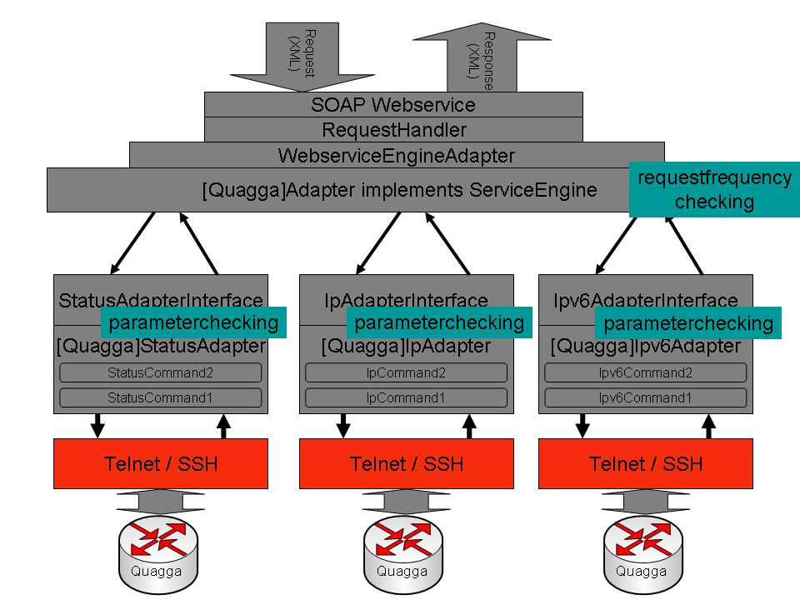
Figure 1: A graphical representation of the architecture of the SSH/Telnet MP

WebServiceEngineAdapter
The entry point for the Telnet/SSH MP Webservice is the WebserviceEngineAdapter, an extension of the RequestHandler which is already implemented in the perfSONAR project. The RequestHandler is responsible for the first processing and filtering of the incoming request messages. Based upon the subject of the request message arriving, the RequestHandler decides which underlying ServiceEngine is capable of answering the incoming request. The underlying ServiceEngine for the Telnet/SSH MP, as previously mentioned, is the WebserviceEngineAdapter. This means that all requests arriving at the RequestHandler, addressing Telnet/SSH MP functionality are forwarded by the RequestHandler to an instance of the WerserviceEngineAdapter. The WebserviceEngineAdapter is then responsible for handling the request and returning an answer back to the RequestHandler, which is then, in its turn, responsible for encapsulating it in a SOAP message and returning it to the original querying actor. It is here the token-bucket algorithm is implemented to limit the number of consecutive requests being processed.

[...]Adapter
Next is the Adapter, which is a class holding all business logic specific to a particular device. So, in the first implementation, there was an Adapter for a Quagga device and for a Cisco Router. At the moment, Juniper devices are supported, as well. More specifically, Telnet-based login to Quagga and Cisco, using username and password, is supported. More secure login on Juniper is provided, as well. Juniper access can be username/password-based and username/public-key-based. Thus, one of the key things for which the Adapter is responsible is the actual information for addressing and connecting to the underlying device.

[...]IP/IPv6/BGP/STATUSAdapter
The last level in the top-down breakdown of this architecture is the SubAdapter. This SubAdapter is responsible for a specific subset of queries supported. The current supported subsets are IP information, IPv6 information, BGP information, and Status information. There is a specific reason why these subsets are created; at the moment, it doesn't seem useful to so do (there is very little difference between the implementation of these Adapters for all subsets), but, if some compulsory functionality is required for a given subset of information, then this can be stated in the interface of each of the several SubAdapters. As explained in section ????, the current implementation leaves room for providing specific functionality of each individual Telnet/SSH MP. If some functionality is required by every implementation of a Telnet/SSH MP Webservice, this class can enforce such obligation. Inside the SubAdapter, there is a list of available Commands. These will be discussed in section ????.
The individual adapters are responsible for evaluating and approving the supplied parameters. This either can be through the application of regular expressions in the configuration file of the MP service, or by implementing the interface [org.perfsonar.service.measurementPoint.lookingGlassType.engine.commands.Parameter CheckerInterface] and naming the class: <name of the device>Checker.java.
- Eg: for JuniperGeantAmsterdam → JuniperGeantAmsterdamChecker.java
This class is then loaded at runtime during execution of the request. Depending on the answer of this checker class, the request will go to the router or not.

Command
The Command is merely a placeholder for all information necessary to fetch the configuration from the underlying device. The information concerned is:
- The corresponding EventType.
- The device specific command to be executed on the underlying device.
- A list of parameters.
- The result.
At the moment, the result is only a container with the cleaned-up output the device returns after executing the Command. If desired, functionality on the result could be provided, e.g. parsing of the output into some more meaningful classes.

Communication with the device
The actual communication with the device is, at the moment, provided by a java-package that is implementing the SSH/Telnet protocol. It uses standard Input/Output Streams to transmit commands to the device and to collect the output from the device. It also provides functionality for scripting, where one can specify a sequence of expected commands and results from the device.

Supported network devices
Below is a list of all supported network devices, together with the attributed communication protocol:
- Quagga (Telnet)
- Cisco (Telnet)
- Cisco (SSH)
  - Key based
  - Username / Password
- Juniper (Telnet)
- Juniper (SSH)
  - Key based
  - Username / Password

Provided features
Currently, one can query two GÉANT routers and several test setup routers, using a deployment of the SSH/Telnet MP in Ghent, Belgium, which can be contacted at: http://chaos169.test.atlantis.ugent.be:8080/axis/services/TelnetSSH.
The source code of the SSH/Telnet MP can be downloaded from the perfSONAR Wiki page (http://www.perfsonar.net). Installation and deployment instructions are also located on the download page.
JUnit style of testing is not included in the current snapshot of the MP, but will be provided in the near future.

Future extensions
Below is a list of the next action items:
- Rewrite the MP to address the feedback from the sessions in Cambridge.
- Integrate Lookup Service.
- Integrate Authentication and Authorization.
- Incorporate Push mechanism for automatic notification procedures.
- Include JUnit-style testing procedures.

Tracefile Capture MP (TCMP)
This section describes the passive measurement tool, the TCMP.

Overview
The Tracefile Capture MP is a perfSONAR-compatible wrapper around Monitoring API (MAPI), developed at Uninet in the SCAMPI and LOBSTER projects. TCMP receives requests to trigger packet capturing using MAPI, which is then called for actual capturing. Packets may be captured on any hardware supported by MAPI. Currently, all NIC cards using libpcap, DAG cards (http://www.endace.com/products.htm), and COMBO6 cards (http://www.liberouter.org/card_combo6.php, http://www.ist-scampi.org/) are supported as stated at Uninet’s MAPI page (http://mapi.uninett.no/). MAPI also supports remote capturing of packets through its DiMAPI extension, not yet fully implemented. The result of capture request is returned to the requesting client. TCMP allows a whole class of users (e.g. NRENs, NOCs, members), who have received proper authorization, to trigger packet capturing without facing the lengthy process of configuring access keys (SSH). They will make use of the general AAI infrastructure and the rights that have been predefined to them.

Specification
This section provides details on the input, output, and errors for the TCMP.

Input

TCMP accepts the following type of input messages:
- SetupDataRequest – without a key

SetupDataRequest – without a key
Once a request of this type is received, TCMP validates a request and then starts to capture packets until the end_time is reached. A request must contain the following parameters to provide more details for the packet capture operation:
- start_time – packet capture start timestamp (the unit is seconds since epoch 1970-01-01) [currently ignored because of a missing scheduler].
- end_time – packet capture end timestamp (the unit is seconds since epoch 1970-01-01).
- flow_h_filter – tcpdump (PCAP) compatible filter expression.
- flow_s_type and flow_s_thre – specify sampling parameters, where flow_s_type may be deterministic (or periodic) or probabilistic.
- flow_p_filter – packet payload filtering regular expression.
- characteristics and granularity – currently ignored (might be removed from future TCMP schema).
Example request:
<nmwg:message id="tcmpmsg1"
type="SetupDataRequest"
xmlns="http://ggf.org/ns/nmwg/base/2.0/"
xmlns:nmwg="http://ggf.org/ns/nmwg/base/2.0/"
xmlns:passivetracefile= "http://ggf.org/ns/nmwg/tools/passivetracefile/2.0/"
xmlns:nmwgt= "http://ggf.org/ns/nmwg/topology/2.0/"
xmlns:nmtm= "http://ggf.org/ns/nmwg/time/2.0/">

<nmwg:metadata id="passivetracefilemeta1">
<passivetracefile:subject id="passivetracefilesub1">
<nmwgt:endPoint type="hostname" value="sonar2.ljubljana.arnes.si" port="/dev/dag0" />
</passivetracefile:subject>

<passivetracefile:parameters id="passivetracefileparam1">
<nmwg:parameter name="flow_h_filter">tcp</nmwg:parameter>
<nmwg:parameter name="start_time">
<nmtm:start type="unix" value="1107492095"/>
</nmwg:parameter>
<nmwg:parameter name="end_time">
<nmtm:end type="unix" value="1150893383"/>
</nmwg:parameter>
</passivetracefile:parameters>

</nmwg:metadata>

<nmwg:data id="data1" metadataIdRef="passivetracefilemeta1">
<nmwg:commonTime type="unix" value="1107492095">
<passivetracefile:datum filename="firstEndPoint.raw" />
</nmwg:commonTime>
</nmwg:data>

</nmwg:message>

Output
TCMP responds with the following type of output messages:
- SetupDataResponse – without a key

SetupDataResponse – without a key
A message of this type is the response for a SetupDataRequest request. Response is similar to request, with the following differences:
- end_time – specifies when server stops capturing packets and the PCAP file will be ready for transfer.
- datum with filename attribute – specifies URL where PCAP file will be accessible, either via HTTP or HTTPS protocol, which is protected by Basic HTTP Authentication.
Example response:
<nmwg:message xmlns:nmwg="http://ggf.org/ns/nmwg/base/2.0/" id="tcmpmsg1_resp" messageIdRef="tcmpmsg1" type="SetupDataResponse">
<nmwg:metadata id="passivetracefilemeta1">
<passivetracefile:subject id="passivetracefilesub1">
<nmwgt:endPoint type="hostname" value="sonar2.ljubljana.arnes.si" port="/dev/dag0" />
</passivetracefile:subject>

<passivetracefile:parameters id="passivetracefileparam1">
<nmwg:parameter name="flow_h_filter">tcp</nmwg:parameter>
<nmwg:parameter name="start_time">
<nmtm:start type="unix" value="1107492095"/>
</nmwg:parameter>
<nmwg:parameter name="end_time">
<nmtm:end type="unix" value="1150893383"/>
</nmwg:parameter>
</passivetracefile:parameters>

</nmwg:metadata>
<nmwg:data id="data1_0" metadataIdRef="passivetracefilemeta1">
<nmwg:commonTime type="unix" value="1107492095">
<passivetracefile:datum xmlns:passivetracefile="http://ggf.org/ns/nmwg/tools/passivetracefile/2.0/" filename="http://sonar2.ljubljana.arnes.si:8080/axis/servlet/perfSONARFileServer?file=firstEndPoint.raw" />
</nmwg:commonTime>
</nmwg:data>
</nmwg:message>

Errors
Possible request errors can occur in if invalid endpoints, interfaces, or parameters are specified. In this case, an error message is returned, and no measurement is carried out. Any errors generated during the measurement are only written to log files on the server side. This is because a capture might be started, in the future, by the scheduler.

Implementation status
At this stage, the TCMP supports:
- Capturing data to PCAP files using MAPI (DiMAPI not fully supported yet).
- Accessing PCAP files over HTTP(S) protocol with predefined Basic HTTP Authentication (Username, Password).

Future extensions
The next steps in the implementation are:
- perfSONAR-compliant error passing.
- Scheduling mechanism.
- Support for Authentication (using AAI schema).
- Resource Protection (prevents unauthorized users from scheduling unlimited packet capturing).
- Lookup Service registration.
- Storing results in an MA for later retrieval.
- Support key requests/responses, thereby enabling simpler requests using a key, rather than a whole parameter set.
- Complete implementation of DiMAPI support, when DiMAPI is mature enough, is also planned.

ABW MP
This section describes the ABW passive bandwidth usage monitoring application.

Overview
The ABW application monitors how the used bandwidth on a network link is divided into different protocols of different layers corresponding to the OSI model, such as transport layer or application layer protocols. The ABW application uses the tracklib library, developed by FORTH as part of the LOBSTER project, to identify application protocols that use dynamic ports.
A commonly-used method to monitor bandwidth utilization of a network link is to read interface byte counters from routers by SNMP. This method is reliable, but it only provides total utilization; it does not provide any information about how the used bandwidth is divided into protocols. It is useful to know what protocols, and particularly what applications, are consuming the most bandwidth for traffic engineering, network planning, and, possibly, accounting.
Moreover, SNMP only can be used to compute bandwidth averages over several tens of seconds. The reason is that routers update their MIB with unpredictable delays of several seconds due to their task scheduling. Thus, we miss short peaks, which can affect throughput of user traffic added to the link. Stress-type achievable-throughput measurement tools, such as Iperf, measure different metrics (useful metrics, but different).
Features of the ABW MP include:
- Computes bandwidth used by different protocols in different layers, and shows percentage of IPv6 and multicast traffic.
- Indicates bandwidth usage in different timescales, including short samples (1 second averages) to detect short peaks.
- Does not affect user traffic in any way.
- Shows real bandwidth dynamics on a line (not after stressing elastic traffic by a throughput test).
- Allows frequent and continuous measurement.
- Computes bandwidth of user-defined flows (specified by header filtering, sampling, and payload searching).

Architecture
Application architecture is shown in Figure 2. The upper part runs on a central monitoring server and the lower part runs on remote monitoring stations distributed close to the monitored links.
In the upper part, the ABW application first reads configuration from a configuration file or from a command-line. This configuration describes what protocols on what remote monitoring stations should be monitored or what user-defined flows (e.g., specified by header filtering or payload searching) should be monitored. The application then creates a set of DiMAPI flows and applies a sequence of monitoring functions on them. DiMAPI is a distributed extension of MAPI, a Monitoring Application Interface, developed by the SCAMPI and LOBSTER projects for development of portable monitoring applications. The application is linked with a DiMAPI stub (or client) library. A flow is originally a sequence of all packets arriving to some monitoring adapter. Monitoring functions applied to a flow can do, for instance, header filtering, payload searching, counting number of packets and bytes, etc. Requests for these functions are passed to mapid daemons that run on remote monitoring stations.
In the lower part, mapicommd daemon provides network communication with the mapid daemon. A monitored link is tapped by an optical splitter or by a mirroring port configured on a router or switch. Packets come to a monitoring adapter, which can be a regular NIC or a specialized hardware monitoring card (e.g., DAG or COMBO). Packets then arrive at the mapid daemon, which implements monitoring functions. It automatically uses monitoring functionality in the hardware monitoring adapter, if such an adapter is used, or it implements monitoring functions in the software, if hardware support is not available. This process is transparent to applications, which can be moved among different monitoring adapters in a source or binary form.
Only results of monitoring functions, rather than whole packets, are passed back to the application, in most cases (except when the application requests packets themselves). Results are then stored in RRD files and presented on user requests in a web-based interface. This interface uses PHP scripts and pure HTML. Neither Java support nor any other applet or plugin are required to be available in user's web browser.
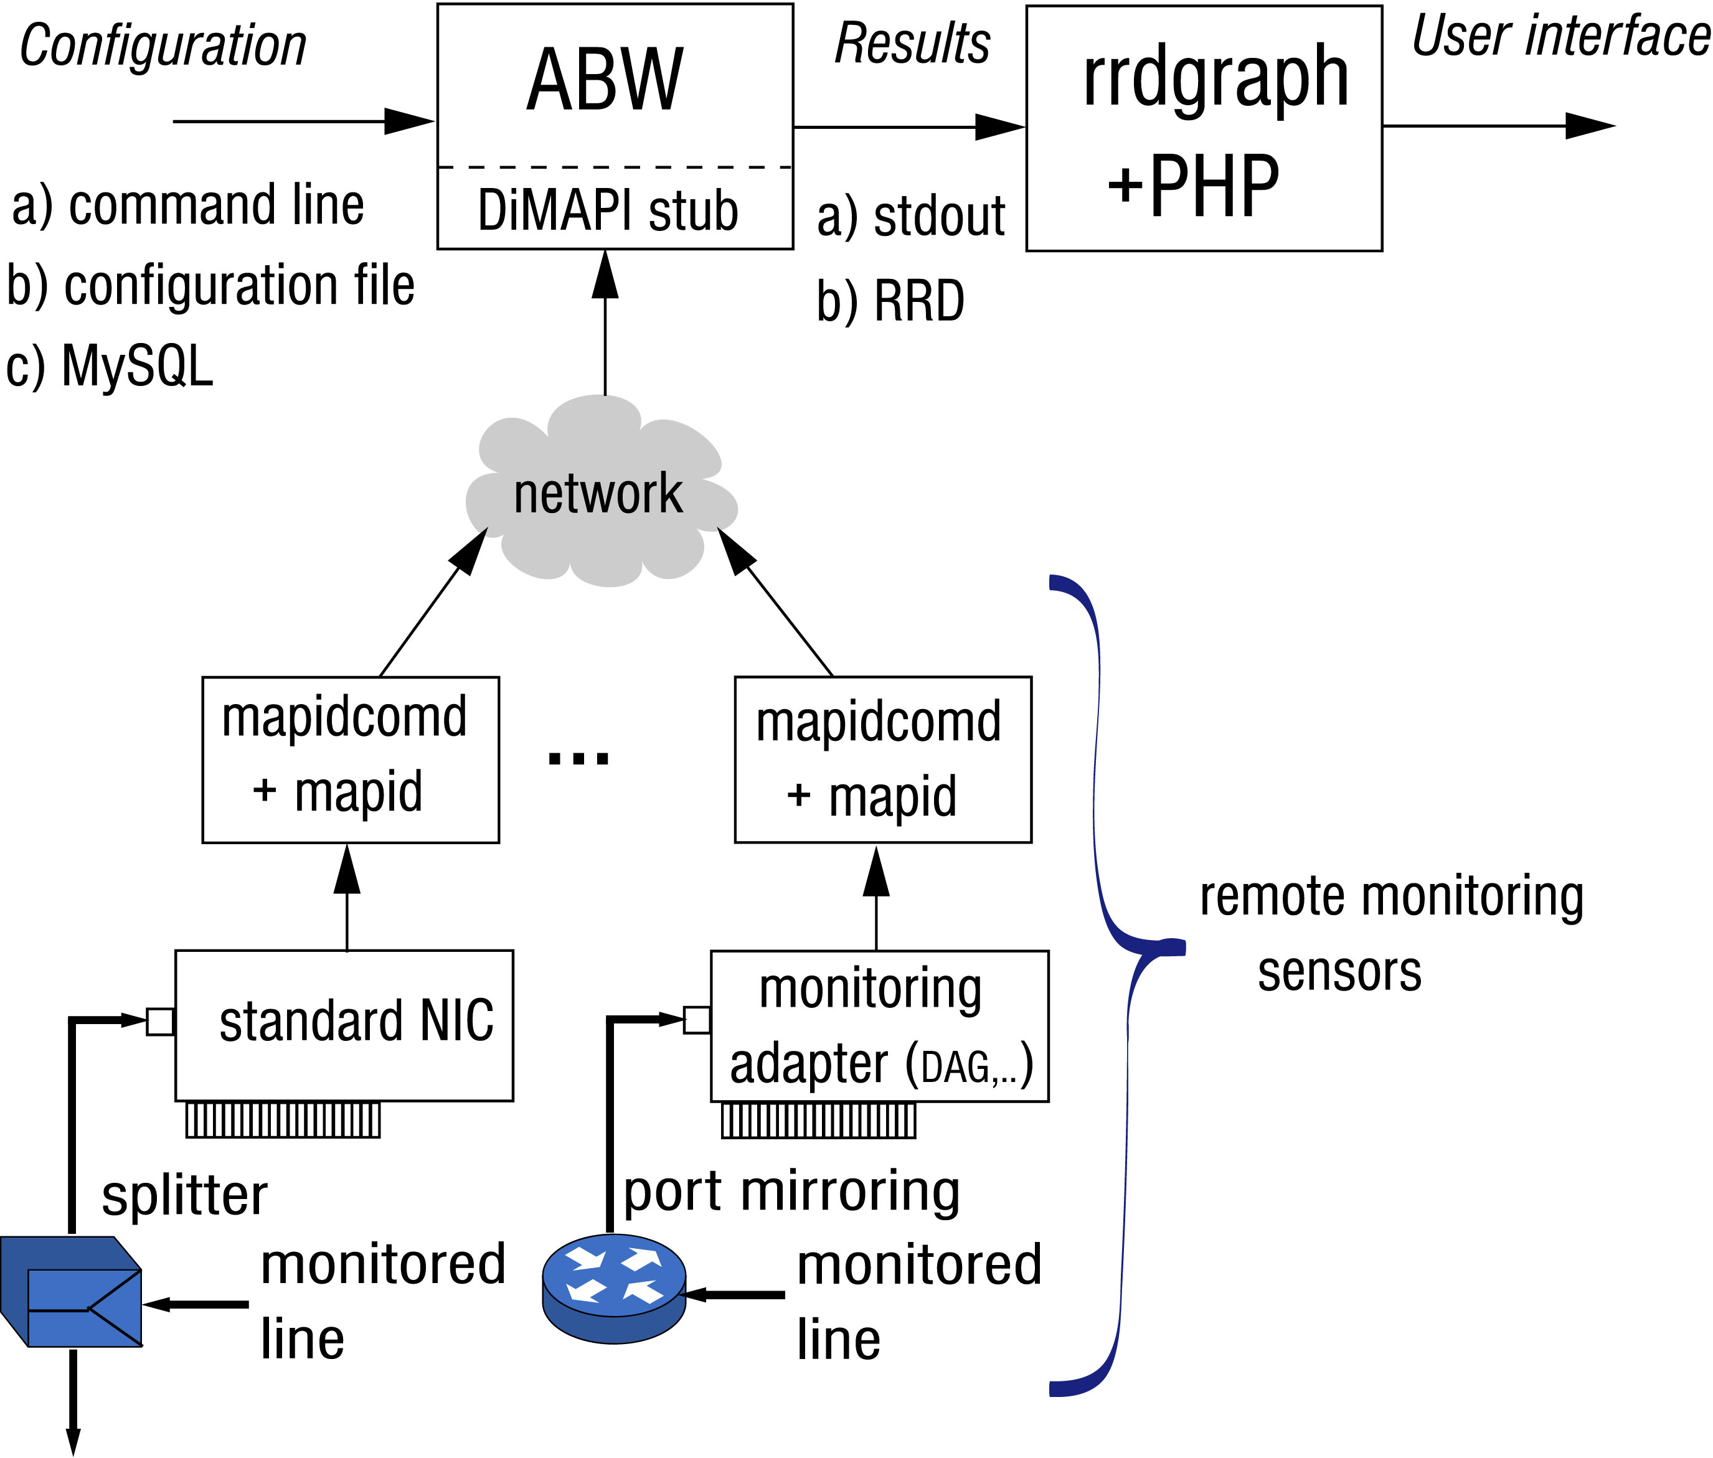

Figure 2: Architecture of ABW application

Interface to perfSONAR
After conducting experiments with an MP specifically designed for the ABW application (and developed in Python), we determined that the most convenient way to integrate the ABW application with perfSONAR is through round robin database (RRD) files.
Each monitored link and each protocol has its own RRD file. These files are stored on a central monitoring server, currently in the /usr/local/abw/rrd directory, and they have the following file name structure:
hostname-interface-port-parameters-protocol.rrd

where:
hostname is the full DNS hostname (including domain name) of a remote monitoring station
interface is the device name of a monitoring adapter, such as eth1
port is the number of a physical port on a multiport monitoring adapter
parameters is an index of a set of measurement parameters, such as user-defined flows
protocol is the name of a protocol being monitored, such as https (L4 protocol), bittorent (application protocol) or multicast (specific part of traffic)

An example filename can look as follows:
jra1-2.cesnet.cz-dev_dag0-0-1-gnutella.rrd
Each RRD file includes three data samples (DS): packets, bytes, and mbps. These filenames can be directly added to the RRD MA configuration and visualised individually in PerfsonarUI. However, for a more convenient visualisation, it would be desirable to group data from more RRD files together in one graph, such as all protocols of one layer, etc.

User interface
A web-based user interface for the ABW application is available; it groups convenient data together, as mentioned above. A snapshot of the main page is illustrated in Figure 3. A user can select protocol types (L4 or application), one or more remote monitoring stations and one or more time periods and granularities and have the graphs drawn by clicking on a button. The application currently runs on six remote monitoring stations in the CESNET network and five more monitoring stations are currently in installation.
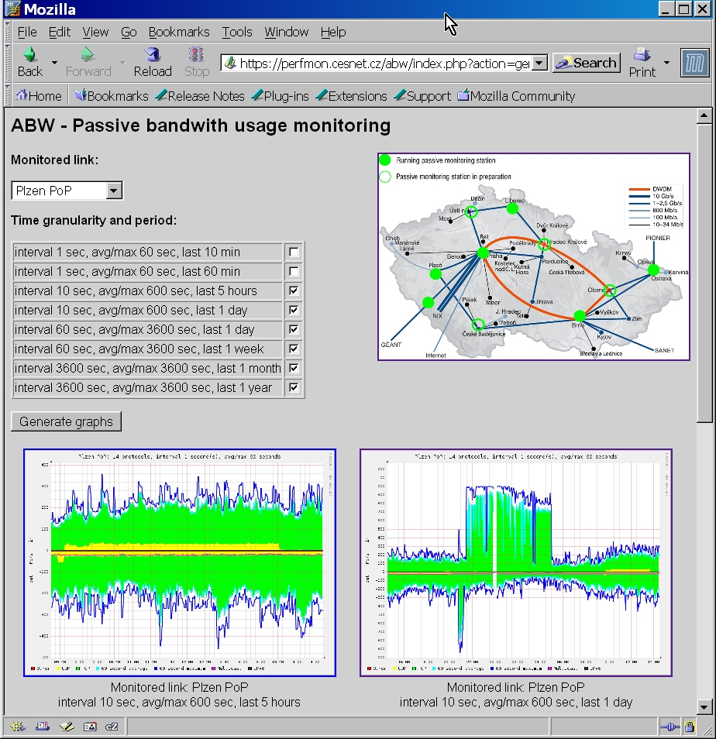

Figure 3: ABW user interface
Figure 4 illustrates monitoring of L4 (transport layer) protocols in a short timescale. TCP in green color dominates the used bandwidth. UDP in yellow color was mostly multicast, as shown by the red multicast curve. The graph shows one-second averages and 60-second averages (in light blue) and maximums (in dark blue). The one-second averages reveal short peaks in used bandwidth, which are much higher than longer-term averages and which would influence throughput of any traffic to be added to this link. IPv6 presence on this monitored line was negligible.
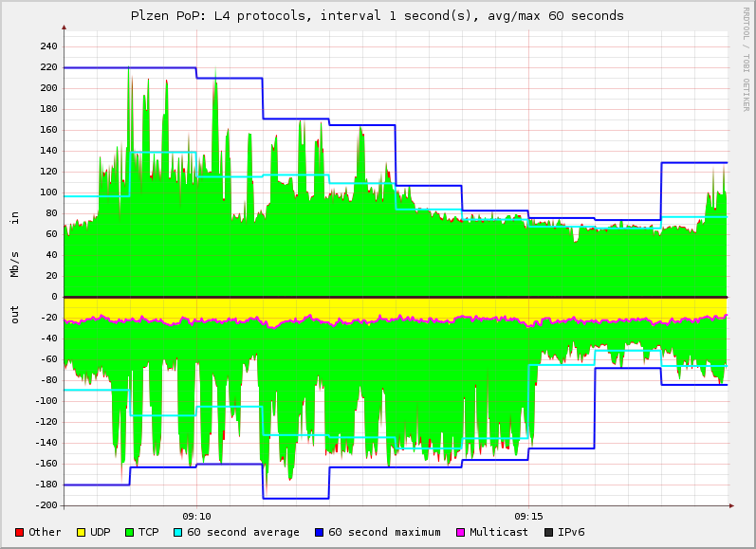
Figure 4: Monitoring of L4 protocols
Figure 5 shows distribution of used bandwidth among application protocols on one of the monitored link in the CESNET network. The graph shows that significant portion of used bandwidth was consumed by file sharing applications. The graph also indicates significantly different distribution of protocols in each direction of the same link.

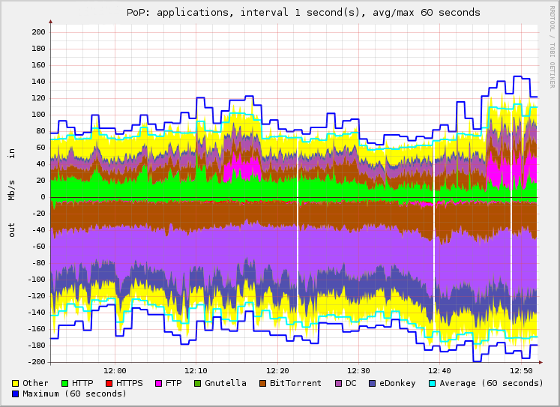
Figure 5: Monitoring of application protocols

Implementation status
The ABW application is available as a prototype. One must install MAPI and the ABW application itself. For convenience, we added the source code to the MAPI distribution. One can download MAPI including the ABW application (in applications/abw subdirectory) from SVN; see http://mapi.uninett.no for more information.
We call this a prototype because the application is not optimized for performance; the installation process muss be made smoother and it currently includes some bugs. Some features will need to be added:specifically, we plan to add support for Lookup Service and, possibly, Authentication and Authorization. Currently, web authentication is used for the latter.

SNMP MP
This section describes the status of the SNMP MP Service Implementation. The first subsection provides an overview of the SNMP MP, describing the purpose of this service and mentioning some of the scenarios in which this service can be used. The second subsection provides detailed information of the request and reply messages, architecture and internal workings of the service. The third subsection describes the current implementation status of the SNMP MP service. The last subsection charts out the future work and possible extensions to the SNMP MP service.

Overview
The SNMP Measurement Point Service aims to provide a Web Service based access to measurement data retrievable via the SNMP protocol (support for popular versions: v1, v2c, v3). The SNMP protocol provides many mechanisms with the help of which measurement data can be obtained (GET, WALK, TRAP, etc) and also network devices can be configured (SET). With the help of SNMP MP, we plan to extend many, if not all mechanisms to the Web Services based message exchange scheme.
The SNMP MP service aims to provide features such as
- On-demand measurements, where a measurement is made immediately following a request
- Scheduled measurements, where a measurement is scheduled to be carried out later
- Periodic measurements, where a measurement is made regularly (as configured)
As soon as the measurement is made, the idea is to make its results available to the user/client without the user/client having to constantly query the service.
Currently, this software is in beta-1 state and is available for testing. In this state, only SNMP Get mechanism is available and only On-demand measurements supported. It has been deployed by DANTE for GEANT2. It is also being investigated by RNP for integration with their NetraMet collector software.

Protocol specification
The SNMP MP currently supports two main types of messages: MetadataKeyRequest and SetupDataRequest
MetadataKeyRequest
The SNMP protocol relies on the presence of OIDs in all communications. If each complete OID provides some measurement data, this measurement data can be associated to certain metadata. For example, if the complete OID is .1.3.6.1.2.1.2.2.1.10, the SNMP Agent is router1.paris.geant2.net, the OID in this example points to an IP interface on the router which has an IP address say 62.40.96.90. The interface name could be so-1/0/0 and line rate ~10,000 Mbps (STM-64). All this information (IP address, router name, interface name, speed, etc) forms the metadata information for the data that can be retrieved using the OID.
This metadata information is important for users/clients as knowing the complete OID is not possible in all cases. Users/clients might be aware of a part of or the complete metadata information. Since SNMP requires at least the OID and the SNMP Agent address in order to retrieve data, a mapping between the metadata information and the OID needs to be maintained by the SNMP MP Service. This mapping helps the clients in
- Discovering the capabilities of SNMP MP Service
- Discovery of OIDs which are required to retrieve data
- Retrieval of keys which can be used to increase efficiency of both client and server when the client expects to make frequent requests for the same data
All the above can be achieved with the help of MetadataKeyRequest type of request. An example of this type of request is below.
<nmwg:message id="msg1"
type="MetadataKeyRequest"
xmlns:nmwg="http://ggf.org/ns/nmwg/base/2.0/"
xmlns:nmwgt="http://ggf.org/ns/nmwg/topology/2.0/" >

<nmwg:metadata id="meta1">
<nmwg:eventType>SNMP.get</nmwg:eventType>
<nmwg:subject id="subject1">
<nmwgt:interface>
<nmwgt:ipAddress type="IPv4">62.40.96.90</nmwgt:ipAddress>
</nmwgt:interface>
</nmwg:subject>
</nmwg:metadata>

<nmwg:data id="data1" metadataIdRef="meta1">
</nmwg:data>

</nmwg:message>

In the example shown above, the client knows the IPv4 address of a particular interface and is interested in knowing the capabilities of the SNMP MP service for this interface address. An example response from the service could be
<nmwg:message id="msg1"
type="MetadataKeyResponse"
xmlns:nmwg="http://ggf.org/ns/nmwg/base/2.0/"
xmlns:nmwgt="http://ggf.org/ns/nmwg/topology/2.0/" >

<nmwg:metadata id="meta1">
<nmwg:subject id="subject1">
<nmwgt:interface>
<nmwgt:ipAddress type="IPv4">62.40.96.90</nmwgt:ipAddress>
<nmwgt:hostName>fr.uk1.uk.geant.net</nmwgt:hostName>
<nmwgt:ifName>so-2/2/0</nmwgt:ifName>
</nmwgt:interface>
</nmwg:subject>

<nmwg:parameters id="param1">
<nmwg:parameter name="OIDAlias">ifInOctets</nmwg:parameter>
<nmwg:parameter name="SNMPAgentPort">161</nmwg:parameter>
<nmwg:parameter name="OIDString">
.iso.org.dod.internet.mgmt.mib-2.interfaces.ifTable.ifEntry.
ifInOctets
</nmwg:parameter>
<nmwg:parameter name="SNMPAgent">uk1.uk.geant.net</nmwg:parameter>
<nmwg:parameter name="SNMPVersion">2</nmwg:parameter>
</nmwg:parameters>
</nmwg:metadata>

<nmwg:data id="data1" metadataIdRef="meta1">
<nmwg:key id>
<nmwg:parameters>
<nmwg:parameter name="SNMPAgentPort">161</nmwg:parameter>
<nmwg:parameter name="OIDNumeric"> .1.3.6.1.2.1.2.2.1.10
</nmwg:parameter>
<nmwg:parameter name="SNMPAgent">uk1.uk.geant.net
</nmwg:parameter>
<nmwg:parameter name="ifIndex">42</nmwg:parameter>
</nmwg:parameters>
</nmwg:key>
</nmwg:data>

</nmwg:message>

In the response, if there are matches, the service provides the complete metadata description available and also a key (which should be treated as opaque). Data can be retrieved by simply using the key (explained in next request type). If there are no matches, the response from the service will specify that there are no matches.
SetupDataRequest
Any user/client wishing to retrieve data is required to make use of the SetupDataRequest message in order to get back a SetupDataResponse message which contains the data. A SetupDataRequest can be of two types:
- A request which contains a key
- A request which doesn’t contain a key
An example SetupDataRequest message containing a key, which was retrieved with the help of MetadataKeyRequest message earlier on, is in the example below.
<nmwg:message id="msg1"
type="SetupDataRequest"
xmlns:nmwg="http://ggf.org/ns/nmwg/base/2.0/"
xmlns:nmwgt="http://ggf.org/ns/nmwg/topology/2.0/" >

<nmwg:metadata id="meta1">
<nmwg:key>
<nmwg:parameters>
<nmwg:parameter name="OIDNumeric">
.1.3.6.1.2.1.2.2.1.10</nmwg:parameter>
<nmwg:parameter name="ifIndex">42</nmwg:parameter>
<nmwg:parameter name="SNMPAgent">
uk1.uk.geant.net</nmwg:parameter>
<nmwg:parameter name="SNMPAgentPort">161</nmwg:parameter>
</nmwg:parameters>
</nmwg:key>

<nmwg:eventType>SNMP.get</nmwg:eventType>

<!-- optional parameters -->
<nmwg:parameters id="param1">
<!--
<nmwg:parameter name="SNMPVersion">2</nmwg:parameter>
<nmwg:parameter name="SNMPCommunityName">password
</nmwg:parameter>
-->
</nmwg:parameters>

</nmwg:metadata>

<nmwg:data id="data1" metadataIdRef="meta1">
</nmwg:data>

</nmwg:message>

Response for the above message will contain the original request along with parameters indicating the assumed defaults but with the data section containing the actual data values as shown in the example below.
<nmwg:message
id="msg1"
type="SetupDataResponse"
xmlns:nmwg="http://ggf.org/ns/nmwg/base/2.0/"
xmlns:nmwgt="http://ggf.org/ns/nmwg/topology/2.0/" >

<nmwg:metadata id="meta1">

<nmwg:key>
<nmwg:parameters>
<nmwg:parameter name="OIDNumeric">
.1.3.6.1.2.1.2.2.1.10</nmwg:parameter>
<nmwg:parameter name="ifIndex">42</nmwg:parameter>
<nmwg:parameter name="SNMPAgent">
uk1.uk.geant.net</nmwg:parameter>
<nmwg:parameter name="SNMPAgentPort">161</nmwg:parameter>
</nmwg:parameters>
</nmwg:key>

<nmwg:eventType>SNMP.get</nmwg:eventType>

<nmwg:parameters id="param1">
<!-- client will be informed about the assumed defaults -->
<nmwg:parameter name="SNMPVersion">2</nmwg:parameter>
<nmwg:parameter name="SNMPCommunityName">****</nmwg:parameter>
</nmwg:parameters>

</nmwg:metadata>

<nmwg:data id="data1" metadataIdRef="meta1">
<nmwg:datum timeType="unix"
timeValue="1146663206"
value="3081751226"
valueUnits="octets per second" />
</nmwg:data>

</nmwg:message>

A SetupDataRequest without keys is very similar to a MetadataKeyRequest message. However, the main difference currently is that such a type of SetupDataRequest will trigger the Service to match the contents of the request against the XML mapping that it has maintained. If there is more than one match available, it will currently take the first match and retrieve data for that match. Hence, it is currently important that if data is being retrieved without using a key, accurate metadata information should be provided in the request. An example request of this kind is shown below.
<nmwg:message id="msg1"
type="SetupDataRequest"
xmlns:nmwg="http://ggf.org/ns/nmwg/base/2.0/"
xmlns:nmwgt="http://ggf.org/ns/nmwg/topology/2.0/" >

<nmwg:metadata id="meta1">
<nmwg:eventType>SNMP.get</nmwg:eventType>
<nmwg:subject id="subject1">
<nmwgt:interface>
<nmwgt:ipAddress type="IPv4">62.40.96.90</nmwgt:ipAddress>
</nmwgt:interface>
</nmwg:subject>
</nmwg:metadata>

<nmwg:parameters id="param1">
<nmwg:parameter name="OIDAlias">ifInOctets</nmwg:parameter>
</nmwg:parameters>

<nmwg:data id="data1" metadataIdRef="meta1">
</nmwg:data>

</nmwg:message>

The SetupDataResponse message to the above request would contain complete metadata information which matched with the metadata provided in the request. Any default values assumed are provided back in the response as well. A key is also provided in the response with the hope that the user would use it in future requests. An example of such a response is below.
<nmwg:message id="msg1"
type="SetupDataResponse"
xmlns:nmwg="http://ggf.org/ns/nmwg/base/2.0/"
xmlns:nmwgt="http://ggf.org/ns/nmwg/topology/2.0/" >

<nmwg:metadata id="meta1">
<nmwg:subject id="subject1">
<nmwgt:interface>
<nmwgt:hostName>fr.uk1.uk.geant.net</nmwgt:hostName>
<nmwgt:ipAddress type="IPv4">62.40.96.90</nmwgt:ipAddress>
<nmwgt:ifName>so-2/2/0</nmwgt:ifName>
</nmwgt:interface>
</nmwg:subject>

<nmwg:eventType>SNMP.get</nmwg:eventType>

<nmwg:parameters id="param1">
<nmwg:parameter name="OIDString">
.iso.org.dod.internet.mgmt.mib-2.interfaces.
ifTable.ifEntry.ifInOctets
</nmwg:parameter>
<nmwg:parameter name="OIDAlias">ifInOctets</nmwg:parameter>
<nmwg:parameter name="SNMPVersion">2</nmwg:parameter>
<nmwg:parameter name="SNMPAgent">uk1.uk.geant.net</nmwg:parameter>
<nmwg:parameter name="SNMPAgentPort">161</nmwg:parameter>
</nmwg:parameters>

<nmwg:key>
<nmwg:parameters>
<nmwg:parameter name="OIDNumeric">
.1.3.6.1.2.1.2.2.1.10</nmwg:parameter>
<nmwg:parameter name="ifIndex">42</nmwg:parameter>
<nmwg:parameter name="SNMPAgent">
uk1.uk.geant.net</nmwg:parameter>
<nmwg:parameter name="SNMPAgentPort">161</nmwg:parameter>
</nmwg:parameters>
</nmwg:key>
</nmwg:metadata>

<nmwg:data id="data1" metadataIdRef="meta1">
<nmwg:datum timeType="unix" timeValue="1146663206"
value="3081751226" valueUnits="octets per second" />
</nmwg:data>

</nmwg:message>

The main difference between a response for a SetupDataRequest containing a key and a response for a SetupDataRequest not containing a key is that complete metadata is provided back in the response when no key was provided in the request.

Detail design
The SNMP Measurement Point Service design consists of two parts: the perfSONAR Base components and the components specific to the SNMP MP Service. In order to explain the design of this MP in good detail, two UML Sequence diagrams will be used to introduce the different components of the service and how they fit together.
Figure 1 shows a sequence diagram which is applicable when the service is satisfying a MetadataKeyRequest
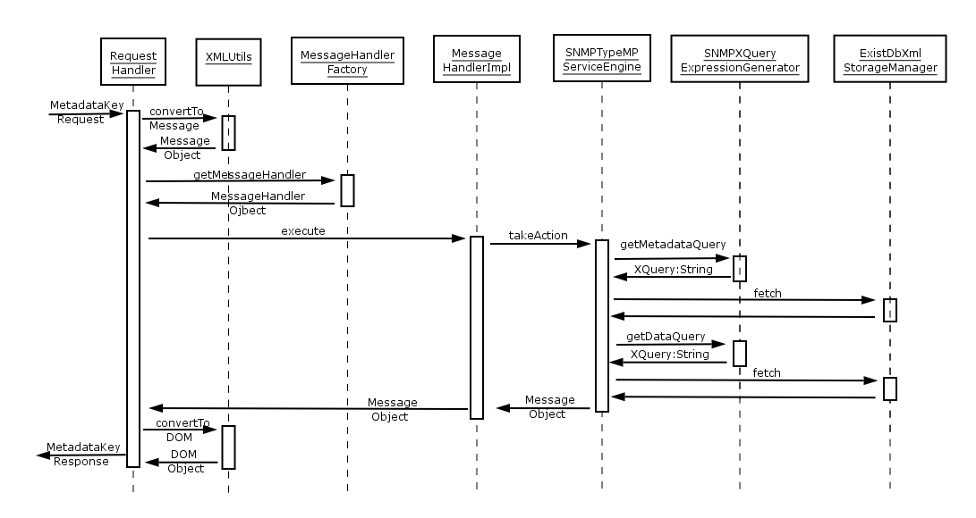
Fig. 1: Sequence diagram illustrating MetadataKeyRequest
- In the above diagram, the interactions between different components can be explained starting from the RequestHandler which gets an XML Document object extracted out of the SOAP messages which are used for Web Services.
- This XML Document is a org.w3c.DOM document which is parsed in order to create a org.ggf.nmwg.Message object, which is the main data container (or bean) for the perfSONAR services
- The Request Handler calls on MessageHandlerFactory to create and return MessageHandler object which can handle the given Message. The MessageHandler is configured to use specific MessageHandler Implementations for particular message types.
- The RequestHandler calls on the MessageHandler object and passes the Message to it. The MessageHandler knows the ServiceEngine Implementation to be used for the service. It creates an object of this ServiceEngine implementation and passes on the Message.
- The ServiceEngine understands the request and takes appropriate action. In the case of MetadataKeyRequest, the action involves calling upon the xml database in order to find matching entries for the given request. XQuery expression is expected in order to find entries within the xml database.
- The ServiceEngine calls on SNMPXQueryExpressionGenerator object to provide an XQuery expression based on the given request. A String object containing the XQuery expression is returned. This will help in retrieving all the matching metadata entries present in the XML database.
- The ServiceEngine calls on the ExistDBXmlStorageManager which is capable of communicating with the XML content
- For each metadata entry match returned, the Service Engine with the help of SNMPXQueryExpressionGenerator, retrieves the linked data elements. These data elements contain the keys.
- The matched metadata elements and the linked data elements are returned to the RequestHandler via the MessageHandler as a MetadataKeyResponse message.
- The Message object is converted back to a org.w3c.DOM object before returning the response via SOAP to the client.
Figure 2 shows a sequence diagram which is applicable when the service is satisfying a SetupDataRequest. This request does not contain a key and hence the service needs to find out from the OID from its mapping/configuration as it did in MetadataKeyRequest.
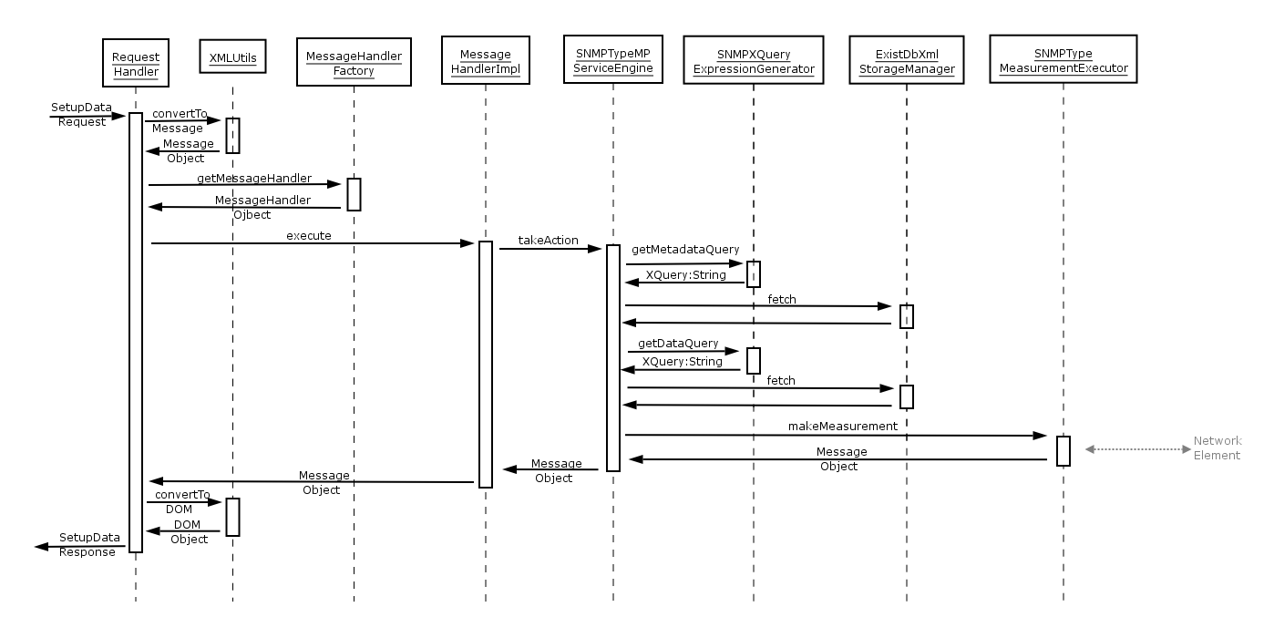
Fig. 2: Sequence diagram illustrating SetupDataRequest (without key in the request)

When a key is not provided in the SetupDataRequest message, the process as shown in figure 2 is similar to MetadataKeyRequest in its first half. Steps 1-8 mentioned in MetadataKeyRequest description can be applied to SetupDataRequest as well. Steps 9 onwards are described below.
- Currently, the SNMP MP is programmed to handle only one request at a time. If the request returns more than one metadata matches, only the first match is considered. Using this match (single chain of metadata and data element), SNMPTypeMeasurementExecutor object is created and the Message object containing the match provided to it.
- The SNMPTypeMeasurementExecutor currently uses Advent SNMP library [ADVENT snmp] to communicate with the Network elements. In order to use SNMP, the measurement executor needs to know the details of the SNMP protocol to be used such as type (GET, SET, WALK, etc), SNMP version, SNMP port and SNMP Agent addresses. It also needs to security related details such as Community name, etc. All of this information can be provided in the request. The client/user has to provide the type (in the eventType parameter). The key contains information such as Agent Address, port, etc. Other parameters are optional and if not provided in the request, default values configured into the service will be used.
- The measurement executor returns the response got back from the Network element to the service engine. It finally reaches the Request Handler via the Message Handler. The Request Handler converts the Message object into DOM before passing it back to the client/user as a SOAP message.

Figure 3 shows a sequence diagram which is applicable when the service is satisfying a SetupDataRequest. This request contains a key and hence the service does not do any query to its mapping/configuration to find out the OID.

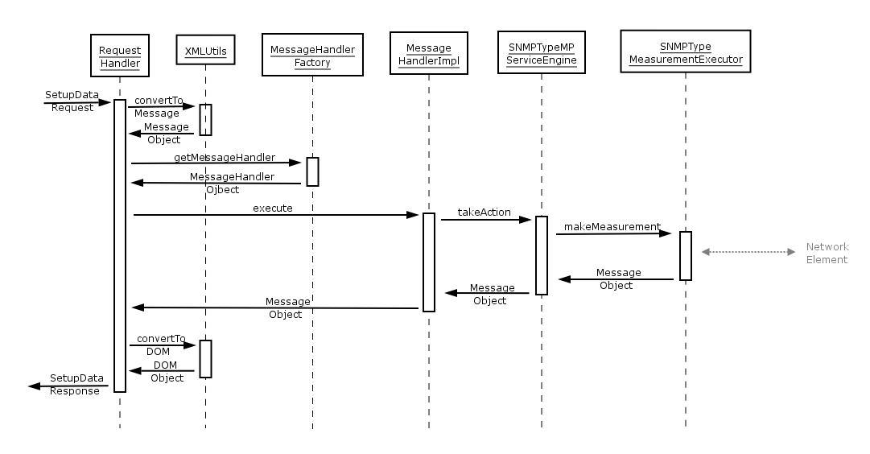
Fig. 3: Sequence diagram illustrating SetupDataRequest (with key in the request)

The above sequence diagram illustrates the process of satisfying a request for Data (SetupDataRequest) when a key in provided in the request. The contents of the key are opaque and as of now, the integrity and validity of the key is not checked. Steps 1-4 in this sequence are similar to the ones described in the MetadataKeyRequest sequence. Steps 5 onwards are discussed below.

- After being provided with the Message object containing the Request, the Service engine looks for the presence of a key. If there is one present, it simply passes the request onto the Measurement Executor or else, it tries to find a key with the help of XML Db Storage Manager as discussed earlier with the help of figure 2.
- The SNMP Type Measurement Executor checks the request to see if the SNMP type to be used (eventType parameter) is present in the request. For other parameters such as SNMP version, community name, etc., if the values are not provided in the request, configured defaults will be used. With the help of the Advent SNMP library, the Measurement Executor contacts the network element and returns data back to the Request Handler via the Service Engine and the Message Handler.

In all the above sequence illustrations, many components such as RequestHandler, MessageHandlerFactory, ServiceEngine, etc are used. Some of these components are for SNMP Type MP only while others are generic and can be used in many other services. Some others are SNMP Type MP only but based on specifications provided in the perfSONAR Base Components. For example, SNMPTypeMPServiceEngine is based on specifications provided in the ServiceEngine component definition.

Future Work
The SNMP Type MP Service has a lot of scope for improvement and addition of new features in the future. It is currently in Beta1 state where public testing is being sought. Some of the improvements and new features that we could think about are:
- Support for more types (eventTypes) such as SET, WALK, etc. Only GET is currently supported
- Handling large number of requests in the same request object (Bulk requests)
- Using Result codes
- Support for Scheduled measurements and periodic measurements
- Capability to PUSH results of Scheduled on periodic measurements
- Capability to handle traps and PUSH them to interested SUBSCRIBERS
- Capability to support more types of metadata (other than just interfaces on routers as it is currently) which allow SNMP MP to be used in more situations (other than just fetching values from counters on routers)
- Resource Protection

Services update
This section presents an overview of the various services that have been implemented, with details on the specification for the service, implementation status, and future extensions. Services in this section include: IPPM (Internet Protocol Performance Metrics) MA, BWCTL (Bandwidth Test Controller) MP, Ping MP, Lookup service, and RRD MA.

IPPM MA
This section continues the description of IPPM MA known as “Hades” framework from DJ1.3.1, Phase I - Implementation Report.

Overview
The Hades framework is a measurement system for active one-way delay measurements. Hades means Hades Active Delay Evaluation System. The Hades framework incorporates measurements on dedicated GÉANT2 measurement boxes, a central server collecting and storing the results, and the MA (MA) for the Hades data as a Perl-implemented perfSONAR interface.
Hades measurements are end-to-end measurements implemented by a sending and receiving host-pair. For one measurement, a parameter set has to be specified including e.g. packet size, sending interval. Results are stored in log files which are collected by the central server.
The log files are analyzed to retrieve the following information: One-Way-Delay (OWD), OWD-Variation (OWDV), Packet Loss (PL), duplicate packets, and Re-ordering. These data are accessible via the perfSONAR MA interface.
The detailed description of Hades is given in DJ1.3.1, Phase I - Implementation Report.

Specification
This section provides details on the input, output, and errors for the IPPM MA.

Input
The NMWG-compliant XML request described in DJ1.3.1 was expanded by two additional features. Because the amount of data for a whole day consists of approximately 800 kBytes, the XML-request must be able to reduce the number of result lines; this was achieved by introducing the “sample” parameter. This parameter is an integer number defining a modulo operation on the data set, returning only the n-th result line. Furthermore, the requester has the ability to define the metric for a customized metric request. For this purpose, the “metric” parameter was implemented to choose between OWD, OWDV, PL, and duplicate packets.
Example for requesting data:
<?xml version="1.0" encoding="UTF-8"?>

<nmwg:message type="SetupDataRequest"
id="datarq2-1"
xmlns="http://ggf.org/ns/nmwg/tools/org/perfsonar/1.0/"
xmlns:perfsonar="http://ggf.org/ns/nmwg/tools/org/perfsonar/1.0/"
xmlns:nmwg="http://ggf.org/ns/nmwg/base/2.0/"
xmlns:nmtm="http://ggf.org/ns/nmwg/time/2.0/"
xmlns:nmwgt="http://ggf.org/ns/nmwg/topology/2.0/">

<nmwg:metadata id="meta1">
<perfsonar:subject id="subj1">
<nmwgt:endPointPair>
<nmwgt:src type="IFname" value="Budapest_GEANT"/>
<nmwgt:dst type="IFname" value="Milano_GEANT"/>
</nmwgt:endPointPair>
</perfsonar:subject>
<nmwg:parameters>
<nmwg:parameter name="packetsize" value="41"/>
<nmwg:parameter name="precedence" value="0x0"/>
<nmwg:parameter name="sample" value="10"/>
<nmwg:parameter name="metric" value="owd"/>
</nmwg:parameters>
<nmwg:eventType>ippm_aggregated</nmwg:eventType>
</nmwg:metadata>

<nmwg:metadata id="meta2">
<perfsonar:subject id="subj2" metadataIdRef="meta1"/>
<nmwg:eventType>select</nmwg:eventType>
<nmwg:parameters id="param2">
<nmwg:parameter name="startTime">1138025449</nmwg:parameter>
<nmwg:parameter name="endTime">1138026469</nmwg:parameter>
</nmwg:parameters>
</nmwg:metadata>

<!-- triggers to indicate head of chains -->
<nmwg:data id="1" metadataIdRef="meta2"/>

</nmwg:message>

The example shows a request of measurement data from Budapest_GEANT to Milano_GEANT in aggregated data format. The parameters “sample” is set to “10,” causing only every 10th line to be returned. The parameter “metric,” which is set to “OWD” in this example, returns only the delay data.

Output
The returned data for the example above looks as follows:
<nmwg:data id="1" metadataIdRef="meta2">
<nmwg:datum med_owd="0.0156180858612061" time="1138025462.94443" max_owd="0.0156478881835938" min_owd="0.0155370235443115"/>
<nmwg:datum med_owd="0.0155580043792725" time="1138025762.32408"
max_owd="0.0156388282775879" min_owd="0.0155279636383057"/>
<nmwg:datum med_owd="0.015606164932251" time="1138026062.7157"
max_owd="0.0156340599060059" min_owd="0.0155758857727051"/>
<nmwg:datum med_owd="0.0155661106109619" time="1138026363.09533"
max_owd="0.0156490802764893" min_owd="0.0155379772186279"/>
</nmwg:data>

Each line represents the requested data set containing the OWD data (minimum, maximum, and median) and the sending timestamp. As the sending interval of this measurement is 30 s and the “sample” parameter was set to “10”, the time-gap between two data sets is 300 s.
In case of errors (no data, incomplete data, etc.), return codes are generated. The structure of these error codes are compliant to a standard defined at t he last developers meeting in Ann Arbor, May 2006.

Implementation status
The Hades service runs as daemon process, providing the data from measurements taken in the GÉANT2 network at gandalf.rrze.uni-erlangen.de on port 8090. These measurements can be accessed conveniently by e.g. the perfSONAR UI. For testing purposes a client application is provided which is compliant with all perfSONAR services.
The modular design provided by Perl modules described in the DJ.1.3.1, is further developed to enhance the service. This provides a mechanism to plug in modules for different data types at run time. Using this design the service can handle requests for different archives in the same running instance. For example, RIPE data can be served also with Hades and other IPPM data.
As corresponding perfSONAR MP for on-demand Hades measurements, the OWAMP MP exists as a prototype. The OWAMP test protocol implements IPPM measurements, similar to Hades measurements. With the perfSONAR OWAMP MP, it is possible to use the owping command-line tool to schedule on-demand tests in addition to regularly scheduled Hades measurements.
To simplify recurring requests with a fixed set of parameters, the perfSONAR concept of key requests is now realised.

Deployment Status
All measurement boxes are assembled and installed at DFN in Erlangen. The installation consists of the DFN-IPPM measurement system and the BWCTL/Iperf implementation of Internet2.

Currently, regularly-scheduled Hades measurements are running at the following JRA1 and SA3 locations.

City | Network | Country
Ljubljana | ARNES | Slovenia
Prague | CESNET | Czech Republic
Lisbon | FCCN | Portugal
Athens | GRNET | Greece
Sofia | ISTF | Bulgaria
Amsterdam | SURFNet | The Netherlands
Tromsoe | UNINET | Norway
Zagreb | CARNET | Croatia
Budapest | Hungarnet | Hungary
Gent | Belnet | Belgium
Thessaloniki | GRNET | Greece
London | GÉANT2 | United Kingdom
Milan | GÉANT2 | Italy
Amsterdam | GÉANT2 | The Netherlands
Geneva | GÉANT2 | Switzerland
Budapest | GÉANT2 | Hungary
Poznan | GÉANT2 | Poland
Frankfurt | GÉANT2 | Germany
Paris | GÉANT2 | France
Petach Tikve | GÉANT2 | Israel
New York City | GÉANT2 | USA

Beyond the running boxes, some more locations will follow shortly:
City | Network | Country
Stockholm | NORDUNet | Sweden
London | UKERNA | United Kingdom
Ann Arbor | Internet2 | USA
Bologna | GARR | Italy
Athens | GÉANT | Greece

About 800 end-to-end Hades measurements with varying parameters are running between the locations listed above.

Future extensions
The storing format of the Hades data will change, from text files to a fast database backend for the MA. This has the advantage of providing a fast and efficient search mechanism and a much more efficient data storing mechanism than storing data in files.
In addition, an authentication mechanism, lookup service registration, and resource protection will be implemented.

BWCTL MP

Overview
This section describes the progress of the development of the BWCTL MP. In addition to an overview of the MP, this section details the specifications, implementation status, and future extensions of this service.
The basic functionality of the service has been already described in DJ1.3.1. In this section, the development of the BWCTL MP since then is given. New features have been added to the BWCTL MP. In detail, an authentication mechanism was integrated, leading to two new parameters “login” and “password”, ToS bits can be set and result codes were added. In addition, a web based PHP user interface for on demand BWCTL testing was developed and exists in a prototype version.

Specification
Only the extensions made since the last deliverable are mentioned here.

Input
New input parameters have been added to BWCTL MP:
- ToS: integer or hex value or bit pattern describing the Type of Service in the IP header, default: 0x0, corresponds to option –S in BWCTL.
- Login and password: BWCTL measurements can cause high loads in networks. Therefore, a limitation of the tests is indispensable. For the MP, the built-in BWCTL authentication mechanism is used. The user has to authenticate against a key file existing on the MP. The MP administrator is able to limit the parameters users can set for measurements.

Output
Similar to Hades, result codes for error messages are returned; see the following example:
<nmwg:metadata id="return">
<nmwg:subject id="subjreturn" metadataIdRef="meta1"/>
<nmwg:eventType>failure.mp.bwctl</nmwg:eventType>
</nmwg:metadata>

<nmwg:data id="data_return" metadataIdRef="return">
<nmwg:datum>BWCTL Error: bwctl: _BWLWriteStartSession: called in wrong
state. bwctl: BWLStartSessions: Failed
</nmwg:datum>
</nmwg:data>
</nmwg:message>

Implementation status
The modular design of the BWCTL MP was improved as described for Hades. Installation process was simplified and is available as release v0.1 and can be installed and tested on every time synchronized host with a Perl environment.

Deployment status
For JRA1, the boxes in Sofia, Ljubljana, and Prague have the BWCTL MP running. Further boxes will follow.

BWCTL web client
A PHP-based web client was developed for on-demand BWCTL testing. To start a BWCTL test, a sender and receiver host and optional parameters must be set. Normally, a login to one of the test hosts and typing the BWCTL commands on a UNIX shell is required. Using the web client for the perfSONAR BWCTL interface on the test boxes, makes this procedure unnecessary.
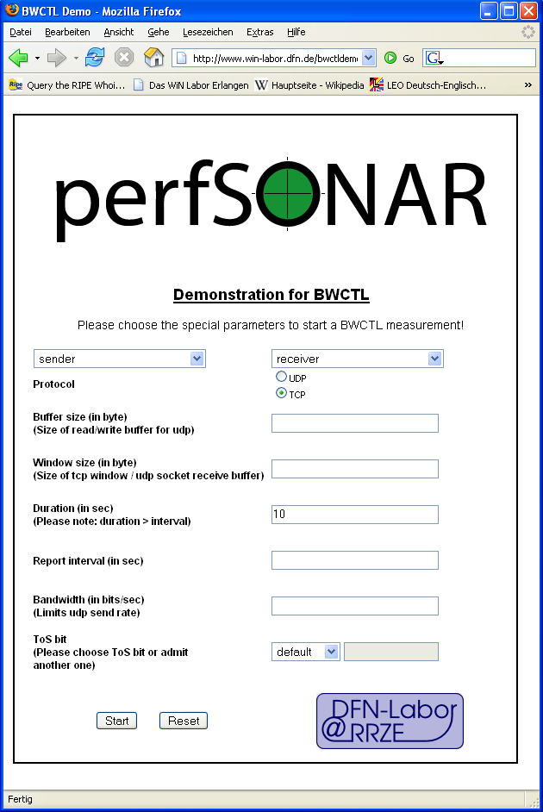
The web tool can be found and tested at: http://www.win-labor.dfn.de/bwctldemo/bwctl_demo.php.

Future extensions
The next step in the implementation is to integrate a scheduling mechanism. The current authentication method will be replaced by the perfSONAR Authentication and Authorization service. A Lookup Service registration will be implemented. The test results will be stored in an MA for later retrieval, and will be processed graphically with the Hades back-end visualisation.

Lookup Service
The Lookup Service was extended to enable result codes functionality and enhance RequestHandler, partly to work with chaining in messages. It was also enhanced to work with the latest available version of XML database eXist. Next steps would be to design and implement a federated LS, add authentication functionality (when available), and client API.

RRD MA
A Measurement Archive using RRD format was extended to enable Lookup Service and result code functionalities. It was also enhanced to work with the latest available version of XML database, eXist. Next steps would be to implement authentication functionality (when available) and resource management.

Services components

Push Interface

Overview
The PUSH Mechanism provides the following capability to different services such as Measurement Point Service, Transformation Service, etc

- Register and provide ‘keep-alive’s to services such as a Lookup Service

- Push data asynchronously to its clients
  - Data could be produced as a result of scheduled measurements that the client requested
  - Data could also be produced as a result of occurrence of an event to which the client has registered interest

A PUSH Mechanism is basically a Client-Server interaction wherein the service (such as a Measurement Point Service) assumes the role of a client, which is requesting for some produced data to be consumed. The actual client (visualization tool or a measurement archive service for example) assumes the role of a Server, which accepts requests, processes them and produces some results. The produced results could be a simple acknowledgement. In some cases, the PUSHing service (Measurement Point Service in this example) might not care for a response. In such cases, the service can totally ignore the content in the response.

The most basic requirement that a service needs to satisfy in order to be able to PUSH some data is to have a Store, which contains linked Metadata and Data elements. At least two metadata elements will need to be chained together (using the filter chain mechanism) and then linked to a data element. The last of the metadata filter chain should contain one or more Subscriber Handles (discussed later) to which the data should be pushed. An example of such a Store is below. This Store is usually the service configuration, which is used to satisfy capability information requests (MetadataKey Requests)

In some types of services (such as the ones which handle Alarms), implementations of EventListener and EventReaction Interfaces will need to be used. These are explained in more detail later on.

All services will then need to use a PushHandler class, which has the capability to ‘PUSH’ data onto multiple subscribers by reading the Subscriber Handles. The details of these interactions are provided later on as well.

As of now, we have plans with a good level of detail which will help us with implementation the implementation of the PUSH mechanism. The following sections describe these plans.

Specifications
This section describes the detailed design of components that will be required for integration of PUSH mechanism into new/existing services. The design is ‘Work In Progress’ and is expected to change based on experience and further investigations.

New classes
The perfSONAR base package will be expanded to include the following packages and their constituent classes. In the sections below, new classes being proposed are explained, some in more detail than the others depending on the level of complexity involved in each class.

Package org.perfsonar.service.commons.transformation

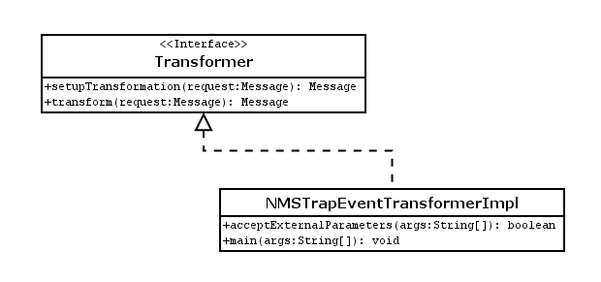
Fig.1: Class diagrams for Transformer Interface and an Implementation example

+ Interface Transformer

This is an interface defined to act as a template for all implementations which transform messages or data from one format to another.

Methods:

+ setupTransformation (request:Message): Message
This method is used to setup the Transformation service for a particular data transformation. This setup requires the following information to be maintained by the service.

- How to identify the data being sent for transformation?
- What to do with this data (i.e. what transformation functions to apply)?
- Whom to send the results to?

+ transform (request:Message): Message
This method is used to actually transform the data received and then push it onto configured list of clients. It uses the setup information previously stored and a list of known EventAction Implementations to actually perform the transformation. After transformation, the clients are notified with the help of WebServicePushEventActionImpl. A confirmation (or result codes) is given back as response.

+ Class NMSTrapEventTransformer implements Transformer

This class implements the Transformer interface but in fact is a different kind of transformer which has been grouped in this package because of identical functionality. It makes use of a main method to take in data in a non NM-WG v2 format and converts it into NM-WG v2 format with the help of ServiceEngineImpl.

Package org.perfsonar.service.commons.eventHandling

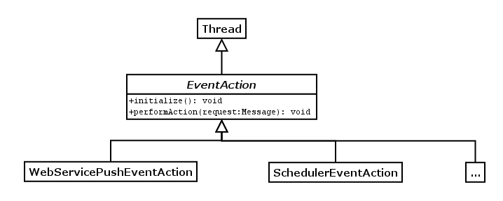

Fig.2: Class diagrams for EventAction Class and Implementation examples

+ Abstract Class EventAction extends Thread

This class acts as a template for other classes, which act as utility classes, performing very well defined set of actions. It supports multi-threading, which is essential in certain cases (such as Scheduler actions).

+ Class WebServicePushEventAction extends EventAction

This class is an eventAction class which can be called upon whenever any service component wants to push data to some clients via the Web Services (SOAP) mechanism. It makes use of a SubscriptionManagerImpl class in order to complete its task.

Package org.perfsonar.service.commons.subscription

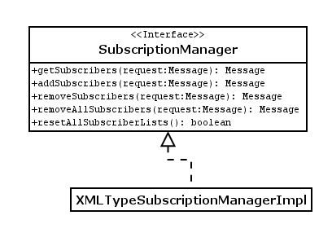
Fig.3: Class diagrams for SubscriptionManager and Implementation examples

+ Interface SubscriptionManager

This is an interface, which defines a template to be used by all implementations of SubscriptionManagement functionality. It supports the following methods.

Methods:

+ getSubscribers (Message):Message
This method should read the subscription information repository, find out the matches between the given Message and the content in the respository. If there are matches, it should return a Message object containing subscriber handles.

+ addSubscribers (Message):Message
This method should check the repository to see if there is an existing entry for the given message. If there is one, it should add the given subscribers to it. If not, it should create a new one and add the given subscribers.

+ removeSubscribers(Message): Message
This method should remove the given subscribers from a match found in repository using the given request message object.

+ removeAllSubscribers(Message): Message
This method should remove all subscribers entered in the list in the match found in the repository based on the given object.

+ resetAllSubscribers(Message): Message
This is an admin function, which should remove all the subscribers present in the repository.

+ Class XMLTypeSubscriptionManager implements SubscriptionManager

An implementation of SubscriptionManager, which uses XML database for managing Subscriptions and Xquery/Xpath for matching requests against the repository.

Package org.perfsonar.service.web
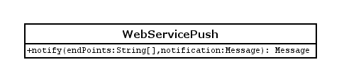
Fig.4: Class diagram for WebServicePush

+ Class WebServicePush

Alterations to existing classes
There is a lot of similarity between SchedulerAction Interface and EventAction Interface. Hence, the suggestion is to merge them both and use only EventAction interface and implementations from now on.

Use case Illustrations
The following sequence diagrams provide an illustration of how different components will be used together in various scenarios in order to push data. Push Mechanism implementation flavours are not limited to these scenarios only.

Scenario 1 (Client registering for event):

In this scenario, a client is interested in notifications provided by a service. However, a measurement is not made specifically to satisfy the client’s request. The service already has some data being produced. The client only expresses interest in a subset of this data. SNMP Traps act as good examples for this scenario.

The sequence diagram below explains how a request from the client is passed on to the Service Engine, which decides, based on the contents of the request, what needs to be done. One of the actions that the service engine can take is to add the client’s details to its Subscriber List which is managed using a SubscriptionManager.

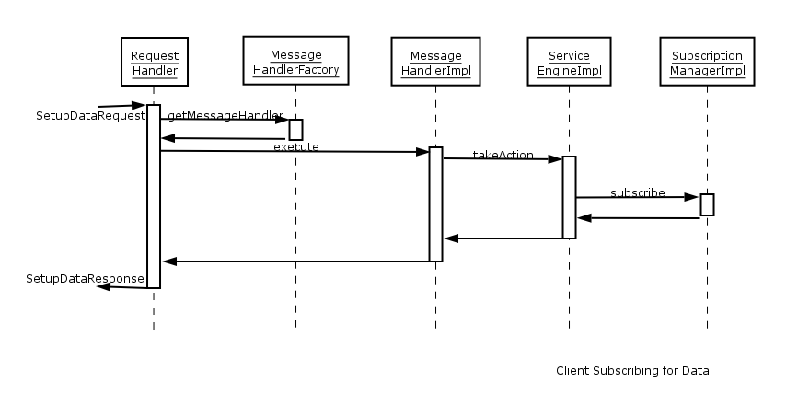
Fig.5: Sequence Diagram illustrating subscription for Event Notifications

The sequence diagram below explains how the client is notified of event occurrences. Events are being monitored by two entities:

- External entity such as a shell script which is in contact with network elements (via SNMP Traps for example)
- Stand-Alone component within the service which is contacted by the external entity using the main method. Data is passed using arguments to the main method.

Upon receiving a stimulus, the stand-alone component, which is an implementation of Transformer interface playing the role of this stand-alone component, transforms the information provided to it into NM-WG Message with the help of ServiceEngine (which has access to Metadata/Key pair repository). All event notifications coming to the TransformerImpl have some metadata information present in them (for example, a lightpath having gone down comes up with the lightpath id, status and time). This metadata information can be used to locate the complete Metadata, which is present in the service’s config file. The Metadata information along with the key and Data (which contains the new status information) together forms the Message.

This new Message also has an eventType element. The TransformerImpl is aware of what value to fill for the eventType element (based on the stimulus it received). The TransformerImpl can then make use of EventAction classes to perform different actions. One such action is the WebServiceEventActionImpl, which contacts the SubscriptionManager to retrieve a list of clients that it should push the notification to.

The SubscriptionManager has access to a registry (XML based for example), which maintains a list of Metadata elements (including obligatory eventType field and possibly a key) along with one or more Subscriber handles (in a linked Data element – one for each Metadata). It matches the contents of the Message object given to it against the entries in the registry to identify the subscriber handles that it should pass back.

The WebServicePushEventActionImpl then calls on the WebServicePush class to push data to each client using the subscriber handles stored by the SubscriptionManager

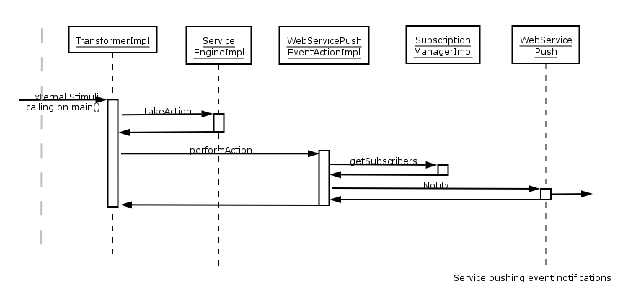
Fig.6: Sequence Diagram illustrating Notification of Events to clients by a Service

Scenario 2 (Client requesting periodic measurement push):

When a client requests for a periodic measurements, the service will need to do the following tasks:
- Identify if the service has the capability to satisfy the request – done by the ServiceEngineImpl via the config file
- Possibly, retrieve a key – again, done by the ServiceEngineImpl via the config file
- Pass the request onto the MeasurementExecutorImpl (including the key, if possible)
- MeasurementExecutorImpl would need to
  - Identify if resources are available (skipped this step in the diagram below)
  - Schedule the measurement – via the ScheduleStorageManager
  - Add the client to the Subscriber list – so that the results can be pushed to more than one clients if needed

The above tasks are described with the help of the following sequence diagram.

Note: In the following sequence diagram, the SubscriptionManagerImpl is contacted before the ScheduleStorageManagerImpl. We cannot cite strong reasons for advocating this sequence. The ScheduleStorageManagerImpl could be contacted first as well. We leave it up to individual implementations to decide how they want to do it.

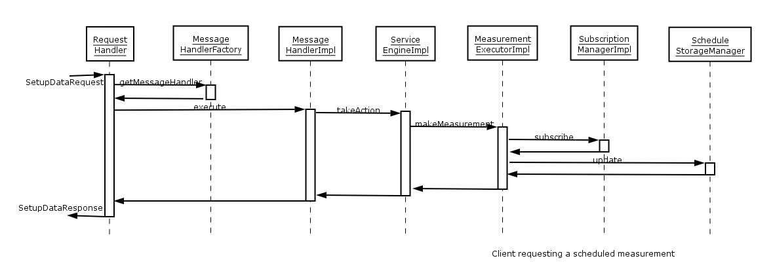
Fig.7: Sequence diagram illustrating a client requesting for a scheduled measurement and push the results

The next diagram explains how data generated by scheduled measurements can be pushed to one or more registered clients. The service will need to do the following in order to complete the task of pushing measurements:

- The scheduler wakes up, reads schedules and discovers that it has a schedule marked to make measurement. It calls on the associated ScheduledMeasurementEventActionImpl and passes on the parameters for the measurement

- The ScheduledMeasurementEventActionImpl does the following tasks
  - Contacts MeasurementExecutor and gets the measurement made and data returned
  - Contacts the ServiceEngineImpl (optional step) if it needs metadata information (because it might just have the key stored in the schedule)
  - Contacts the GenericPushEventActionImpl in order to push get the data pushed onto interested clients

- The GenericPushEventActionImpl contacts the SubscriptionManager and retrieves a list of clients that it should push to. It then calls on the WebServicePush class to push data to each client using the subscriber handles stored by the SubscriptionManager.

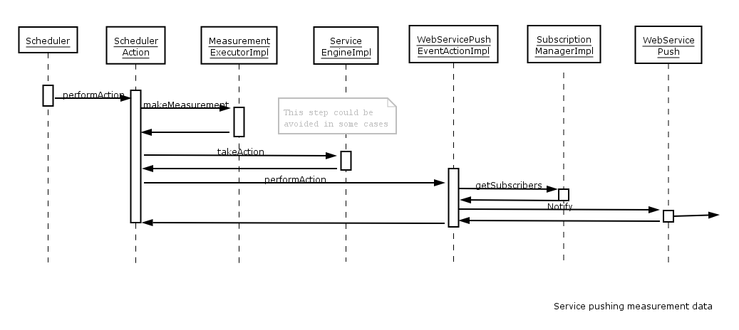
Fig.8: Sequence diagram illustrating the service pushing measurement data that was previously scheduled

Scenario 3 (Transformation Service):

The explanations provided for this scenario are first thoughts only and will need to be further improved later on.

Setting up the Transformation Service: The following diagram illustrates how a Transformation service can be setup to do transformations (when data is provided at a later point in time) and push data to one or more interested clients.

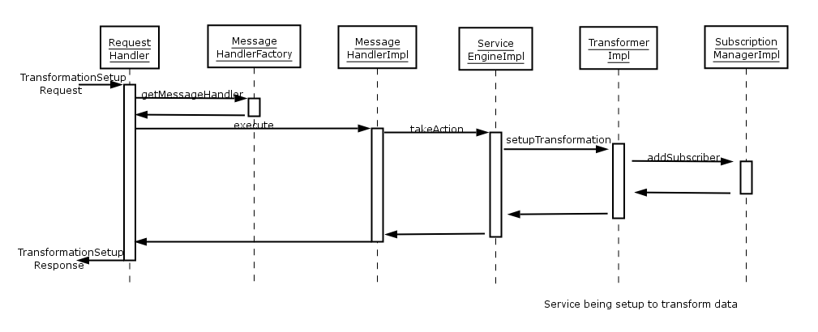

Fig.9: Sequence diagram illustrating a client setting up a Transformation Service session

Pushing data to be transformed: The following diagram illustrates how a Transformation service, which was previously setup, can transform data and push the results to multiple clients.
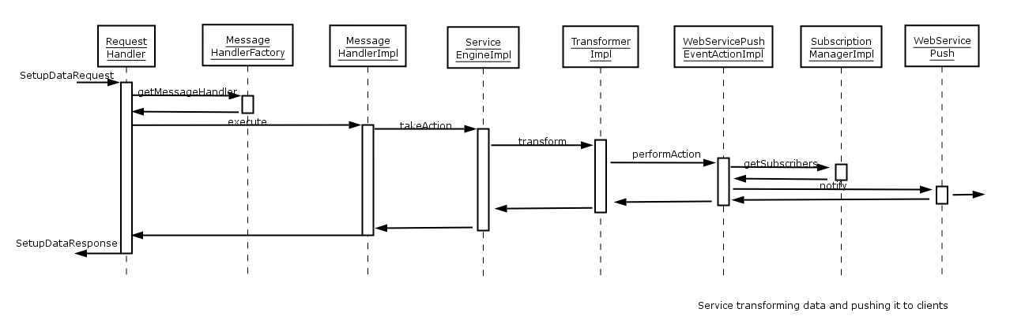

Fig.10: Sequence diagram illustrating how a previously setup Transformation Service is used to transform data

The following points are open questions for the above scenario. More thoughts and discussions are required for these.

- During the Setup process, the Transformation Service needs to maintain state information (in XML database for example) for the following
  - How to identify the data being sent for transformation
  - What to do with this data (i.e. what transformation functions to apply)?
  - Whom to send the results to

- What information should be passed on to the client after completing the transformations

Implementation status
As of now there is no implementation of the above mechanism. Implementation is expected to begin soon with first results available for trail by end of October.

Future extension

Web Service Notification Standards
Upon first inspection, it looks like WS-N standards define a standard XML structure to be used for managing subscriber and event information. Using this XML structure will mean having to either
- Don’t use NM-WG v2 structures for this area
- Try to fit NM-WG v2 structure within the specified XML structure
- Try to fit the specified XML structure within the NM-WG v2 structure

The above possibilities need further investigation.

Subscriber Handle
More thoughts are required for the content and structure of Subscriber Handles and also for the process of creation of a Subscriber Handle.

Result codes
This section describes result codes used for reporting service operations results.

Overview
Result codes are used within services to return to the requestor information about the result of requested operation e.g. lookup query or request for some data.
A result code is divided into two parts. One (metadata) contains the result code identifier and another (data), which is related to the first one, contains the result description. The result code identifier is a concatenation of:
- Result type – indicates major result type, e.g. error.
- Service type – indicates service which returns this code, e.g. ma.
- Service specific part – indicates specific type of action or service part where the code refers to, e.g. no_data. Service specific part may be composed of several parts separated by points.
Examples of result code identifiers are: success.ls.register or error.sqlma.db_connection.
The datum element inside a data block contains an additional description of the result useful to debug service work. It may be any string or characters (e.g. exception message, stack trace, detailed description of what happened and where, information on what was done wrong, and even a suggestion how a user can fix it).
Clients may parse result codes as far as possible. For example, some clients stop parsing errors after error.ls because they don't understand more detailed errors of LS (error.ls.register.foo.foo), but other clients will parse the whole result code and take proper action for it.
If an exception is thrown by the service, it is caught by the proper MessageHandler (for detailed description of service components see deliverable DJ1.2.2 [ref]), which may further split incoming message into a number of separate requests and serve them separately. If the proper MessageHandler cannot be found, the appropriate RequestHandler should return an error code. If everything is correct, the success result code must be put into the response message in ServiceEngine.

Hierarchy specification
To create result codes, their hierarchy was established. Below is a hierarchy specification example for Lookup Service and MA, presented as a list of used result codes for various components of the application.

perfSONAR base
- error.common.no_configuration – Service internal error: service cannot find configuration component and doesn't work properly
- error.common.no_logger – Service internal error: service cannot find logger component and doesn't work properly
- error.common.parse_error – Parsing error – something wrong with request message (not well-formed XML or not NMWG accordant)
- error.common.manager.no_configuration – Service internal error:wrong server configuration, service cannot finds internal components configuration
- error.common.manager.cant_create_component – Service internal error – wrong server configuration, service cannot create internal components (probably wrong class names)
- error.common.action_not_supported – Selected service Engine doesn't support such request type. Often occurs when trying to send for instance MA-request to non-MA service (e.g. LS)
- error.common.action_not_implemented – Action not implemented (some message types may be reserved for future use)
- error.common.storage.xmldb.open – XML DB Storage Manager – cannot open database (perhaps wrong collection/username/password)
- error.common.storage.xmldb.close XML DB Storage Manager – cannot close database (problems with database connection)
- error.common.storage.xmldb.wrong_query – XML DB Storage Manager - wrong query (not XQuery/XPath or wrong-formed expression)
- error.common.storage.xmldb.empty_query – XML DB Storage Manager – empty query (without content)
- error.common.storage.xmldb.query – XML DB Storage Manager – problems with query expression
- error.common.storage.xml_file.fetch – XML File Storage Manager – fetch error (wrong query, file not found, IO error)
- error.common.storage.xml_file.init – XML File Storage Manager – initialization error
- error.common.scheduler.init – Scheduler initialization error
- warning.common.no_metadata – Warning – no metadata in request/response

MA
- error.ma.writing – unable to write data in MA
- error.ma.fetching – unable to fetch data from MA
- error.ma.action – action type is not supported by MA (there are 3 types of action: get key, get data, store data)
- error.ma.query – srtucture of query to MA is wrong
- error.ma.metadata_configuration – component responsible for managing metadata encountered serious problem
- warning.ma.metadata_configuration – component responsible for managing metadata encounterd minor problem
- error.rrdma.rrd_file – unable to get data from rrd file
- error.rrdma.rrdjtool – problem with rrdjtool library
- error.sqlma.db_connection – unable to connect with a database
- error.sqlma.db_connection_ibatis – no iBatis configuration file name in the parameter list of request

Lookup Service registration component
- error.lsregistrator.no_service_description – Cannot find service.r.* properties (in service.properties file) which are responsible for creation registration metadata
- error.lsregistrator.no_service_content – Cannot find data elements (perhaps wrong XML information file)
- error.lsregistrator.no_ls_url – LS address is not provided
- error.lsregistrator.other – Any other exception, would be described in additional data description

Lookup Service
- error.ls.no_storage – XML DB Storage Manager is not loaded (check components.properties)
- error.ls.action_not_suported – LS action not supported
- error.ls.no_scheduler – No scheduler component (required for LSCleanup)
- error.ls.no_metadata – Metadata cannot be found in request message
- error.ls.no_key – No Key in request message (in deregistration, update, keepalive)
- error.ls.key_not_found – Key not found in the database. For instance when trying deregister not-registered data
- error.ls.no_querytype – No query type in query/lookup message
- error.ls.querytype_not_suported – Given query type is not supported
- error.ls.update.key_not_found – Key not found when trying to update data
- error.ls.no_data_trigger – No empty data element. For most of LS requests all parameters are passed by metadata, but empty data trigger with the reference to the metadata (<data metadataIdRef="xxx"/>) should be also added.
- error.ls.cant_replace_data – Old data can't be replaced by new one. No write rights to database for such user?
- success.ls.register – data registered correctly
- success.ls.deregister – data deregistered correctly
- success.ls.keepalive –

Examples
The following examples show messages content with result codes included:
- success.ls.remove – successful Lookup Service registration
<nmwg:metadata id="result-code1">
<nmwg:subject id="reference-to-metadata" metadataIdRef="metadata_X"/>
<nmwg:eventType>success.ls.register</nmwg:eventType>
</nmwg:metadata>

<nmwg:data id="result-code-description1" metadataIdRef="result-code1">
<nmwgr:datum>
Lookup info registered with key
http://stout.pc.cis.udel.edu:8080/services/RRDMA
has been removed!
</nmwgr:datum>
</nmwg:data>

or, without subject, if there is no metadata to refer to:
<nmwg:metadata id="result-code1">
<nmwg:eventType>success.ls.register</nmwg:eventType>
</nmwg:metadata>

<nmwg:data id="result-code-description1" metadataIdRef="result-code1">
<nmwgr:datum>
Lookup info registered with key
http://stout.pc.cis.udel.edu:8080/services/RRDMA
has been removed!
</nmwgr:datum>
</nmwg:data>

- error.sqlma.db_connection – service wasn’t able to fetch data from relational database
<nmwg:metadata id="resultCodeMetadata_0">
<nmwg:eventType>error.sqlma.db_connection</nmwg:eventType>
</nmwg:metadata>

<nmwg:data id="resultDescriptionData_for_resultCodeMetadata_0" metadataIdRef="resultCodeMetadata_0">
<nmwg:datum value="SQLStorageManager.fetch: Unable to fetch data: java.sql.SQLException: Access denied for user 'perfsonar_ma'@'localhost' (using password: YES)" />
</nmwg:data>

- warning.common.no_metadata - no output metadata was returned by MessageHandler
<nmwg:metadata id="resultCodeMetadata">
<nmwg:eventType>warning.common.no_metadata</nmwg:eventType>
</nmwg:metadata>

<nmwg:data id="resultDescriptionData_for_resultCodeMetadata" metadataIdRef="resultCodeMetadata">
<nmwg:datum value="No output metadata was returned by MessageHandler. Maybe there was no data trigger, or data trigger didn't have valid metadataIdRef? " />
</nmwg:data>

Visualization tools update

Introduction
The development of the visualisation tools concentrated on different aspects during the past months. The focus was on adding new features to perfSONARUI (see Section 3.2) and CNM (see Section 3.3), and the development of the Looking Glass Client, which is presented in detail in Section 3.4. Due to a lack of staff, the integration of Nemo did not make significant progress. VisualperfSONAR was not able to show geographical network paths due to the unavailability of data. Also, lacking staff, the tool does not access the MAs along a given path, yet.
As there is currently a set of visualisation tools under development, the aim was to avoid the duplication of work in the development (e.g. both perfSONARUI and VisualperfSONAR take a traceroute output as input), and to avoid confusion among the users about what tool to use for a certain purpose. Therefore, a profile of each tool was created that shows the relevant features of each tool for the perfSONAR user groups (end-users, project members, NOC/PERT staff, network managers). The profile of the tools is summarised in Table 1.
<<add table from paper>>
For end users, easy-to- use network maps are provided by Nemo and CNM, and a network path will be easily traceable by VisualperfSONAR. For project members, the CNM allows the customisation of maps. For troubleshooting, VisualperfSONAR and perfSONARUI are very useful to investigate the behaviour of a data transfer along a path. Nemo is also addressing this functionality by linking its network elements with test tools which is easily extensible. For network managers, the CNM will provide a dashboard to aggregate data within a network domain.
The work on this issue also has lead to the publication of a project paper.
(Reference: Andreas Hanemann, Vedrin Jeliazkov, Olav Kvittem, Luís Marta, Joe Metzger, Igor Velimirovic: “Complementary Visualization of perfSONAR Network Performance Measurements”, Proceedings of the International Conference on Internet Surveillance and Protection (ICISP), Cap Esterel, France, IARIA/IEEE, August, 2006)

PerfsonarUI
PerfsonarUI is designed and implemented as an open source, easy-to-use, and yet powerful standalone graphical user interface client, capable of querying a range of perfSONAR services deployed around the world (currently 15 RRD MAs and 1 IPPM MA).

Overview
Some of the main features of the current version (v0.08) of PerfsonarUI, released on 13 June 2006, are:
- a sample user interface (UI) application implemented in Java;
- retrieval of published data from RRD MA services;
- retrieval of published data from Hades MA services;
- ability to run queries to RRD MAs and Hades MAs simultaneously (in parallel threads);
- visualization of OWD, IPDV and packet loss between Hades (IPPM) MPs;
- compatible with all currently deployed RRD MA services, using either the "NMWG(v2) 2" or the older "perfsonar" XML schema;
- search for interfaces within a list of user-supplied IPv4 or IPv6 addresses;
- parsing of arbitrary IPv4 or IPv6 traceroute command output and visualization of summary/details for the matched interfaces;
- utilization summary for all selected interfaces in tabular and graphical form;
- visualization of utilization details for a chosen interface and a selected time period;
- interface selection through the interfaces table, the bar summary graph or the radar (spider) chart;
- time interval for summary selection through radio buttons;
- time interval for details selection through a slider;
- measurement identifier (mid), packet size, group size, interval, and precedence selection for Hades measurements;
- zoom-in (right-click & drag in SE direction) and zoom-out (right-click & drag in NW direction) in Hades measurement plots;
PerfsonarUI requires Java 2 Runtime Environment, Standard Edition 1.4 or newer on the target system and it is platform-independent. It runs under any host operating system that supports Java 2 Runtime Environment, Standard Edition. It uses the Apache Axis SOAP implementation to query perfSONAR services. The visualization is based on JFreeChart – an open source Java library for generating charts.

Description of the new functionalities and their usage
Since v0.07, released on 05 May 2006, PerfsonarUI is distributed with a fully-automated offline installer (PerfsonarUI-vX.YZ-setup.exe), compatible with recent versions of the Microsoft Windows (NT, 2000, XP, 2003) operating system, as well as a ZIP archive. Both distributions include the source code of the application, which is released under the GNU LGPLv2.1. Windows users should prefer the automatic installer, while the ZIP archive is suitable for any other platform.

Installation procedure
The application could be installed on Windows platforms by running the installer and following its instructions. It contains all the required packages, including the Java(TM) 2 Runtime Environment, Standard Edition 1.4 setup. Users of other platforms should unzip the PerfsonarUI-vX.YZ.zip archive and launch the application.
If the installer does not detect Java(TM) 2 Runtime Environment, Standard Edition 1.4 or newer on the target system, it will attempt to install it before proceeding with application’s setup. In this case, the user running the installer should have administrative privileges on the target system (otherwise the Java(TM) 2 Runtime Environment, Standard Edition setup would be aborted and PerfsonarUI would not be installed).
If the installer detects Java(TM) 2 Runtime Environment, Standard Edition 1.4 or newer already installed on the target system, it will proceed directly with application’s setup. In this case, administrative privileges are recommended but not necessarily required.
When the installer is launched by a user with administrative privileges, it will create PerfsonarUI start menu shortcuts for all the users registered in the target system. Otherwise, start menu shortcuts will be created only for the unprivileged user, who launched the installation.
After a successful installation, PerfsonarUI could be launched from the Start Menu (“Start -> All Programs -> PerfSONAR -> PerfsonarUI-vX.YZ -> PerfsonarUI-vX.YZ”).
Each version of PerfsonarUI could be uninstalled either by using the “Control Panel -> Add or Remove Programs” or by clicking the “Uninstall” link located in “Start -> All Programs -> PerfSONAR -> PerfsonarUI-vX.YZ -> Uninstall-PerfsonarUI-vX.YZ”. Any application files that may happen to be locked during the uninstall procedure would be deleted after the next reboot of the system. Java(TM) 2 Runtime Environment, Standard Edition would not be uninstalled by PerfsonarUI's uninstaller. If needed, it could be uninstalled via its own entry in “Control Panel -> Add or Remove Programs”.

Functionality
PerfsonarUI provides seamless access to network performance data across different domains through a flexible and universal user interface, integrating an easily extensible set of different performance metrics. The multi-domain scenario is natively supported, thanks to the fully distributed design and implementation of the interactions between the User Interface Layer and the Service Layer.
At present, PerfsonarUI is able to query one or several RRD and/or Hades (IPPM) MAs simultaneously (in parallel threads) and visualize the returned data. Users can apply filters (a list of IPv4/IPv6 interface addresses or arbitrary traceroute output) to search for a particular subset of interface utilization data. The visualization is done both in tabular and graphical form. A condensed summary of interface utilization is provided in a radar chart. Users can select different criteria for sorting the data. The tool provides a quick overview of the interface utilization vs. capacity in several user-selected domains simultaneously, as well as detailed views for any particular interface. Time intervals for summary and detailed views are selectable through radio buttons and sliders. Another important feature of PerfsonarUI is the ability to visualize one-way delay (OWD), IP Delay Variation (IPDV), and packet loss between Hades (IPPM) MPs. Graph zooming capabilities are built-in. Users can select source, destination, measurement identifier (mid), probe packet size, group size, interval, precedence, and date. Support for more options, as well as better error handling and reporting are planned for future releases.

Use cases
The primary target user groups for PerfsonarUI include NOC and PERT staff, as well as projects with demanding network performance requirements. End-users with some basic technical background also CAN master the tool quite easily.
In the following subsections, we present two typical usage scenarios. In both cases, a higher level of integration between different performance metrics reporting is achieved, while multi-domain lookups are also supported by design.

Path load visualization
One possible scenario for PerfsonarUI usage is searching for interface utilization data at successive traceroute hops in a multi-domain environment and subsequent visualization of summary and detailed statistics for the matched interfaces. Data is gathered by 15 perfSONAR MAs (MAs), deployed by GÉANT, CARNet, CESNET, GRNET, ISTF, MREN, PIONIER, SEEREN, SWITCH, UNINETT, ESnet, Internet2, and RNP. Summaries for a user-defined time interval are presented both in the radar (spider web) and bar chart graphs, while detailed ingress/egress utilization statistics are available at the bottom of the tab. Interfaces can be sorted by different parameters and detailed statistics are directly accessible by selection in the table, radar, or bar charts. In addition, the concept of path load visualization is introduced.

OWD, IPDV, and packet loss visualization
Another possible scenario is looking for OWD, IP delay variation, and/or packet loss over a given circuit, possibly between different administrative domains. Data is gathered by the Hades (IPPM) framework, designed by the Regional Computing Centre of Erlangen, Germany, and deployed at several dozen locations across Europe and the USA.
PerfsonarUI interacts with the Hades (IPPM) infrastructure via a perfSONAR Hades (IPPM) MA service, deployed at DFN-Erlangen. OWD, IPDV, packet loss, and duplicate packets for a selected source/destination pair and date are plotted on three aligned graphs for easier comparison. The graphs have built-in zooming capabilities, accessible through right click and drag in SE (zoom-in) or NW (zoom-out) directions on the graphs.
By default, PerfsonarUI retrieves Hades measurements with a measurement identifier (mid) “0” for the current day. Users can optionally select a different measurement identifier, probe packet size, group size, interval, and/or precedence. In cases when there is no data for the specific combination of parameters or more than one match exists, an error message with hints for available similar data for the same source/destination pair and date would be displayed.

Implementation status and future evolution
The user feedback received so far is very positive. A number of enhancement requests have been recorded and the implementation of those enhancements in PerfsonarUI is ongoing. Support for the Lookup Service and Authentication and Authorisation Service is planned to be available in upcoming versions of PerfsonarUI in the near future. Ultimately, integration between PerfsonarUI and all deployed perfSONAR services could be achieved by using a powerful plug-in interface.

CNM
The following gives a brief overview of the CNM tool, which was presented in more detail in the previous deliverable (DJ1.3.1). New features that have been added since that time are described and next steps for the tool development are presented.

Overview
In 1997, DFN started the development of its CNM tool to provide universities and research institutions in Germany information about the national research backbone. Since the start of the JRA1 project in September 2004, DFN has begun to provide and evolve the CNM for its application in perfSONAR. In a prototypical version, the tool shows seven networks (GÉANT, ESnet, SWITCH, UNINETT, PIONIER, CARNet, SURFnet) for which topological data is available. The aim is to provide an overview to users about the current and past performance of networks, which is useful in deciding whether a problem is located in the user’s own network or in the backbone.
The tool shows the network topology using a set of hierarchical topology maps. The maps contain network nodes and links including related performance metrics. In the prototypical version, the link utilisation is the first metric that is displayed since it is available from more than 10 MAs. It is not only possible to see the current situation in the network, but also to go back to a situation in the past, which is enabled by a time navigation function. In addition, graphs can be opened to show the course of metrics over time, using statistics on a daily, weekly, or monthly basis.
The CNM tool has the capability to customise views and to limit the access to metrics. This is done using its authentication mechanism. This functionality is particularly useful for projects, since it can offer a view onto the network connecting the partners.

Description of new Functionalities and their Usage
Some networks, like UNINETT and SWITCH, provide information about many nodes in their network so that the maps for these networks are quite large. In addition, the CNM display of maps on screens with a low resolution may not be optimal so that it was decided to implement a zoom function. This zoom function allows the user to zoom in and out of a current network map, reset the zoom level and to fit the zoom to the window size, its height, or its width.
All data contained in the CNM used the GMT time as time zone because it is regarded as default when involving different countries in the perfSONAR project (e.g. MA data use GMT). Due to multiple user requests, a function was implemented to display the data with relation to a local time zone, which can now be selected from a set of standard time zones. This selection can also be stored for the next use of the CNM.

Implementation Status and Future Evolution
The CNM is provided in a password-protected version for which the password is contained on the GÉANT2 Wiki. Therefore, its data is accessible to all partners involved in the project. Another version, without password protection, will be offered to show data to the public. This offer is also useful for the international collaboration, in particular with RNP (Brasilian NREN).
Further steps of the CNM development include the access to the Hades MA and the visualisation of its IPPM measurement results on topological maps. In addition to the inclusion of other network topologies for which utilisation MAs are available, it is planned to improve the display of graphs according to some “best practice” guidelines collected earlier.

Looking Glass
This section describes the Looking glass visualisation client. In Section 3.4.1, an overview of the tool is given, followed by Section 3.4.2, which is devoted to the tool’s User’s Guide. Section 3.4.3 describes the current implementation status. Section 3.4.4 is devoted to the description of future work and possible extensions. Also, pointers are included to find the client and its sources online.

Tool overview
The Looking Glass Client is only the front-end of a larger Service in the perfSONAR framework. It is used as the visualisation of the behind the scenes active SSH/Telnet MP. It serves as a perfSONAR-integrated replacement of the currently available looking glasses written in Perl or CGI. The ultimate goal of this tool is to provide users the ability to obtain static, real-time configuration information from network equipment such as routers.
It is a stand-alone Java application, that can be run using the standard Java -jar invocation, or otherwise, can be deployed in a Webserver as a Java Web Start application. Currently, the features supported are listed here. A screenshot of the tool is presented below:
- Wizard-style request composition
- Multiple devices in one request
- Multiple parameters
- Information representation about the commands to be executed
- Representation of the result codes
- Persistent configuration of the available SSH/Telnet MPs
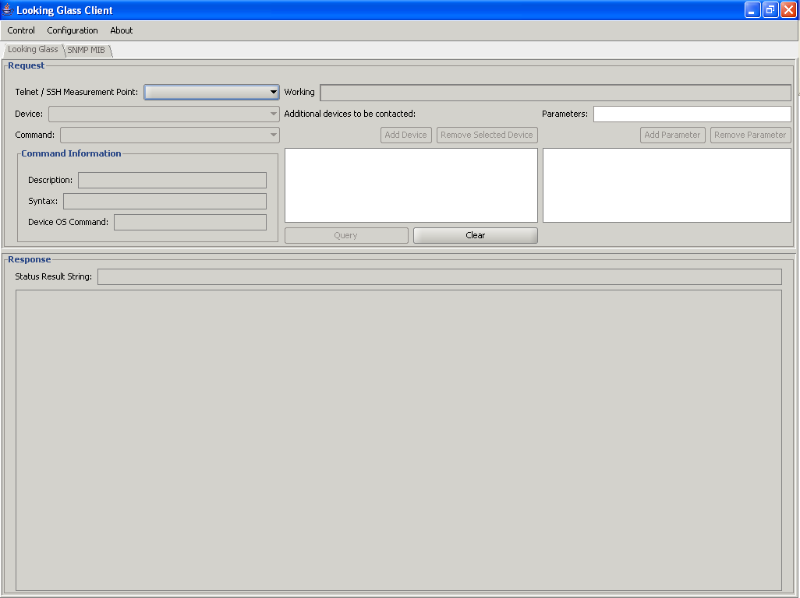

Specification
This section gives a step-by-step walkthrough on how to use the Looking glass visualisation client. The workings of the tool are explained at the end of this subsection by means of some examples.

Running the client
Currently, there are two possible ways to use the Looking Glass Client. Either you can download the zip-file from the perfSONAR wiki page [http://www.perfsonar.net/jra1-wiki/index.php/Looking_Glass]. The jar-file that sits in this zip-file can be run using standard Java-invocation. java –jar LookingGlassClient.jar
The second possibility is by using Java Web Start. An example deployment of the Looking Glass Client can be found here: http://chaos169.test.atlantis.UGent.be/. Follow the “Launch the application” link at the top op the screen. The application is written and compiled using Java 1.5 technology. This means that you must have a Java 1.5 version installed on you machine, because of the incompatibility with earlier Java RE versions.

User’s Guide
In this section, a step-by-step guide is given on how to use the application. The numbers between brackets refer to the screenshot at the end of this paragraph.
- Firstly, one has to select the desired MP from the combobox (1).
NOTE: When first running the application, one has to configure the application with a list of available Telnet/SSH MPs. This can be done using the “Configuration” menu and “Configure SSH/Telnet” submenu. We intend to use the Lookup Services in the future. An example MP can be found at: http://chaos169.test.atlantis.ugent.be:8080/axis/services/TelnetSSH.
- Select a device you want to retrieve information about (2). You can also query multiple devices in one go, using the “Add Device” and “Remove Selected Device” buttons. (3)
- Now select the desired command (4) to be executed on the device(s). These commands are the classic “Show-like” commands. Extra information (if available) for the selected command is displayed in the box “Command Information” (5). Three types of extra information are provided, being a textual description of the command, the desired syntax of possible arguments (see also the next bullet-point) and the translation from the generic perfSONAR command towards device specific syntax.
- An optional last step is the inclusion of parameters in the request (6). This won’t be necessary for some commands, but for others it is. A common example is the request for a routing table entry. With this command, it is compulsory to specify the network about which you wish to retrieve the routing table entry, otherwise one would retrieve the entire routing table.
- Now, you can execute the query by clicking on the button “Query” (7). All the information is retrieved via the MP.
- Once the results are returned, you can select the device from the list (3), and the corresponding result is displayed (8). Also, some status information (9) is displayed as well as status information to notify the user if for some reason the request has failed to retrieve the desired data.

Example requests
In the following paragraphs, some off-the-shelf examples are provided that can be used to test the application. The numbers between brackets indicate the place in the application where you have to perform the action. The screenshot below can be used as a reference.

Example 1
- (1) chaos169
- (2) JuniperGEANTAmsterdam
- (3) Add
- (2) JuniperGEANTParis
- (3) Add
- (2) JuniperGEANTParis
- (3) Add
- (3) Look that you can’t add twice the same device
- (4) IP_ROUTE
- (7) Query
- (3) Select one of the routers
- (9) Look at the reason for the failed request
- (6) Add a network address as parameter (eg: 157.193.0.0/16)
- (7) Query
- (3) Select one of the routers
- (8) Look at the routing table entry for this network.

Example 2
- (1) chaos169
- (2) JuniperGEANTAmsterdam
- (3) Add
- (2) cisco1
- (3) Add
- (4) STATUS_INTERFACE
- (7) Query
- (3) Select cisco1
- (8) Take a look at the output
- (3) Select JuniperGEANTAmsterdam
- (9) Take a look at the result for this and notice that this command is not allowed for this particular router.
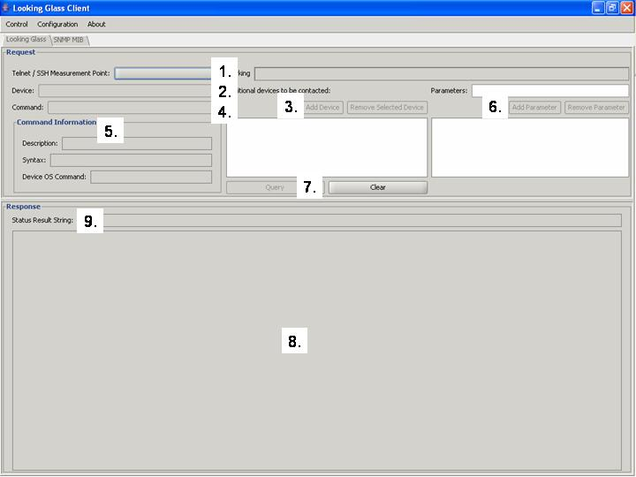

Implementation status
The primary target user groups for the Looking Glass Client include NOC and PERT staff. Due to the wizard-style query construction, end-users can master the tool quite easily.
We are already in the 4th iteration of the implementation of this visualisation tool. Mainly, this is because the development of the back-end SSH/Telnet MP has been done in parallel with this front-end. During the sessions in the last Technical Meeting in Cambridge in June 2006 and on the developers mailing list, many comments and requests for enhancements were received. In all, the tool is perceived as good and easy to use. A summary of the remarks is listed below. These remarks will be analysed and implemented in the coming months.
This application is appreciated as it is easy to use and makes it possible to have a single application to globally query routers in different domains. Some people have asked to merge the application in perfSONARUI to keep a single tool, which is a reasonable request as we certainly must try to integrate all the individual tools to try to create an overall application. Some other interesting features were asked; like the possibility to easily compare outputs from different routers, and the possibility to make more than one command at the same time. Another very interesting feedback received is the need for the provision of a filtering functionality, so that the output can be filtered by “grep”-style filtering command. Some ideas for improvement of the overall graphical layout were suggested as well. Also, some minor bugs were found, and these should be rectified as soon as possible.

Details and future evolution
Detailed, up-to-date information about the tool, change log, and all released versions are available at the perfSONAR wiki page (http://www.perfsonar.net/jra1-wiki/index.php/Looking_Glass). Also, source code for the client can be obtained from this page.
The future enhancements planned for this tool, next to the requests and remarks presented in the section above, are listed below:
- LS integration
- AA integration
- SNMP/MIB visualisation using the SNMP MP

Targeting the NOC users
<more body text>

Functional test results
<more body text>

Release management process
The Release Management process, described in detail in DJ1.3.1, was applied to selected services for the first time in the GÉANT2 JRA1 activity. The services chosen to be included in this first release were:
- RRD MA - used to publish historical monitoring data that is stored in an archive. It acts as a wrapper around an existing RRD, to provide data to the outside world. This service was chosen because it was the most advanced service at the time. Also because it has been deployed by several networks, as RRDs are widely deployed within the community.
- Lookup Service - enables users to discover other services, and in particular the tools and the capabilities or the data covered by those services. The Lookup Service acts as a service directory, where services can advertise themselves (provide their lookup information) and requestors are able to find any service they need. This service was chosen because it is essential to identify what is available.

The perfSONAR activity is getting very useful information from this first run of the release management process. For example, we are now more aware, by experience, of the complexity associated with assembling a release, the necessary interaction with the developers, with the different groups and teams described in DJ1.3.1, and who needs what information and at which stage. To have a stable and official release is crucial to ensure a consistent combination between the services, and thus helping to motivate a large deployment of those services by the NRENs.
The process documented in DJ1.3.1 begun by having the release management team fulfilling some needs of the activity, namely by setting up two new tools: Subversion and Bugzilla. The first one gave the activity a more flexible and faster version control system, replacing CVS. The second was needed so that the developers and release management team have a reliable and easy to use bug-tracking system that also can be used for managing tasks. Therefore, it both helps the management of software releases and the development process, being a way to:
- Track bugs and code changes
- Communicate with team mates
- Submit and review patches
- Manage quality assurance (QA)

Being the first release, not all time intervals described on the release management process were respected. We hope to be able to learn from the time each stage took, and adjust the time intervals accordingly, after analyzing how the second run of the release process behaves.
The first step of the process, after the installation of the tools mentioned earlier, was to send an email (on the 8th of May, 2006) to the developers, announcing what services would be on the new release, the date of the upcoming code slush - on the 15th of May – and, on the same date, the migration from the old version control system (CVS) to Subversion. Basically, all code that was expected to be a part of the release had to be in the CVS ‘head’ branch (the STABLE branch defined in DJ1.3.1) by May 15th.
So, the developers had the opportunity to integrate new changes into the selected services, performing “Merge from CURRENT” sweeps until the control of the STABLE branch was given to the release management team, the source repository entered a “code slush”, and each change to the source code of the services asked by the developers was evaluated against the kind of changes that are allowed during this period: bug fixes, documentation updates, security related fixes, and changes the release engineering team feel are justified given the risk.
During this period of “code slush,” a meeting between the release management team, testing team, and developers of the services was very valuable to discover an important task that will always have to be completed right after choosing the services included in each release: the testing team needs detailed documentation about each possible input accepted or output generated by each service, which parameters are mandatory and which are optional, so that the functional testing scripts can be built.
After code slush, on the 22nd of May, the Release branch was created. The release management team started to work on an installer system that would work for everyone. Both a text-based and a graphical installer were developed, together with documentation instructing users on how to install all the tools that already need to be in place before staring the installation of perfSONAR.
The first Release Candidate was announced on the 8th of June. The community of users and developers was asked to install and try the Release Candidate, filling in the eventual bugs on the bug-tracking software – Bugzilla. Three bugs were reported, one on a testing script for the Lookup Service, one on the installation procedure, and finally one on the performance of XML parsing.
The bugs were corrected, and a second Release Candidate was ready on 16th of June. Again, more users tried the package and reported another five bugs. Two of them were on the GUI installer, two were on the installation scripts, and one on the registration of the RRD MA on the Lookup Service.
On June 26th, a third Release Candidate was available. This last one had resolved all the bugs that were reported until that date, and the release management team agreed with the testing team that this third Release Candidate would not be upgraded again in a period of two weeks, so that they would have time to perform the functional tests. On this third Release Candidate, three bugs were reported: two on the installation scripts, and one on the documentation for the installation. Two other bugs are now open: one for resolving the fact that copyright and license text is missing, and another for launching the official release – perfSONAR v1.0, as soon as copyright/license issues are resolved.
On the 7th of June, the Testing Team reported that they were not able to test the third Release Candidate, due to the complexity of the tests and the lack of manpower. They committed to perform the functional testing on the official release.

Conclusions
<This section should come after the main body of the Deliverable, but before the References and Acronyms>

References
<This section should come after the Conclusions, but before the Acronyms. Use SHIFT+RETURN to put a line break in a URL while retaining the correct indentation alignment>
[REF e.g. [GGF NM-WG] ] URL e.g. http://www.internet2.edu/presentations/jtcolumbus/20040720-piPEfitters-Simar.ppt
[REFERENCE] URL

[CPAN] Comprehensive Perl Archive Network. A collection of Perl software and documentation, http://www.cpan.org
[COMBO6] http://www.endace.com/products.htm
[CVS] perfSONAR WebCVS,
http://anoncvs.internet2.edu/cgi-bin/viewcvs.cgi/perfsonar/?cvsroot=sonar
[DAG] http://www.endace.com/products.htm
[DJ1.3.1] J. Boote, J. Durand, M. Głowiak, A. Hanemann, V. Jeliazkov, L. Kudarimoti, P. Louridas, R. Łapacz, L. Marta, N. Simar, M.Swany, S. Trocha, I. Tsompanidis, V. Venus, “D.J.1.3.1 - Phase I - Implementation Report”
[FEATHRES] M. Feathers “Working Effectively with Legacy Code”, Prentice Hall, 2005
[GFD] Jeff Boote, Eric Boyd, Mauro Campanella, Jérôme Durand, Susan Evett, Maciej Glowiak, Andreas Hanemann, Roland Karch, Stephan Kraft, Loukik Kudarimoti, Olav Kvittem, Roman Lapacz, Athanassios Liakopoulos, Luís Marta, Joe Metzger, Maurizio Molina, Martin Swany, Szymon Trocha, Sven Ubik, “DJ.1.2.1 - GEANT2 General Monitoring Framework Design”
[ICISP 2006] Andreas Hanemann, Vedrin Jeliazkov, Olav Kvittem, Luís Marta, Joe Metzger, Igor Velimirovic: “Complementary Visualization of perfSONAR Network Performance Measurements”, Proceedings of the International Conference on Internet Surveillance and Protection (ICISP), Cap Esterel, France, IARIA/IEEE, August, 2006.
[MAPI] http://mapi.uninett.no/
[MICO] MICO Common Object Request Broker Architecture (CORBA) implementation, http://www.mico.org/
[MYERS] G. J. Myers, C. Sandler, T. Badgett, T. M. Thomas “The Art of Software Testing”2nd edition, Wiley, 2004
[NETRAMET] http://www.auckland.ac.nz/net/NeTraMet/
[NETRAMET Collector]
[SCAMPI] http://www.ist-scampi.org/
[SEEREN2] South-Eastern European Research & Education Network project, http://www.seeren.org
[XQUERY] XML Query Language W3C recommendation, http://www.w3.org/TR/xquery/
[

Acronyms

[AA] [Authentication and authorization]
[ADVENT snmp]
[API] [Application program interface, a set of routines, protocols, and tools for building software applications.]
[BWCTL] [Bandwidth Test Controller, a tool for establishing bandwidth; currently a wrapper around Iperf.]
[CNM] [Customer Network Management, a graphical user interface]
[CORBA] [Common Object Request Broker Architecture]
[CPAN] [Comprehensive Perl Archive Network]
[CSV] [Comma-Separated Values]
[CVS] [Concurrent Versions System]
[DiMAPI] [Distributed MAPI]
[FAQs] [Frequently Asked Questions]
[GUI] [Graphical user interface]
[HTTP] [Hypertext Transfer Protocol]
[HTTPS] [HTTP with additional encryption/authentication]
[ID] [Identification]
[IPPM] [Internet Protocol Performance Metrics]
[JRA3] [Joint Research Activities 3: Security Services]
[JRA4] [Joint Research Activities 4: Development of Network Services]
[JRA5] [Joint Research Activities 5: Roaming and Authorisation Services]
[LS] [Lookup Service; see Section 4.4 and 4.4 for more information.]
[MA] [Measurement Archive; see Section 4.3 for more information.]
[MAPI] [Monitoring Application Interface]
[MP] [Measurement Point; see section 4.2 for more information]
[MRTG] [Multi-Router Traffic Grapher]
[NEMO] [Network Monitor]
[NMWG] [Network Measurement Working Group; part of the Global Grid Forum effort. The group has focused on developing schemas for network measurement requests and responses.)
[NIC] [Network Interface Card]
[NOC] [Network Operations Center]
[NREN] [National Research and Education Network]
[ORB] [Object Request Broker]
[OSI] [Open Source Initiative]
[OWD] [One-way delay]
[OWDV] [One-way delay variation]
[P2P] [Peer-to-peer]
[PCAP] [Application programming interface for packet capturing]
[PERT] [Performance Enhancement Response Team]
[Q/A] [Quality assurance]
[RC] [Release Candidate]
[RRD] [Round robin database]
[SEEREN2] [South-eastern European Research & Education Network, second generation]
[SOAP] [Simple Object Access Protocol]
[TCMP] [Tracefile Capture Measurement Point]
[TCP] [Transmission Control Protocol]
[UDP] [User Datagram Protocol]
[UI] [User interface]
[URL] [Uniform Resource Locator]
[XML] [eXtensible Markup Language]

<Appendix Heading Text Goes Here>
<The style for the Appendices that is equivalent to Heading 1 is Heading 6>

<Appendix Heading 2 Text Goes Here>
<Appendix headings equivalent to levels 2-4 are represented by styles Heading 7- Heading 9>

<Appendix Heading 3 Text Goes Here>

Figure A.2: <Example appendix figure caption - text here – in Word, type figa and press F3 to insert new appendix figures>
<To paste a graphic into the box, choose Edit -> Paste special -> [picture] or [metafile] (Word) or Edit -> Paste special -> GDI metafile (OpenOffice). For Word: choose Format -> Picture -> Layout, In Line with Text to place the picture inside the border; for OpenOffice: right-click on the graphic and choose Anchor -> As Character.>
<Can’t use autotext? Copy and paste an existing border and caption - make sure you copy an appendix figure rather than a main figure as the numbering system is different - and use F9 to update the number.>
Column Header | Column Header | Column Header | Column Header | Column Header
Table data
Table A.1: <Example appendix table - caption text goes here – in Word, type tablea and press F3 to add additional tables>
<Can’t use autotext? Copy an existing table and caption - make sure you copy an appendix table rather than a main table as the numbering is different - select both and press F9 to update the number.>
<If you add or delete columns using the Insert or Delete -> Columns options from the Table menu, the table width should ideally be reset to 17.4cm with a left indent of 0.15cm (via Table -> Table Properties dialog) to align correctly with the page margins.>

<Appendix Heading 4 Text Goes Here>
<more text>

<Appendix Heading Text Goes Here>
<More body text>
<Use Insert -> Break -> Section Break, Next page (Word) or Insert -> Manual Break… (OpenOffice) to add new sections (in OpenOffice, select an appropriate page style from the Style drop-down to apply the correct headers)>

Deliverable must be changed and reviewed again before submission to the EC can be considered
Deliverable may be submitted to the EC after the author has made changes to take into account reviewers' comments as appropriate
For submission to EC

