Experiment 1
We create linear 3 nodes topology in mininet
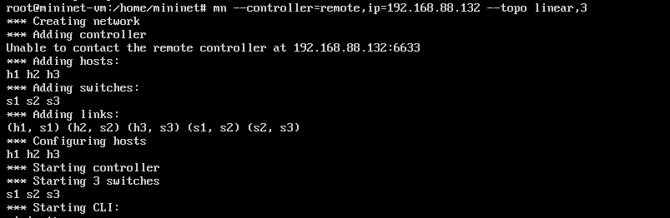
Then in oess you can see these nodes but they are not yet confirmed by administrator
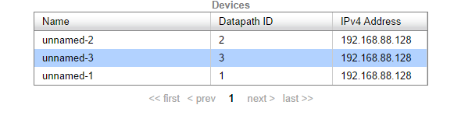
Next I confirmed them so they go to network section of oess
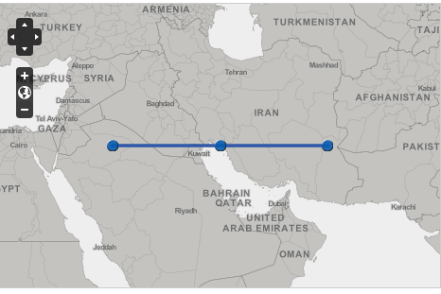
Then I exit mininet and created new topology in mininet but this time it is four nodes and linear
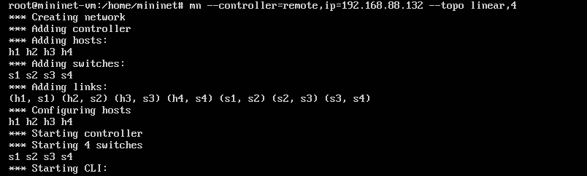
I asked oess to rediscover the topology by refreshing the browser since node 1 to node 3(sw1-sw3) are in oess database in discovery part you can onle see newly added node (sw4) and this is expected
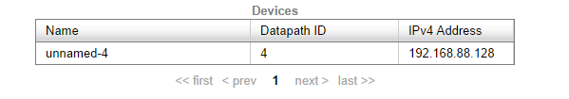
Without confirming this node I got back to mininet and revert the topology to three nodes linear topology
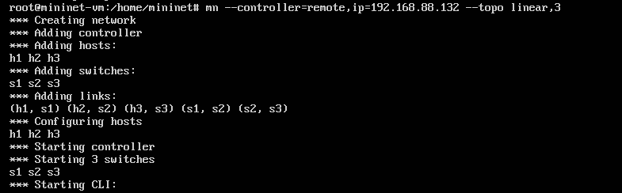
Here is where problem occurs. I came back to oess node 4 is still there and there is no way to get rid of that so I confirmed that an as expected it goes to network section
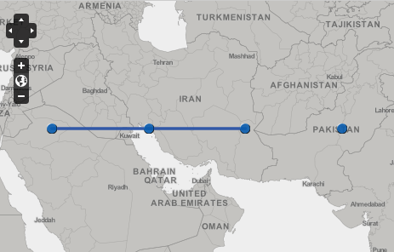
Then I tried to dismiss that by decommission option when you right click on node and I got error
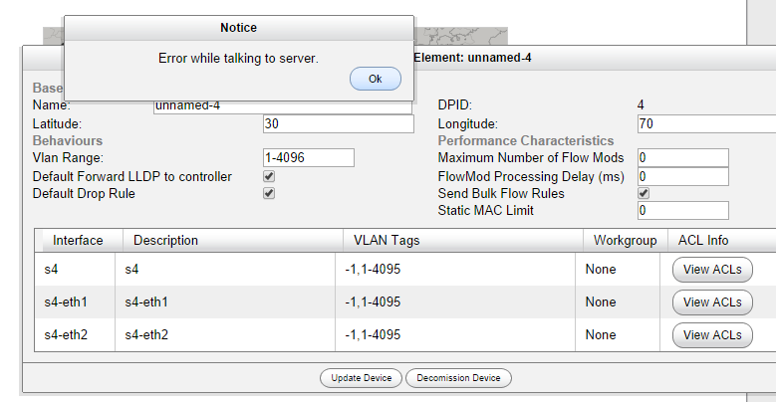
Which is expected because there is no such a link in mininet
Experiment 2
This time I repeated same experiment with little difference
First I created three nodes topology and confirmed them .Then in mininet I created four nodes topology this time after getting discovered by oess I confirmed node 4 and changed the topology to three nodes again(In mininet)
Same thing happened again
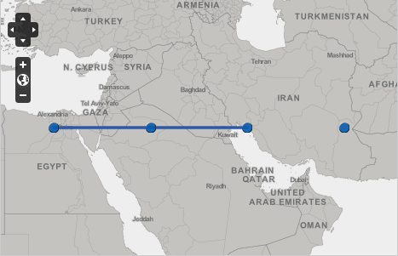
You can see node 4 again

Conclusion
In these two experiments one new node is turned on and off (I simulated this with changing the topology in mininet from 3nodes 4 nodes 3 nodes)
In experiment one administrator does not notice node 4 in experiment 2 administrator notice that and confirmed that but the problem is in both cases node 4 remains after going back to 3 nodes topology

