Jack: 10 Upload, 30 download. Nobody using internet at home.
Test on Windows 7 Latitude E6410 –Flash 17,0,0,169

 | Chrome |  | Firefox |  | IE
BUFFER | DOWNLOAD | UPLOAD | DOWNLOAD | UPLOAD | DOWNLOAD | UPLOAD
8K | 27.9 Mbps | 6.3 Mbps | 26.8 Mbps | 4.3 Mbps | 26.2 Mbps | 4.2 Mbps
8K | 26.2 Mbps | 6.2 Mbps | 26.6 Mbps | 4.1 Mbps | 27.5 Mbps | 4.1 Mbps
16K | 29.6 Mbps | 10.0 Mbps | 28.9 Mbps | 6.9 Mbps | 23.2 Mbps | 6.6 Mbps
16K | 27.3 Mbps | 9.6 Mbps | 22.3 Mbps | 6.8 Mbps | 23.7 Mbps | 7.0 Mbps
32K | 28.5 Mbps | 10.0 Mbps | 24.8 Mbps | 8.7 Mbps | 25.5 Mbps | 8.9 Mbps
32K | 29.7 Mbps | 9.8 Mbps | 26.7 Mbps | 9.0 Mbps | 28.5 Mbps | 8.9 Mbps
48K | 28.0 Mbps | 10.3 Mbps | 28.8 Mbps | 9.0 Mbps | 25.8 Mbps | 9.4 Mbps
48K | 29.7 Mbps | 9.7 Mbps | 23.1 Mbps | 9.4 Mbps | 26.8 Mbps | 9.5 Mbps
64K | 25.7 Mbps | 9.9 Mbps | 23.7 Mbps | 9.5 Mbps | 21.3 Mbps | 9.5 Mbps
64K | 28.1 Mbps | 10.0 Mbps | 28.7 Mbps | 9.6 Mbps | 26.3 Mbps | 9.9 Mbps
 |  | Control Test: Videotron FIBE 30 Download / 10 Upload

Usage includes in/out + ack packets… so a little bit more on the graphs.
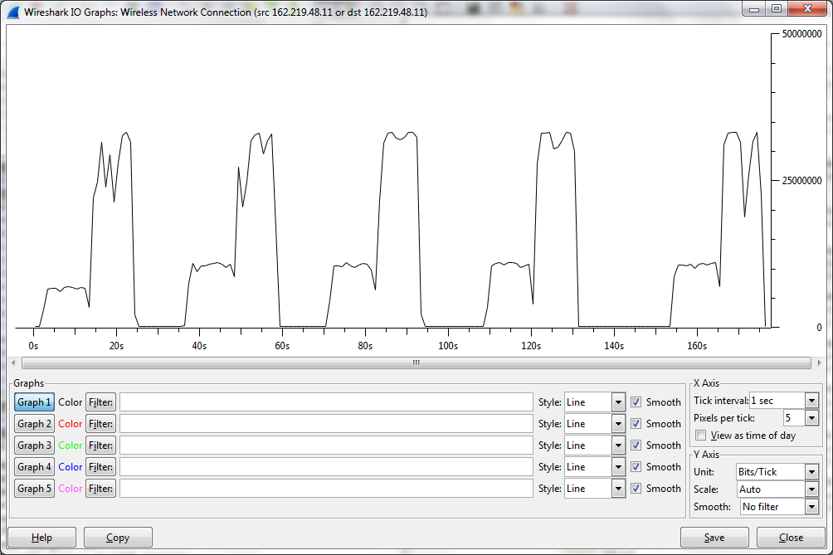
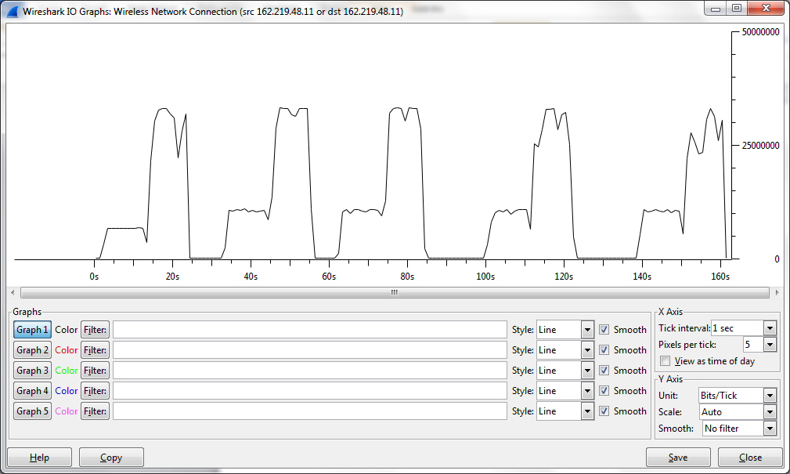
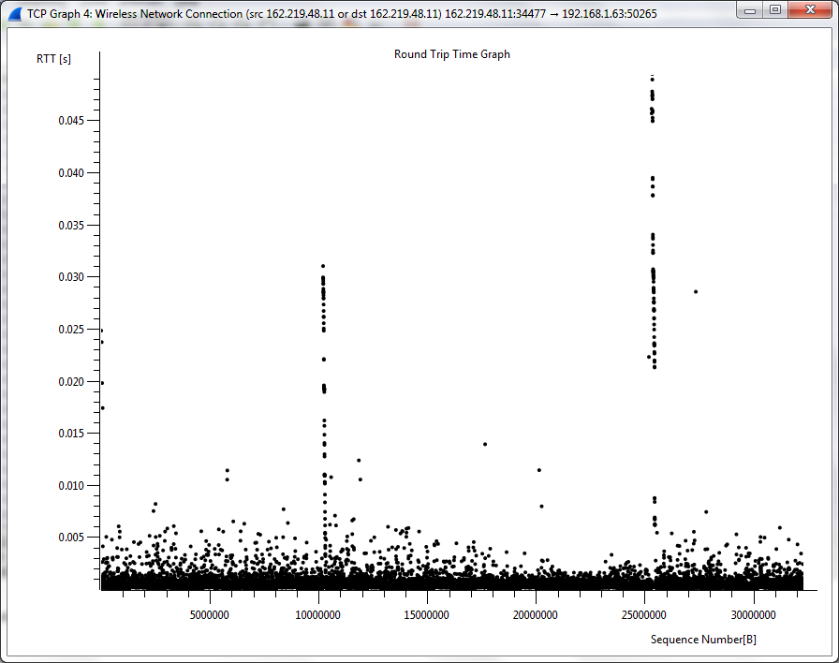
Chrome: 8K, 16K, 32K, 48K, 64K
8K
DOWNLOAD SPEED 27.9 Mbps
UPLOAD SPEED 6.3 Mbps

DOWNLOAD SPEED 26.2 Mbps
UPLOAD SPEED 6.2 Mbps

16K
DOWNLOAD SPEED 29.6 Mbps
UPLOAD SPEED 10.0 Mbps

DOWNLOAD SPEED 27.3 Mbps
UPLOAD SPEED 9.6 Mbps

32K
DOWNLOAD SPEED 28.5 Mbps
UPLOAD SPEED 10.0 Mbps

DOWNLOAD SPEED 29.7 Mbps
UPLOAD SPEED 9.8 Mbps

48K
DOWNLOAD SPEED 28.0 Mbps
UPLOAD SPEED 10.3 Mbps

DOWNLOAD SPEED 29.7 Mbps
UPLOAD SPEED 9.7 Mbps

64K
DOWNLOAD SPEED 25.7 Mbps
UPLOAD SPEED 9.9 Mbps

DOWNLOAD SPEED 28.1 Mbps
UPLOAD SPEED 10.0 Mbps

Firefox: 8K, 16K, 32K, 48K, 64K
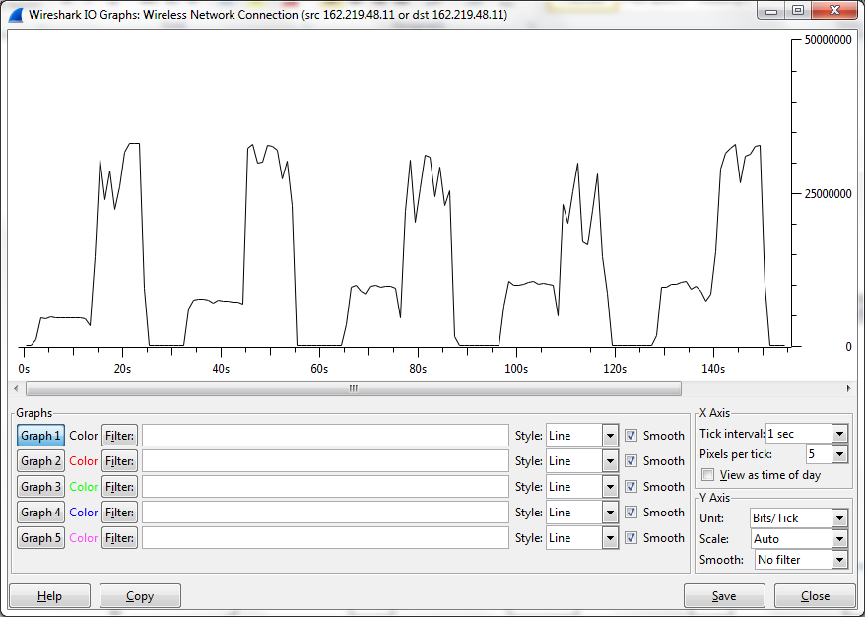
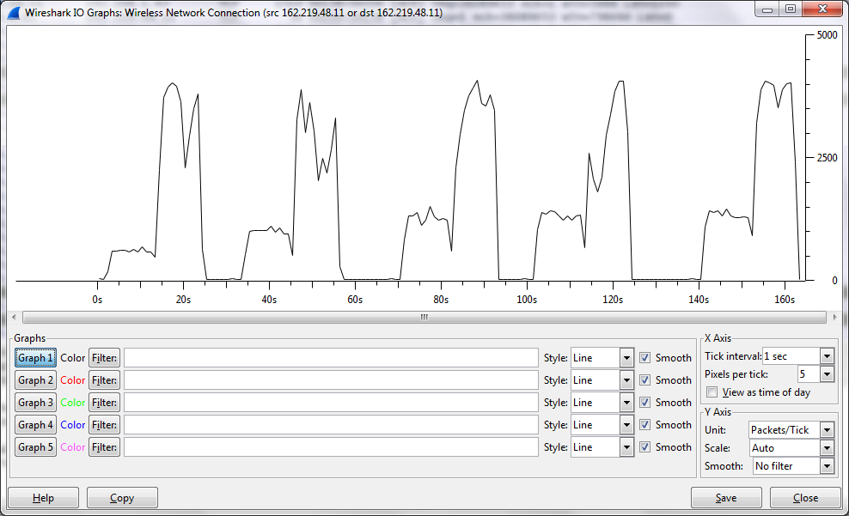
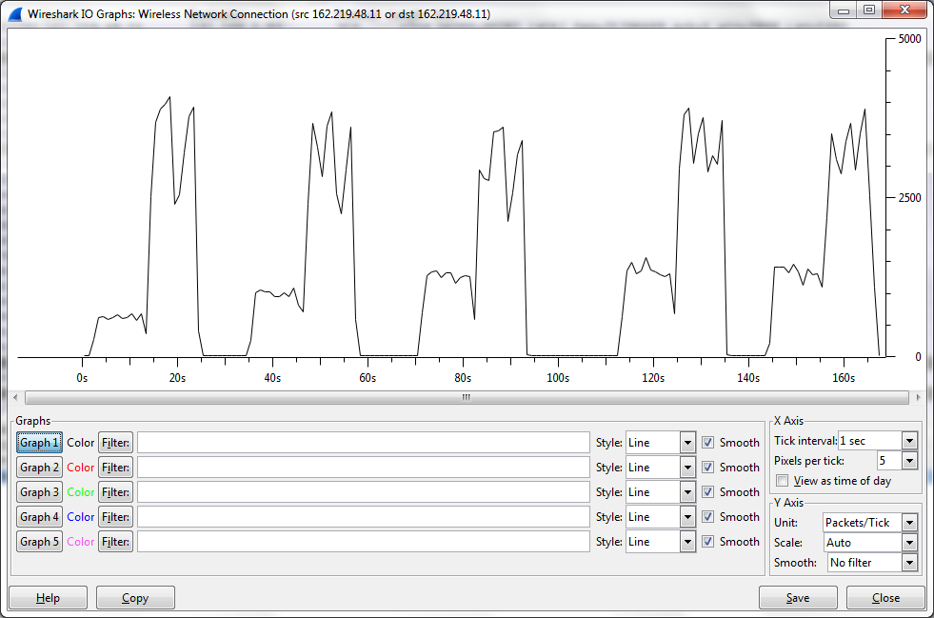
(oups, packets instead of bit/sec, but same patterns)

8K

DOWNLOAD SPEED 26.8 Mbps
UPLOAD SPEED 4.3 Mbps

DOWNLOAD SPEED 26.6 Mbps
UPLOAD SPEED 4.1 Mbps

16K
DOWNLOAD SPEED 28.9 Mbps
UPLOAD SPEED 6.9 Mbps

DOWNLOAD SPEED 22.3 Mbps
UPLOAD SPEED 6.8 Mbps

32K
DOWNLOAD SPEED 24.8 Mbps
UPLOAD SPEED 8.7 Mbps

DOWNLOAD SPEED 26.7 Mbps
UPLOAD SPEED 9.0 Mbps

48K
DOWNLOAD SPEED 28.8 Mbps
UPLOAD SPEED 9.0 Mbps

DOWNLOAD SPEED 23.1 Mbps
UPLOAD SPEED 9.4 Mbps

64K
DOWNLOAD SPEED 23.7 Mbps
UPLOAD SPEED 9.5 Mbps

DOWNLOAD SPEED 28.7 Mbps
UPLOAD SPEED 9.6 Mbps

IE: 8K, 16K, 32K, 48K, 64K
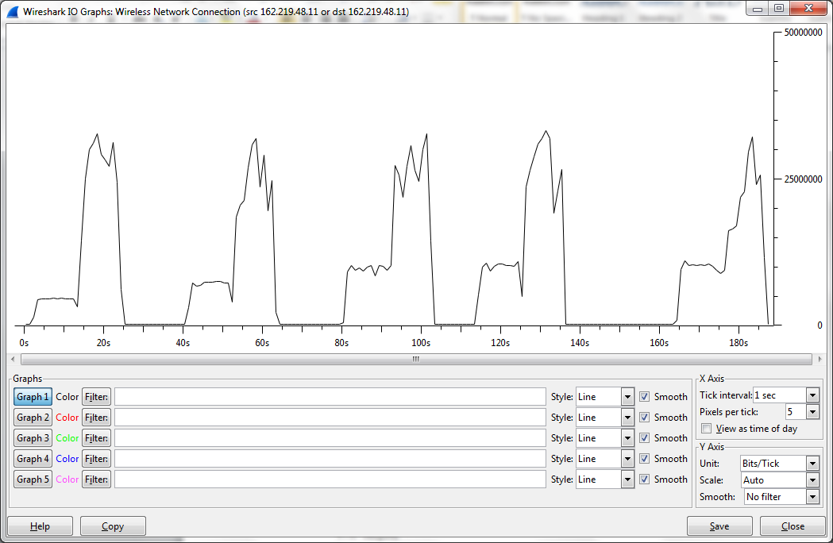
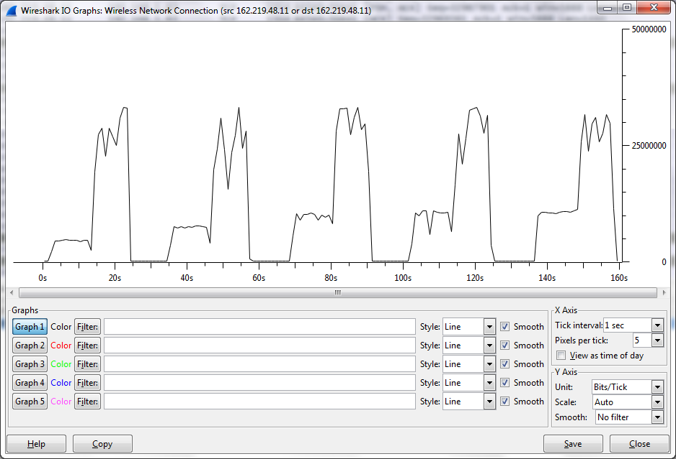

8K
DOWNLOAD SPEED 26.2 Mbps
UPLOAD SPEED 4.2 Mbps

DOWNLOAD SPEED 27.5 Mbps
UPLOAD SPEED 4.1 Mbps

16K
DOWNLOAD SPEED 23.2 Mbps
UPLOAD SPEED 6.6 Mbps

DOWNLOAD SPEED 23.7 Mbps
UPLOAD SPEED 7.0 Mbps

32K
DOWNLOAD SPEED 25.5 Mbps
UPLOAD SPEED 8.9 Mbps

DOWNLOAD SPEED 28.5 Mbps
UPLOAD SPEED 8.9 Mbps

48K
DOWNLOAD SPEED 25.8 Mbps
UPLOAD SPEED 9.4 Mbps

DOWNLOAD SPEED 26.8 Mbps
UPLOAD SPEED 9.5 Mbps

64K
DOWNLOAD SPEED 21.3 Mbps
UPLOAD SPEED 9.5 Mbps

DOWNLOAD SPEED 26.3 Mbps
UPLOAD SPEED 9.9 Mbps

