**GenAI Use Case: Contract Analysis**  
**Objective**: Compare vendor/sponsor agreements to your institution’s standard terms and conditions.

**Key Rules:**

1. **Avoid using the upload button:** ­When using the upload button to upload the contract(s), you’re most likely triggering the RAG system behind the application, it's important to understand that your document is being chunked and indexed in a Vector Database. When performing critical tasks like contract analysis, you want the AI to consider the entire file rather than isolated parts. To ensure this, copy the content of the agreement and paste it directly into the chat box. Don’t worry about formatting—the LLM doesn't mind.
2. **Ask the AI to "Show Its Work":** To reduce hallucinations and ground the model in the facts provided within the vendor/sponsor contract and Cornell's standard terms and conditions, we use a technique we call "show me your work." This is similar to the Chain of Thought prompting method, where we ask the model to present its reasoning explicitly before providing the answer. In this use case, the prompt directs the AI as follows:
   * Sponsor Term: [Quote the relevant term from the provided agreement]
   * Cornell Term: [Quote the corresponding term from Cornell's standard agreement]
   * Conflict Reasoning: [Explain why these terms are in conflict]
   * Suggested Conflict Resolution: [Propose a potential solution to resolve the conflict]

By having the AI explicitly write down the relevant quotes first, it becomes harder for the model to hallucinate. Once these specific tokens are written, the model is more likely to provide reasonable conflict identifications and resolutions.  
  
**Here’s a sample of the response:**  
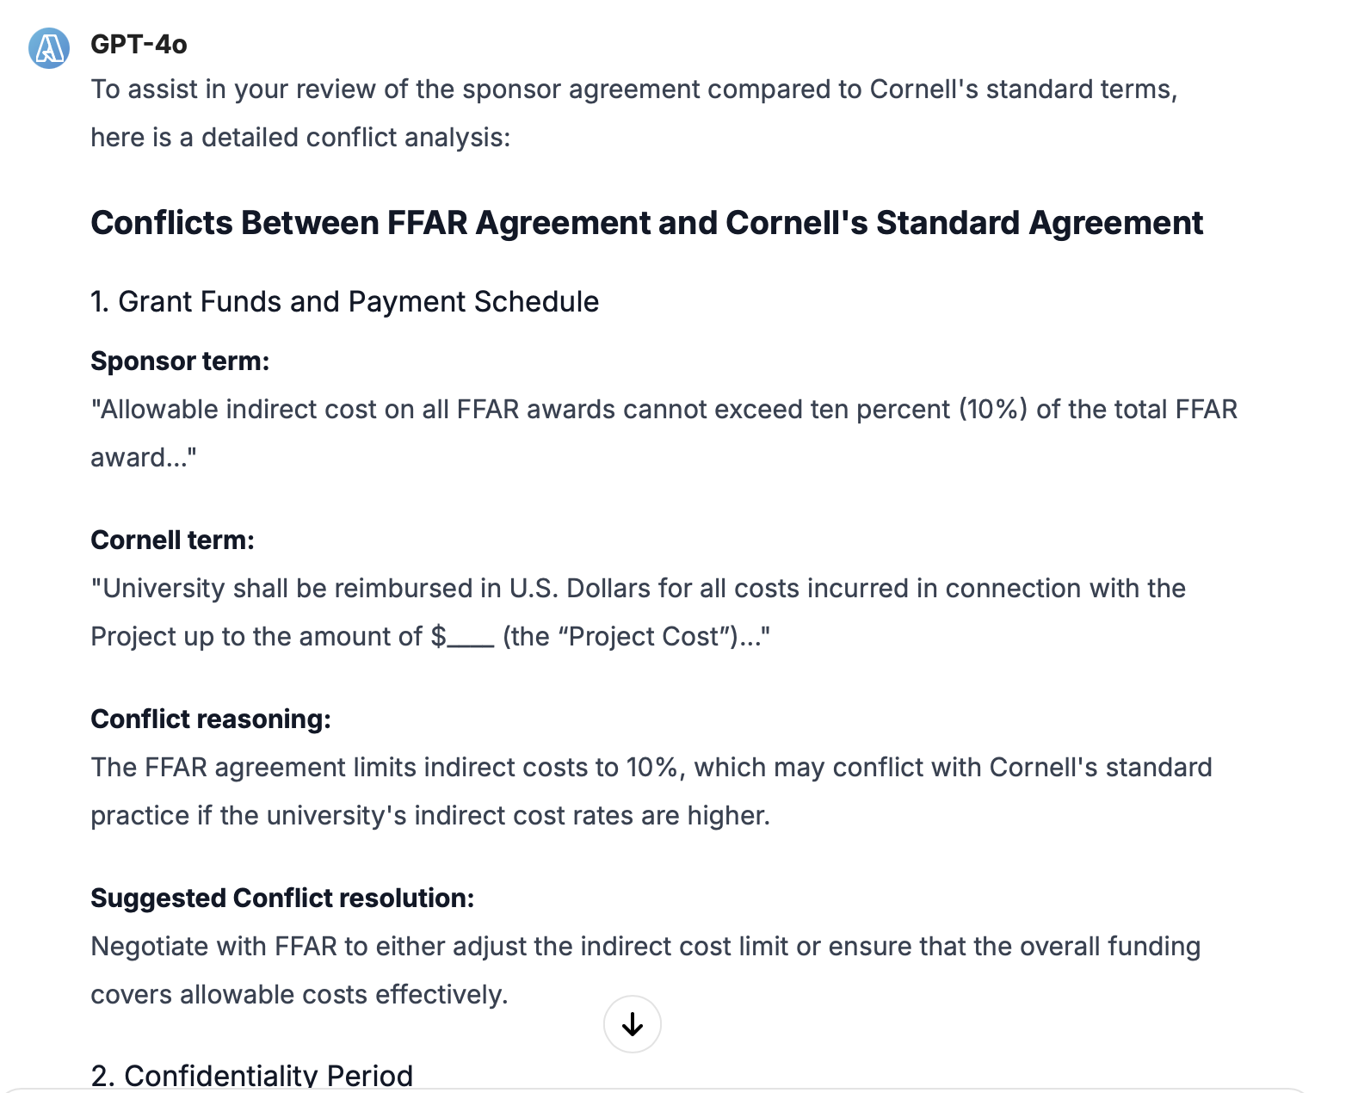

**And here’s the full prompt:**

*You are an expert sponsored program agreement negotiator. Your task is to help me improve my job performance by comparing agreements for conflicting terms and conditions. You are not providing legal advice; instead, you're assisting me in reviewing these agreements so I can conduct the legal review myself.*

*I will provide you with the terms and conditions of a research agreement. Your task is to compare these terms with Cornell's standard research agreement terms and conditions. Please follow these steps:*

*Identify any conflicts between the provided agreement and Cornell's standard terms.*

*For each conflict, present the information in this format: Sponsor term: [Quote the relevant term from the provided agreement] Cornell term: [Quote the corresponding term from Cornell's standard agreement] Conflict reasoning: [Explain why these terms are in conflict] Suggested Conflict resolution: [Propose a potential solution to resolve the conflict]*

*Be thorough in your analysis, highlighting any terms that could potentially be conflicting, even if the conflict is not immediately obvious.*

*After addressing all conflicts, identify any terms in the provided agreement that are not present in Cornell's standard research agreement. List these as: Sponsor Research Agreement Missing terms: [List the terms that are present in the provided agreement but missing from Cornell's standard agreement]*

*Here are Cornell University's standard research terms and conditions:   
"""  
{Cornell Standard Terms and Conditions}  
"""  
Now, please analyze the following sponsor agreement in comparison to Cornell's standard terms  
"""  
{Sponsor Terms and Conditions}  
"""*